# Advanced Identity in AWS

## AWS Organizations

* Global service
* Allows to manage multiple AWS accounts
* The main account is the management account
* Other accounts are member accounts
* Member accounts can only be part of one organization
* Consolidated Billing across all accounts - single payment method
* Pricing benefits from aggregated usage (volume discount for EC2, S3…)
* Shared reserved instances and Savings Plans discounts across accounts. If a reserved instance is unused in one account, another account can benefit from it and therefor the discounts apply across the entire organization
* API is available to automate AWS account creation

We have what's called a root organizational unit, or OU, and this is the outermost OU of your accounts and then within it sits the management account. Then you can create sub-OUs, so you can create for example an OU for the dev accounts and then you can create member accounts within the dev OU, or you can create OU for a prod account and add member accounts there, but you can be as free as you want. You can create within the prod OU, an OU for your HR member accounts and an OU for your finance member accounts. So, you can organize it the way you want. You have different examples for your OUs. You can organize business units, so you have, for example, the management account and then the sales, retail and finance OU and then different accounts within each OU. Or you can have an OU by environment, so for example, one OU for prod, one OU for test, one OU for dev and within each OU, some accounts. Or project-based, so you can have an OU per project within an account, within each project. And you can mix and match. You're free to do whatever you want.

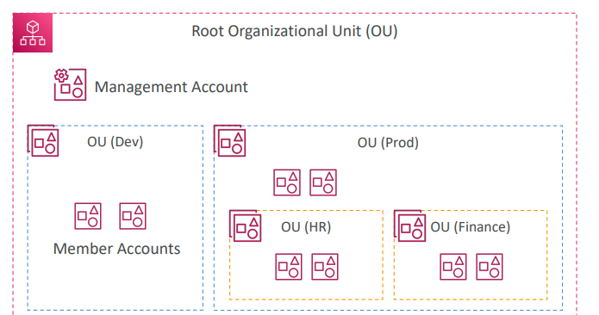 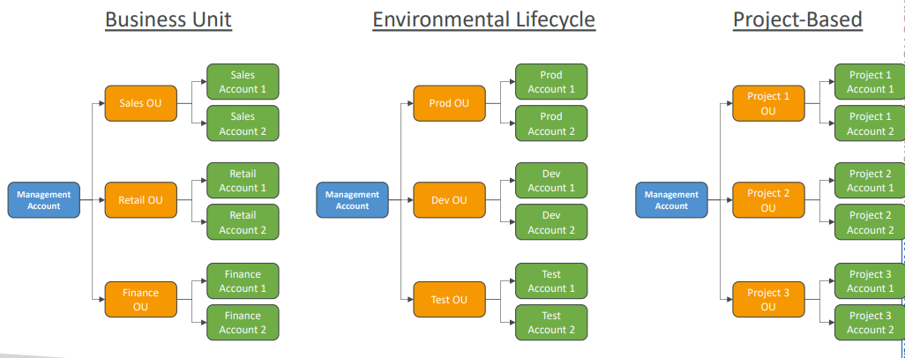

**AWS Organizations**

* Advantages
  + Having multiple accounts, you can have better security versus having one account with multiple VPC, because accounts are more separate than VPCs Use tagging standards for billing purposes
  + Enforce tagging standards for billing purposes and you can enable CloudTrail for all your accounts and send all the logs into a central S3 account Send CloudWatch Logs to central logging account
  + Send CloudWatch logs to a central logging account, and we can establish cross account roles for admin purposes automatically
  + Establish Cross Account Roles for Admin purposes
  + We can administer all the other accounts from the management account
* **Service Control Policies** (SCP) are an IAM policy applied to specific OUs or accounts, and this allows you to restrict what the users and roles all of them can do within the accounts. The SCPs apply to everything but to the management account, which will forever have full admin power, otherwise you could do a mistake and never come back from it. The SCP has the specificity that if you need to compute what is happening on this specific account, you need to make sure that each OU, including the root, has an explicit allow along the way to allow a specific action
* IAM policies applied to OU or Accounts to restrict Users and Roles
* They do not apply to the management account (full admin power)
* Must have an explicit allow from the root through each OU in the direct path
* to the target account (does not allow anything by default – like IAM)

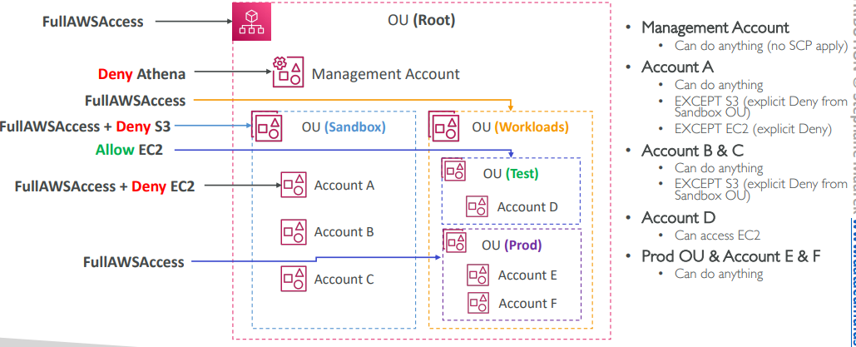

For example, a root OU and we apply full AWS access underneath. The management account is under the root OU and then we have more OU, the Sandbox, the workload, test and prod, with accounts within the OUs. If we apply for an SCP, which denies Athena on the management account, what is happening to the management account? Well, the management account can do anything, because there's a role that says that no SCP ever applies to the management account. This is safe, because of course, if you lock yourself out of your management account, this would be terrible. The management account can do anything, no matter what. But let's say for example, we apply on the Sandbox OU a full AWS access plus deny S3. As you can see, here we still need to apply full AWS access to give allow to everything explicitly, because if we didn't have full AWS access, then nothing would be allowed within that OU. So explicit allows are needed every single way. And on account A, say, we will also do apply full AWS access and deny EC2, then account A can do anything, because it has full AWS access on the root OU and on the Sandbox OU and on the account itself, but because we have two explicit denies, we have one deny S3 from the Sandbox and one deny EC2 from the account itself, then it cannot access Amazon S3 or Amazon EC2. For accounts B and C, because it doesn’t have a specific SCP attached to them, then they can do anything except accessing Amazon S3, because you have an explicit deny coming from the Sandbox OU. Next, if we apply full AWS access to the workloads OU and we also apply an allow EC2 SCP to the test OU then account D can only access EC2 and if we look at the prod OU and accounts E and F within it, well, we must first apply the full AWS access SCP to the prod OU and then accounts E and F can do anything..

So here are some examples of SCPs. This is the first one blocking a specific service. First, we allow all actions and then we deny DynamoDB or on the allow list, here, we allow EC2 and CloudWatch, but we don't allow anything else. So those are some examples of SCPs

<https://docs.aws.amazon.com/organizations/latest/userguide/orgs_manage_policies_example-scps.html>

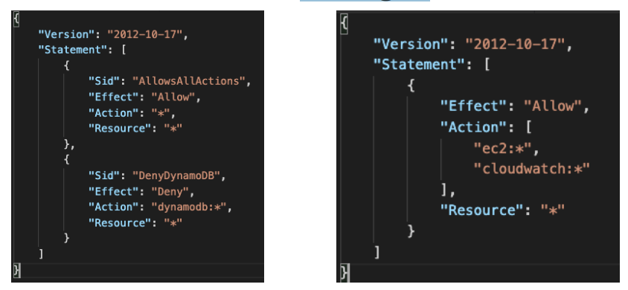

## IAM Conditions

IAM conditions can apply to policies within IAM. So that could be for policies for users, that could be policies for your resource policies, for example, for your S3 buckets, or that could be endpoint policies, and so on

**SourceIP**  This is used to restrict the client IP from which the API calls are being made. If we look at this one right here, it has a Deny star on everything if it's not an IP address. And then we have a list of two CIDRs, of two IP address ranges. So that means that unless the client makes an API call from within these IP addresses, then the API call is being denied. And this can be used, for example, to restrict usage on AWS only to, for example, your company network and, therefore, guaranteeing that only your company can access your own AWS environment.

Then we have **aws:RequestedRegion**. It's restricting the region the API calls are made to. In this one we deny anything on EC2, RDS, and DynamoDB if we are in the region eu-central-1 or eu-west-1. Okay, so here we deny access to these services in specific regions. And this can be applied more globally to their organization SCP to deny or to allow only access to a specific region.

|  |  |
| --- | --- |
| **aws:SourceIp**  restrict the client IP from  which the API calls are being made | **aws:RequestedRegion**  restrict the region the  API calls are made to   |

Next, we have ec2:ResourceTag. So, as you can see now, the prefix of this tag is EC2, therefore, this applies to the tags on your EC2 instance. And, so, here we allow to start and to stop instances, okay, for any instance if the ResourceTag/Project is equal to DataAnalytics. So that means that if the EC2 instance has the correct tags, being Project and DataAnalytics, then we're good.

But then, as you can see, there is the aws:PrincipalTag, and this applies to your user tag, okay. So it's not an EC2 instance tag, this is a user tag. And, so, the user must also be part of the department data to perform these actions.

We have **aws:MultiFactorAuthPresent** to force multifactor authentication. The user can do anything on EC2, but they can only stop and terminate instances if they have MultiFactorAuthenticationPresent, so this is a deny on the false.

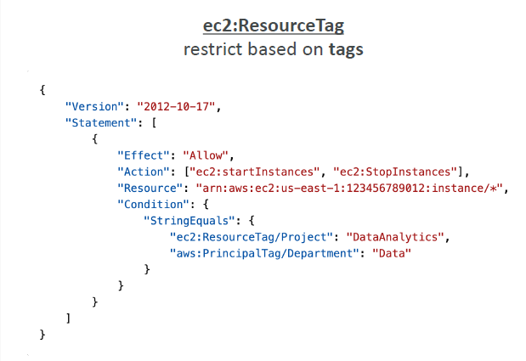 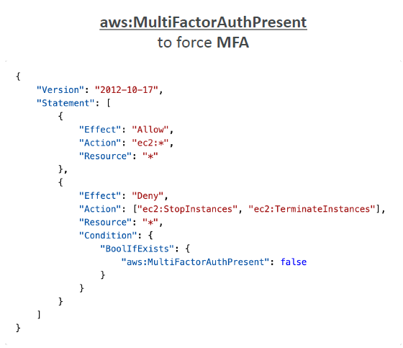

Now let's have a look at an IAM policy for your S3 buckets. So this is a bucket policy, and we have two statements. And the first one is a ListBucket, and this applies to this arn right here, s3:::test. Because it's a bucket level permission and, therefore, we have to specify the bucket itself. But if we have a look at GetObject, PutObject, and DeleteObject, this applies to objects within a bucket and, therefore, your arn is going to be different, and you're going to have /* to represent all the objects within your buckets. And this is why you have a different arn here because this is an object level permission. And, again, this is something that can come up in the exam.

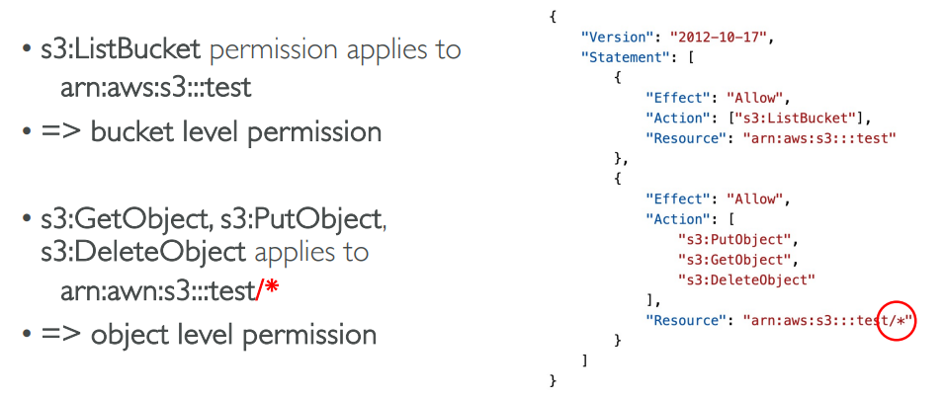

aws:PrincipalOrgID, can be used to restrict resource policies to only accounts that are a member of an AWS organization. So we have an organization with multiple accounts, and say we have S3 buckets with this policy on it. And it's saying that you can do a PutObject or a GetObject only if the API call is made from an account that has the PrincipalOrgID of whatever. And, therefore, it's only going to allow member accounts from your organization to access the S3 bucket, but any user outside the organization will be denied because of this S3 bucket policy.

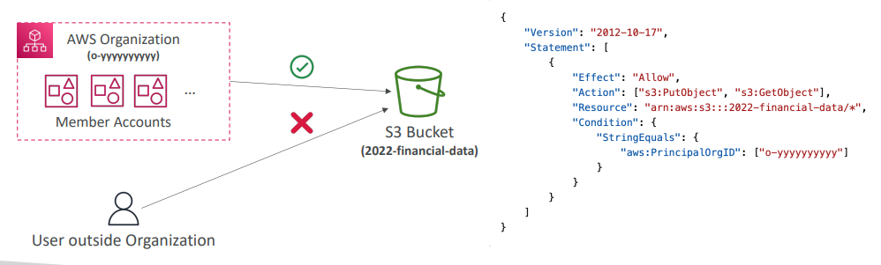

## IAM Roles vs Resource Based Policies

For cross accounts, especially when you want to perform an API call on an S3 bucket cross account, you have two options. You can attach a resource-based policy to a resource, for example, an S3 bucket policy on an S3 bucket, or you can decide to use a role that can access the resource

* Cross account:
* attaching a resource-based policy to a resource (example: S3 bucket policy)
* OR using a role as a proxy

Example where the user in Account A can assume a role in Account B, and that role has the permission to access your Amazon S3 buckets. Or similarly, the user in Account A, through a bucket policy placed on the Amazon S3 bucket in Account B, can access the S3 buckets. So both these two situations are valid, but there is a little bit of difference, okay? The first one is an IAM role that has access to the S3 bucket. The second one is the S3 bucket policy that allows the user. So, what's the difference? When you assume a role, okay, you give up all your original permissions, and you take all the permissions assigned to the role. That means that we, for example, assume a role, and this role can do whatever. We can now do anything that the role does, but we cannot use our original permissions. And so, when you use a resource-based policy, instead, the principal does not assume a role, and therefore, he does not have to give up his permissions. So if you take an example of user in Account A, they need to scan a DynamoDB table in Account A, and then dump it in an S3 bucket in Account B. What they can do is we should use a resource-based policy because this way, we don't have to assume a role, and we can both scan the DynamoDB table and write to an S3 bucket in another account.

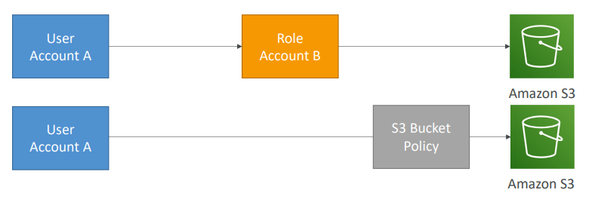

So resource-based policies are supported by more and more AWS services and resources over time. So we have the Amazon S3 buckets, the SNS topics, the SQS queues, the Lambda functions, and so on

And the big difference of when this comes into play is when you use Amazon Event Bridge. So when an Event Bridge rule runs, it's going to need permission on the targets. And if your target supports resource-based policies, for example, Lambda functions, SNS topics, SQS queues, S3 buckets, or API Gateway, then it's possible that Event Bridge will just add a resource-based policy on the target to allow the invocation from the Event Bridge rule. That's one case. On the other hand, if the resource doesn't necessarily support a resource policy, then Event Bridge will use an IAM role to invoke the target service, for example, for Kinesis Stream, EC2 Auto Scaling, System Manager Run Command, ECS task, and so on. And for example, for Kinesis Data Streams, as a note, it supports resource-based policies, but still, Event Bridge is going to use an IAM role. So how do you know which one is going to be used in which? Well, you need to look at the configuration of the Event Bridge role itself to see how this is going to work, and then you will know, okay? But as a matter of fact, Lambda, SNS, SQS, S3 buckets are using resource-based policies. And Kinesis Data Streams, EC2 Auto Scaling, and so on are using IAM roles. Even though it's possible for you to use a resource-based policy with Kinesis Data Stream, that's not yet supported by Event Bridge

**IAM Roles vs Resource-Based Policies**

* When you assume a role (user, application or service), you give up your original permissions and take the permissions assigned to the role
* When using a resource-based policy, the principal doesn’t have to give up his permissions
* Example: User in account A needs to scan a DynamoDB table in Account A and dump it in an S3 bucket in Account B.
* Supported by: Amazon S3 buckets, SNS topics, SQS queues, etc…

|  |  |
| --- | --- |
| * When a rule runs, it needs permissions on the target * Resource-based policy: Lambda, SNS, SQS, S3 buckets, API Gateway… * IAM role: EC2 Auto Scaling, Systems Manager Run Command, ECS task… |  |

## IAM Permission Boundaries

* IAM Permission Boundaries are supported for users and roles (not groups)
* Advanced feature to use a managed policy to set the maximum permissions an IAM entity can get.

We have these IAM permission boundaries. It looks just like an IAM policy. We're saying, allow everything on S3 CloudWatch and EC2. So we attach this, for example, to an IAM user and that's its permission boundaries. That means that it can only do things within S3 CloudWatch and EC2. And then you need to specify on top of things an IAM permission through policy. And so here, say we attach to the very same user, allow iam:CreateUser, resource *. So there is a boundary and there is an IAM policy with permissions. What is going to be the results permission in this case? Well, nothing, no permissions because the IAM policy is outside the IAM permission boundary. Therefore, our user is not allowed to create other IAM users because that is not in its IAM permission boundary

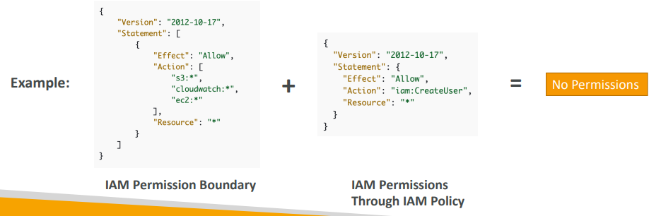

**IAM Permission Boundaries**

So, we have created John and we're going to set permission boundaries for John. So, imagine John is a developer in our company and he needs to have certain permissions, but we want to make sure that he has a permission boundary. So, for this, we could assign a policy, for example, for John, so if I add permission and I say, "Hey, John, I'm going to attach to you Administrator Access." It seems like John can do everything right now. So, John is a super user. But I'm also going to set a permission boundary on John. And I'm going to say, okay, here is your boundary and this is an advanced feature. And I'm going to say the only thing you can do John, is to have AmazonS3FullAccess. And so here, what I've been setting is a permission boundary for John. And so, through this AWS S3 full access managed policy, even though John has an administrator access, when John logs in, the only thing he can do is to access S3 because S3 is its boundary. So here we've seen that, even though there is a policy attached to John that gives him administrator’s access, the boundary is going to be more restrictive. So IAM permission boundaries can be used in combination with AWS Organizations SCP.

So, if look at this diagram, we have the effective permissions to be in the middle of your identity-based policy, so whatever is attached to your user or your group. The permission boundary, which only applies to a user or a role and not a group. And your organization SCP, which applies to every single IAM entity in your account. In the middle lies what the users can do. We can use permission boundaries for a few use cases. For example, to delegate responsibilities to non-administrators within their permission boundaries, for example to create new IAM users. Or to allow developers to self-assign and manage their own permissions, while making sure they can't escalate their privileges, that means making themselves administrators. Or for example, restrict one very specific user inside your organization instead of applying an entire SCP to your account and restricting everyone in your whole account.

|  |  |
| --- | --- |
| Can be used in combinations of AWS Organizations SCP  <https://docs.aws.amazon.com/IAM/latest/UserGuide/access_policies_boundaries.html> | Use cases   * Delegate responsibilities to non administrators within their permission boundaries, for example create new IAM users * Allow developers to self-assign policies and manage their own permissions, while making sure they can’t “escalate” their privileges (= make themselves admin) * Useful to restrict one specific user (instead of a whole account using Organizations & SCP) |

**IAM Policy Evaluation Logic**

Let's have a look at the IAM Policy Evaluation Logic. Because this diagram basically explains to you how you are authorized, or not, to do actions within AWS. And you don't need to know by heart, but it should make sense to you. So, we can see there's a whole flow, but at every step, there is an evaluation. And so, we're going to look at Deny evaluation, we're going to look at Organizations SCP, Resource-based policy, Identity-based policy, IAM permission boundaries, and then finally, Session policies to allow or deny a specific IAM action. So, let's have a look in detail to see how that works. So, we're going to look at all the possible policies here. And if there is an explicit deny, then we know that it's going to be denied automatically. Then we look at the organizations SCP, and is there an allow? If yes, then go to the next step. If not, then it's a deny because it's an implicit deny. Then we look at resource-based policy, for example, that can be applied to S3 buckets. They can be applied to SQS and so on. And again, we have a look, is there a resource-based policy? If so, is there an allow? Yes, or no? Then we have an identity-based policy. So, we look, again, as whether there's an identity-based policy, whether or not there's an allow, and then we deny implicitly or go onto the next step. Then we look at the IAM permission boundaries that we just saw. And then finally, we look at session policies that won't go over them, this is more related to SDS. But what I want you to remember is that all these things are evaluated when making a specific IAM action. And so, only if all these things are allowing and working together, or not denying specifically, then you will have a final decision allow, and you'll be able to do your action.

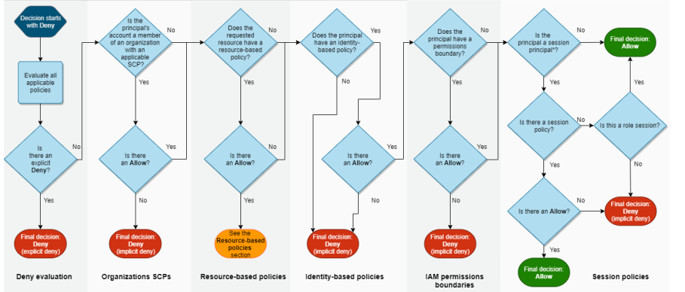

So let's have a look at this policy and see what it can do to make it a bit more concrete. So we have sqs:*, Deny on resource *, and we have action, sqs:DeleteQueue, Allow on resource *. So first question is, can you perform sqs:CreateQueue? The answer is no, you cannot because there is a Deny star on SQS, and CreateQueue belongs to that block and there's a deny on it, so it's going to be denied. Now, can you perform an sqs:DeleteQueue? So there's a deny on the top part and there's an allow on the bottom part and they conflict. There's a deny and allow. But what did I just tell you? I told you that as soon as you have an explicit deny, then the decision is going to be denied. So because there is an explicit deny on sqs:*, and sqs:DeleteQueue is within that sqs:*, then no matter what, even there's an allow here, this is going to be denied this action. So you cannot perform sqs:DeleteQueue, even though you have allowed it explicitly in the second block. So very important to know. And finally, can you perform ec2:DescribeInstances? So as we can see, there's nothing on EC2 in this thing. And this is an IAM policy. And so, because there is no explicit deny but also there's no explicit allow, then you cannot perform ec2:DescribeInstances with this IAM policy. All right, hope that makes sense.

<https://docs.aws.amazon.com/IAM/latest/UserGuide/reference_policies_evaluation-logic.html>

**Example IAM Policy**

|  |  |
| --- | --- |
| * Can you perform sqs:CreateQueue? * Can you perform sqs:DeleteQueue? * Can you perform ec2:DescribeInstances? |  |

## AWS IAM Identity Center

**AWS IAM Identity Center (successor to AWS Single Sign-On)**

* One login (single sign-on) for all your
  + AWS accounts in AWS Organizations
  + Business cloud applications (e.g., Salesforce, Box, Microsoft 365, …)
  + SAML2.0-enabled applications
  + EC2 Windows Instances
* Identity providers can be like
  + Built-in identity store in IAM Identity Center
  + 3rd party: Active Directory (AD), OneLogin, Okta…

**AWS IAM Identity Center – Login Flow**

I can click on the account I want and connect directly for example in the management console And then if I do this, then I'm taken directly from this into the home page of your console. But I'm logged in in that specific console. So, the idea is that I don't need to know how to log in into that specific console. I can just log in into my IAM Identity Center portal. And from there, I have SSO. So, no need to enter your password once you have single sign-on have SSO access to accounts, business applications, and so on.

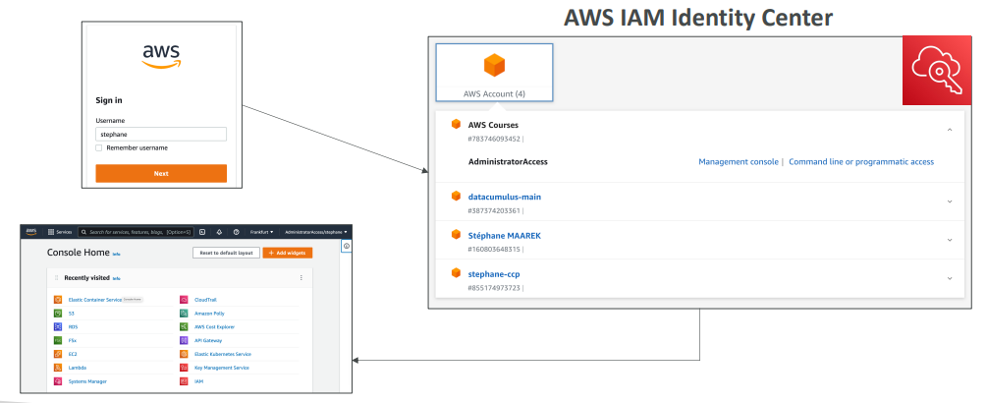

**AWS IAM Identity Center**

the browser interface is going to connect to the login page of your AWS IAM Identity Center. And then you must integrate it as I said, with different user stores. So, it could be an Active Directory, it could be on the cloud or On-premises. And this is where you would use Active Directory to manage your users and your groups. Or you can use the IAM Identity Center. This is the built-in identity store. And this is where, for example, you would define your users and your groups as you are used to in IAM. Then you integrate the Identity Center with SSO for your organization, or your Windows EC2 Instances, your Business Cloud Applications, or your custom SAML2.0 enabled applications.

When you log in, you don't have access to everything. You define something called permission sets in the Identity Center to define which users have access to what. So, how does everything relate to the IAM Identity Center for permissions, and users, and groups? Again, the cool thing is that you have one login for all of this, and that simplifies a lot your flow. Now, of course, when you log in, you don't have access to everything. You define something called permission sets in the Identity Center to define which users have access to what.

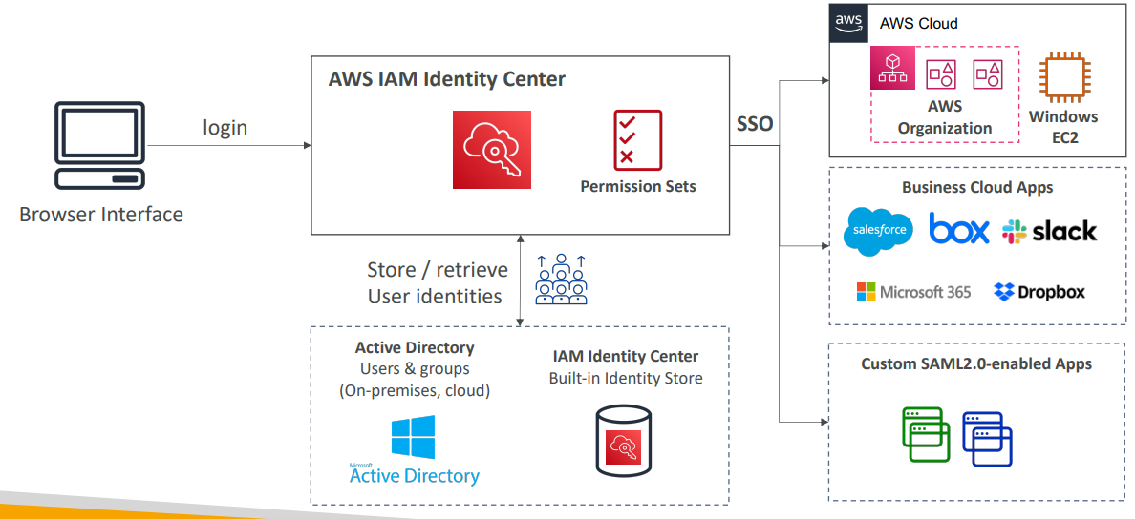

**IAM Identity Center**

So, we have an organization, and we set up IAM Identity Center in the management accounts. We have two OUs, a development, and a production OU each with our own accounts. Now, we have two developers in our company. We have Bob and Alice. So first of all, we're going to do just like we do in IAM, we're going to create a group of developers for Bob and Alice. Now, we want to make sure that Bob and Alice both have full access to the OU for development. So, we're going to create what's called permission sets and we're going to allow admin access on it. And then we must associate this permission set with a specific OU. So, we associate the purchase with the development OU and then we assign these permission sets to our group of developers, which will allow Bob and Alice to assume a role in any development accounts that gives them full access to that account. Similarly, we could create another permission set called ReadOnlyAccess for Production OU. So, we associate it, and again, we assign these permissions with a group of developers. So, this is how you relate users to groups, to permission sets, to assignments of specific accounts on IAM Identity Center.

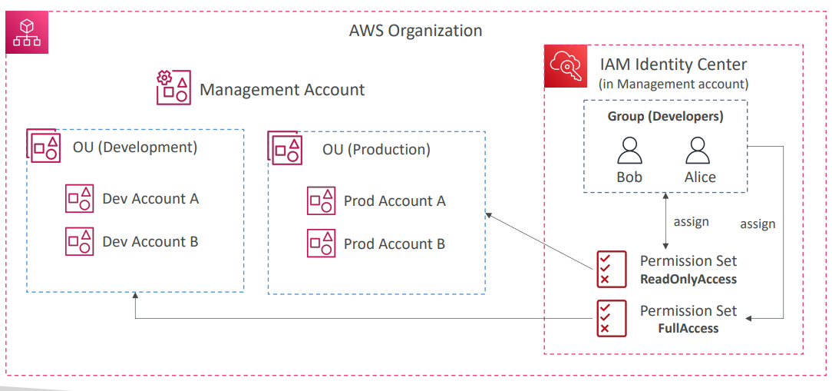

So, now let's talk about the fine-grained permissions and assignments. And the first one is multi-account permission. So of course, using the service, you can manage access across multiple accounts in your organization. And using permission sets, you define one or more IAM Policies that you assign to users and to groups to define what they can access in AWS. So, here is the IAM Identity Center, and it's integrated with your organization, and you define a permission set for database admins. So, it's a collection of IAM policies. And you say for example, that you have access to RDS and Aurora in your Dev account as well as RDS and Aurora in the Prod account. And this will automatically create a corresponding IAM role for your users. And therefore, when you have your database admins, it could be a group for example, and your users are in this group, you will assign it the permission sets of database admins. And whenever users log in through the IAM Identity Center and access the console of your Dev accounts or your Prod accounts, they automatically assume an IAM role in those specific accounts. They will give them the permissions they're supposed to get, which is pretty good. So, it works the same way. So, you have application assignments, and you can define which users or groups can access which applications. And it gives them the required URL, the certificates and metadata. So all of this is supported out of the box. And something that enables it is called Attribute-Based Access Control. So, the idea is that you're going to have fine-grained permissions based on the user's attributes stored in the IAM Identity Center Store. So, that means that you can have tags and so on. And using this, you can, for example, assign a user to a cost center, or give them a title. So, like junior, senior, or a locale, whatever. So, don't only have access to a specific region. And the use case of this is that you define the IAM permission sets once, and they leverage these attributes and you only modify the access to AWS of your users on your groups, but it's just changing these underlying attributes. So, this is a use case that is advanced but that is enabled by using the AWS IAM Identity Center.

**AWS IAM Identity Center**

Microsoft AD is, it is a software that is found on any Windows Server with AD Domain Services. And it's a database of objects, and the objects can be user accounts, computers, printers, file shares, security groups. So all your users manage within your entire Microsoft ecosystem on premise is going to be managed by Microsoft Active Directory.

|  |  |
| --- | --- |
| * Fine-grained Permissions and Assignments * Multi-Account Permissions   + Manage access across AWS accounts in your AWS Organization   + Permission Sets – a collection of one or more IAM Policies assigned to users and groups to define AWS access * Application Assignments   + SSO access to many SAML 2.0 business applications (Salesforce,Box, Microsoft 365, …)   + Provide required URLs, certificates, and metadata * Attribute-Based Access Control (ABAC)   + Fine-grained permissions based on users’ attributes stored in IAM Identity Center Identity Store   + Example: cost center, title, locale, …   + Use case: Define permissions once, then modify AWS access by changing the attributes |  |

We're create an account username is John, and the password is Password. And the idea is that all the other Windows machines we have within our network are going to be connected to the domain controller. So that's if we're using the John password on the first machine, it's going to look it up in the controller and say, yes, we have that login. And then, allow you to log in from that machine. So all these machines are going to be connected to your domain controller and that allows you to have the users accessible on any single machine. So that's the whole idea behind Active Directory in a very, very high level.

## Active Directory Services

**What is Microsoft Active Directory (AD)?**

|  |  |
| --- | --- |
| * Found on any Windows Server with AD Domain Services * Database of objects: User Accounts, Computers, Printers, File Shares, Security Groups * All your users manage within your entire Microsoft ecosystem on premise is going to be managed by Microsoft Active Directory. * Centralized security management, create accounts, assign permissions * Objects are organized in trees * A group of trees is a forest |  |

Let’s take an example, we have a domain controller and we're going to create an account on it. Let’s say we're creating an account with username is John, and the password is Password. And the idea is that all the other Windows machines we have within our network are going to be connected to the domain controller. So that's if we're using the John password on the first machine, it's going to look it up in the controller and say, yes, we have that login. And then, allow you to log in from that machine. So, all these machines are going to be connected to your domain controller and that allows you to have the users accessible on any single machine

**AWS Directory Services**

AWS Directory Services provides you with a way to create an Active Directory on AWS.

We have three flavors on it

|  |  |
| --- | --- |
| 1. AWS Managed Microsoft AD    * Create your own AD in AWS, manage users locally, supports MFA    * Establish “trust” connections with your on- premises AD    * What that means is that your AD can be trusted with the on-premises AD and on-premises AD trust AWS. If your users authenticated to the right and used an account that is not managed by AWS, it can go and look up the accounts into the on-premises Active Directory. And similarly, if an on-premises directory user goes and authentic to your on-premises AD using the AWS accounts, it can be trusted to go and look it up. So here our users are going to be shared between our on-premises Active Directory and AWS, |  |
| 1. AD Connector    * Directory Gateway (proxy) to redirect to on- premises AD, supports MFA    * Users are managed on the on-premises AD    * This is a direct gateway proxy to redirect to the on-premises AD and it supports MFA if you need multi-factor authentication, and the users are solely managed into the on-premises AD. Our AD Connector is just acting as a proxy. If the users try to authenticate with our AD Connector it's going to proxy the request back to our on-premises AD and look it up. |  |
| 1. Simple AD    * AD-compatible managed directory on AWS    * Cannot be joined with on-premises AD    * The idea is that if you don't have an on-premises AD and you need an Active Directory for your AWS Cloud, then you can have just a Simple AD as a standalone thing. |  |

The idea here is that using Active Directory you can create EC2 instances that are going to be running Windows. And these Windows instances can join the domain controllers for your network and share all the logins, and the credentials, and so on. So, this is why we want to have a directory in AWS to have a directory closer to your EC2 instances running Windows

The exam can ask some very, very high-level question, saying we want to proxy our users to on-premise and therefore you need AD Connector, or we want to manage our users on the cloud in AWS and have MFA and therefore you need AWS Managed AD, or we just want a Simple AD and we don't have any on-premise stuff. In this case, you want a Simple AD

**IAM Identity Center – Active Directory Setup**

* Connect to an AWS Managed Microsoft AD (Directory Service)
  + Integration is out of the box

if you connect to an Active Directory that is managed on your AWS using the directory service then the integration is out of the box. You just tell IAM Identity Center to integrate and connect to your AWS Managed Microsoft AD.

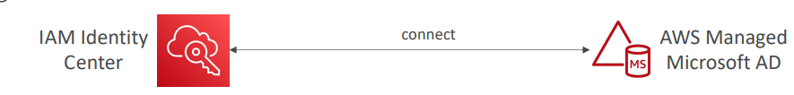

But what if you don't manage your Active Directory users on the cloud? What if you have a self-managed directory, for example, on premises? In that case, you have two ways of connecting to your self-managed directory

The first one is what we should call a two-way trust relationship using AWS Managed Microsoft AD. So, you would create a Managed Microsoft AD from the directory service, and then you would set up a two-way trust relationship between your Active Directory, for example on premises and your Managed AD. And then you would use the out of the box integration coming from the IAM Identity Center for single sign-up. The other option would be to use an AD Connector. So, an AD Connector here would have the role to of course integrate with IAM Identity Center. And then you would connect to it and then it would automatically proxy any kind of request into your self-managed directory. So, if you had to choose one or the other, it will depend on if you want to also be able to manage users from within the cloud on Active Directory in the cloud. And then the first solution may be better. But if you just wanted to proxy API calls then the second solution could be a fit, although with a bit more latency.

* Connect to a Self-Managed Directory
  + Create Two-way Trust Relationship using AWS Managed Microsoft AD
  + Create an AD Connector

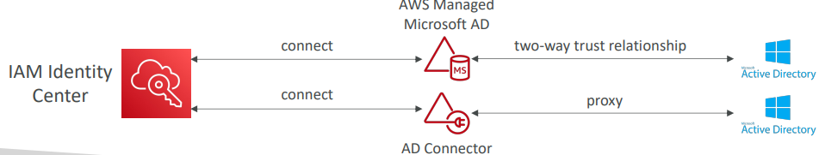

## AWS Control Tower

* Easy way to set up and govern a secure and compliant multi-account AWS environment based on best practices
* AWS Control Tower uses AWS Organizations services to create accounts
* Benefits:
  + Automate the setup of your environment in a few clicks
  + Automate ongoing policy management using guardrails
  + Detect policy violations and remediate them
  + Monitor compliance through an interactive dashboard

**AWS Control Tower – Guardrails**

So, say you set up multiple accounts on AWS, but you want to restrict all of them at once for certain kind of things, or you want to monitor the compliance for certain kind of things. So, using these guardrails, you're going to get ongoing governance for all your accounts within your Control Tower environments.

Provides ongoing governance for your Control Tower environment (AWS Accounts)

1. Preventive Guardrail – using SCPs (e.g., Restrict Regions across all your accounts)

For example, we could create a preventive guardrail to restrict regions across all your accounts to say, hey, you should only operate in the us-east-1 in the eu-west-2 regions. And so therefore behind the scenes, Control Tower is going to tell organizations to use SCPs.

1. Detective Guardrail – using AWS Config (e.g., identify untagged resources)

So, this time, we want to just detect non-compliance. And because I talk to you about compliance, of course, it's using the AWS Config service. For example, we want to identify untagged resources in our accounts. So, we have Control Tower and we set up a detective guardrail. And so it's going to use Config and Config is going to be deployed on all your member accounts and is going through the rules, monitor any untagged resources. In case anything is non-compliant, it's going to trigger an SNS topic. So we could be notified as an administrator or the SNS topic can also invoke a Lambda function. And the Lambda function can automatically remediate the action and add tags to your untagged resources.

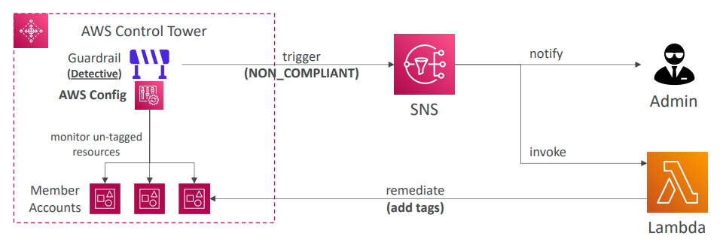

## Questions

**Top of Form**

**You have strong regulatory requirements to only allow fully internally audited AWS services in production. You still want to allow your teams to experiment in a development environment while services are being audited. How can you best set this up?**

* **Provide the Dev team with a completely independent AWS account**
* **Apply a global IAM policy on your Prod account**
* **Create an AWS Organization and create two Prod and Dev OUs, then Apply an SCP on the Prod OU**
* **Create an AWS Config Rule**

**Bottom of Form**

Ans C Correct

D

**You are managing the AWS account for your company, and you want to give one of the developers access to read files from an S3 bucket. You have updated the bucket policy to this, but he still can't access the files in the bucket. What is the problem?**

**{**

**"Version": "2012-10-17",**

**"Statement": [{**

**"Sid": "AllowsRead",**

**"Effect": "Allow",**

**"Principal": {**

**"AWS": "arn:aws:iam::123456789012:user/Dave"**

**},**

**"Action": "s3:GetObject",**

**"Resource": "arn:aws:s3:::static-files-bucket-xxx"**

**}]**

**}**

* **Everything is okay, he just needs to logout and login again**
* **The bucket does not contain any files yet**
* **You should change the resource to arn:aws:s3:::static-files-bucket-xxx/* , because this is an object-level permission**

Ans C Correct

**Top of Form**

**You have 5 AWS Accounts that you manage using AWS Organizations. You want to restrict access to certain AWS services in each account. How should you do that?**

* **Using IAM Roles**
* **Using AWS Organizations SCP**
* **Using AWS Config**

**Bottom of Form**

Ans B correct

**Top of Form**

**Which of the following IAM condition key you can use only to allow API calls to a specified AWS region?**

* **aws:RequiredRegion**
* **aws:SourceRegion**
* **aws:InitialRegion**
* **aws:RequestedRegion**

**Bottom of Form**

Ans D Correct

**Top of Form**

**When configuring permissions for EventBridge to configure a Lambda function as a target you should use ………………….. but when you want to configure a Kinesis Data Streams as a target you should use …………………..**

* **Identity-Based Policy, Resource-based Policy**
* **Resource-Based Policy, Identity-based Policy**
* **Identity-Based Policy, Identity-Based Policy**
* **Resource-based Policy, Resource-based Policy**

**Bottom of Form**

Ans B Correct

# AWS Security & Encryption

## Encryption

It’s of 3 types

1. **Encryption in flight** (TLS / SSL)
   * Data is encrypted before sending and decrypted after receiving
   * TLS certificates help with encryption (HTTPS)
   * Encryption in flight ensures no MITM (man in the middle attack) can happen

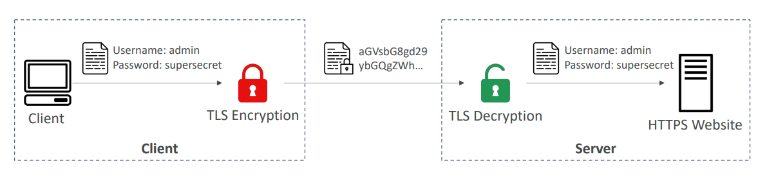

1. **Server-side encryption** at rest
   * Data is encrypted after being received by the server
   * Data is decrypted before being sent
   * It is stored in an encrypted form thanks to a key (usually a data key)
   * The encryption / decryption keys must be managed somewhere, and the server must have access to it

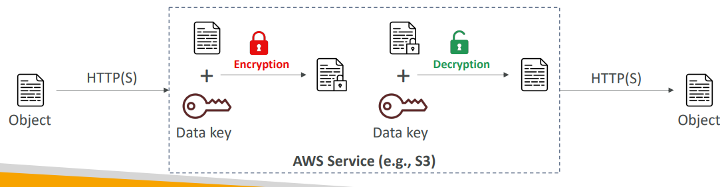

1. **Client-side encryption**
   * Data is encrypted by the client and never decrypted by the server
   * Data will be decrypted by a receiving client
   * The server should not be able to decrypt the data
   * Could leverage Envelope Encryption

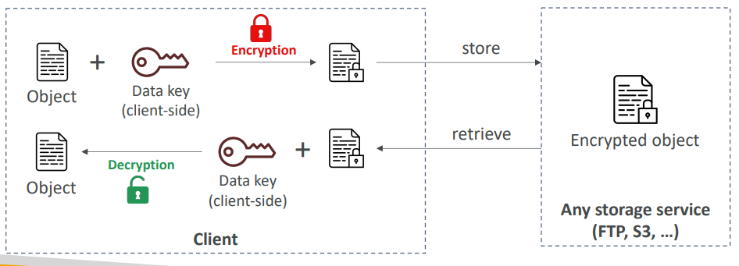

## AWS KMS

**Key Management Service**

* Anytime you hear “encryption” for an AWS service, it’s most likely KMS
* AWS manages encryption keys for us
* Fully integrated with IAM for authorization
* Easy way to control access to your data for encryption.
* Able to audit KMS Key usage using CloudTrail
* Seamlessly integrated into most AWS services (EBS, S3, RDS, SSM…)
* Never ever store your secrets in plaintext, especially in your code instead we can leverage KMS via
  + KMS Key Encryption also available through API calls (SDK, CLI)
  + Encrypted secrets can be stored in the code / environment variables

**KMS Key Types**

* KMS Keys is the new name of KMS Customer Master Key
* Symmetric (AES-256 keys)
  + Single encryption key that is used to Encrypt and Decrypt
  + AWS services that are integrated with KMS use Symmetric CMKs
  + You never get access to the KMS Key unencrypted (must call KMS API to use)
* Asymmetric (RSA & ECC key pairs)
  + Public (Encrypt) and Private Key (Decrypt) pair
  + Used for Encrypt/Decrypt, or Sign/Verify operations
  + The public key is downloadable, but you can’t access the Private Key unencrypted
  + Use case: encryption outside of AWS by users who can’t call the KMS API. In which case they will use the public key to encrypt the data. Send it over to you. And you within your account, you would use the private key of AWS to decrypt that data.

**Types of KMS Keys:**

* AWS Owned Keys (free): Used for SSE-S3, SSE-SQS, SSE-DDB (default key)
* AWS Managed Key: free (aws/service-name, example: aws/rds or aws/ebs) They're free and you can just use them as you please, but only from within the service that it's assigned to.
* Customer managed keys created in KMS: $1 / month. These keys can be imported at $1 / month

KMS also has a pricing of 3 cents per 10,000 API calls for each API call made to the KMS service.

**Automatic Key rotation:**

* AWS-managed KMS Key: automatic every 1 year
* Customer-managed KMS Key: (must be enabled) automatic & on-demand

Imported KMS Key: only manual rotation possible using alias

**Copying Snapshots across regions**

So KMS keys are scoped per region. That means that if you have an EBS volume encrypted with KMS key in a region, for example, eu-west-2, then if you want to copy that to a different region, we must do several steps. First, we must take a snapshot of this EBS volume. And if we take a snapshot from an encrypted snapshot, then this snapshot itself will also be encrypted with the same KMS key. Then to copy the snapshot to another region, we need to re-encrypt the snapshot using a different KMS key. And this is something AWS will do for you. But the same KMS key cannot live in two regions. So now we have an EBS snapshot, it's encrypted with KMS with a different key, and it lives in another region. Now, we restore the snapshot into its own EBS volume with KMS, and it's KMS key B into the region ap-southeast-2.

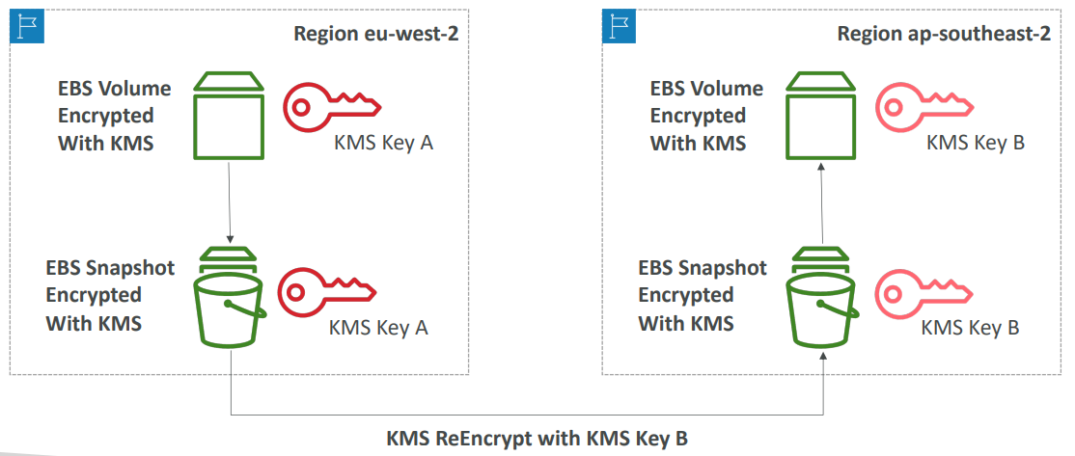

**KMS Key Policies**

* Control access to KMS keys, “similar” to S3 bucket policies
* If you don't have the KMS key policy on your KMS key, then no one can access it.

Types

* Default KMS Key Policy:
  + Created if you don’t provide a specific KMS Key Policy
  + Complete access to the key to the root user = entire AWS account
* Custom KMS Key Policy:
  + Define users, roles that can access the KMS key
  + Define who can administer the key
  + Useful for cross-account access of your KMS key

We use this if we want to copy encrypted snapshots across accounts.

|  |  |
| --- | --- |
| * Create a Snapshot, encrypted with your own KMS Key (Customer Managed Key) * Attach a KMS Key Policy to authorize cross-account access * Share the encrypted snapshot * (in target) Create a copy of the Snapshot, encrypt it with a CMK in your account * Create a volume from the snapshot * caller account shows which account can use it a * via service means which service can use it for e.g. ec2 here |  |

## KMS Multi -Region Keys

the key material is going to be replicated. The same key is going to be in other Regions. And the key ID is going to be the exact same. So as you can see the key ID slash mrk and then whatever is the same across all Regions.

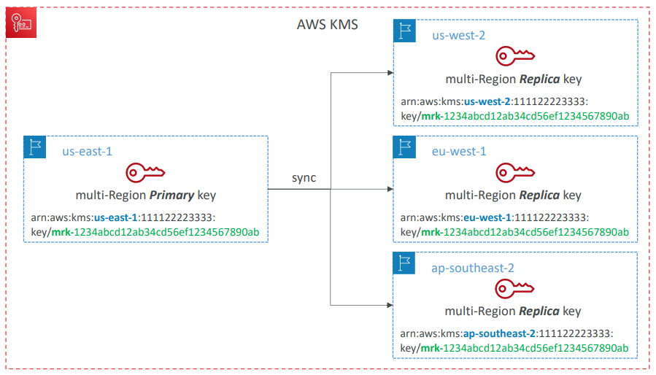

**KMS Multi-Region Keys**

* Identical KMS keys in different AWS Regions that can be used interchangeably. you can encrypt in one Region and then decrypt in another Region.
* Multi-Region keys have the same key ID, key material, automatic rotation…
* Encrypt in one Region and decrypt in other Regions
* No need to re-encrypt or making cross-Region API calls. and you don't need therefore to re-encrypt your data when moving from one Region to the next; or to make cross Region API calls.
* KMS Multi-Region are NOT global (Primary + Replicas)
* Each Multi-Region key is managed independently

Use cases: global client-side encryption, encryption on Global DynamoDB, Global Aurora. it's not recommended to use multi-Region key, except in very specific use cases because KMS likes to have the fact that a key is bounded to a single Region. And so, the use cases for using Multi-Region keys is if you want to have a global client-side encryption. So to be able to encrypt client-side in one Region and to decrypt client-side in another Region. or to do encryption on Global DynamoDB tables or on Global Aurora

**DynamoDB Global Tables and KMS MultiRegion Keys Client-Side encryption**

So the idea is that you want to encrypt not just the whole table because this is just at rest encryption. You want to encrypt actual attributes on your table. And so that they're only available to specific clients. Not even to database administrators. For this we're going to use the Amazon DynamoDB Encryption Clients. So let's take an example where we have us-east-1 and ap-southeast-2. So the KMS service is having a Multi-Region key which is replicated to another Region. The Region ap-southeast-2. And the client application wants to insert data into a DynamoDB table. So first is going to encrypt the attribute that it needs to be encrypted with the primary Multi-Region key. So the idea is that the DynamoDB table, most of the fields will not be encrypted client-side. Okay. But then one of them, for example the Social Security number is going to be encrypted. So this is great because well, your database administrators that have accessed your DynamoDB table, if they don't have access to the KMS key that we used to encrypt that one attribute, the Social Security number. Then they will not be able to access it. So it gives you a protection even against the database administrators. So if this DynamoDB table happens to be a Global Table then this data is going to be replicated to another Region. And so this is now in ap-southeast-2. And thankfully we've decided to encrypt our data, the attributes, with a Multi-Region key. And therefore, a client's application in the ap-southeast-2 Region can retrieve the row, see that one attribute is encrypted and then perform an API call to actually decrypt the attribute with the replica Multi-Region key. And this is why we are doing Multi-Region key this instance. Is it so that client applications in the ap-southeast-2 can do a local API call to KMS to decrypt that one attribute. So using this client-side encryption technique we can protect specific fields or attributes on our data and only guarantee decryption when our client has access to an API key. And thanks to Global Tables we can make sure the data and the encryption keys are also replicated together. So the same concept can be applied to Global Aurora.

|  |  |
| --- | --- |
| * We can encrypt specific attributes client-side in our DynamoDB table using the Amazon DynamoDB Encryption Client * Combined with Global Tables, the client-side encrypted data is replicated to other regions * If we use a multi-region key, replicated in the same region as the DynamoDB Global table, then clients in these regions can use lowlatency API calls to KMS in their region to decrypt the data client-side * Using client-side encryption we can protect specific fields and guarantee only decryption if the client has access to an API key |  |

**Global Aurora and KMS Multi-Region Keys Client-Side encryption**

So the same concept can be applied to Global Aurora. So I will go a bit faster. And this time we're going to use the AWS Encryption SDK. So we have two Regions and we have a Multi-Region key in KMS replicated across these two Regions. And so the client application wants to encrypt a column yet to get it is my SSN column. And this time we put the data into an Amazon Aurora database with a table. And so all the data is unencrypted on this one row, except that one column, which is the SSN, which is encrypted actually with the, mrk, the Multi-Region key. Now this is a Global Database. So that means that the tables are going to be replicated globally. And therefore the same data is going to happen to be in the ap-southeast-2. And because we have clients in the ap-southeast-2 they're going to get this encrypted data from your table. And because we are using a Multi-Region key they can do a local API call to KMS to decrypt this attribute. And therefore we have achieved lower latency. So we've seen that using client-side encryption, we can also protect this data even from database administrators. So if you have a database admin that accesses your Amazon Aurora database and wants to access that one column, the Social Security number. Unless they have access to the KMS key they will not be able to read this data which is very helpful.

|  |  |
| --- | --- |
| * We can encrypt specific attributes client-side in our Aurora table using the AWS Encryption SDK * Combined with Aurora Global Tables, the client-side encrypted data is replicated to other regions * If we use a multi-region key, replicated in the same region as the Global Aurora DB, then clients in these regions can use low-latency API calls to KMS in their region to decrypt the data client-side * Using client-side encryption we can protect specific fields and guarantee only decryption if the client has access to an API key, we can protect specific fields even from database admins |  |

## Encrypted S3 replication

**S3 Replication Encryption Considerations**

* If you enable S3 Replication from one bucket to another, then any unencrypted objects and objects encrypted with SSE-S3 will be replicated by default.
* Objects encrypted with SSE-C (customer provided key) can be replicated
* For objects encrypted with SSE-KMS, you need to enable the option. By default, they're not replicated but we need to enable the option to replicate these objects
  + We must specify which KMS Key to encrypt the objects within the target bucket
  + Then we adapt the KMS Key Policy for the target key
  + We create an IAM Role with kms:Decrypt for the source KMS Key and kms:Encrypt for the target KMS Key, to allow the S3 Replication service to first decrypt the data in the source bucket and then re-encrypt the data in the target bucket
  + When you do this it enables replication, and because there is a lot of encryption and decryption happening. You may get KMS throttling errors, in which case you need to ask for a service quota.
* You might get KMS throttling errors, in which case you can ask for a Service Quotas increase
* You can use multi-region AWS KMS Keys, but they are currently treated as independent keys by Amazon S3 (the object will still be decrypted and then encrypted)

## AMI Sharing

**AMI Sharing Process Encrypted via KMS**

|  |  |
| --- | --- |
| * AMI in Source Account is encrypted with KMS Key from Source Account.  How do you launch an EC2 instance in account B from the AMI in account A? * Must modify the image attribute to add a Launch Permission which corresponds to the specified target AWS account. This is how you share an AMI. You must modify the launch permissions and add the specified target to its account ID. This is done usually with a key policy * Must share the KMS Keys used to encrypted the snapshot the AMI references with the target account / IAM Role * The IAM Role/User in the target account must have the permissions to use both the KMS key and the AMI. You must have it on the KMS side, access to the Describekey API call, the ReEncrypted API call, CreateGrant and Decrypt API calls. * When launching an EC2 instance from the AMI, optionally the target account can specify a new KMS key in its own account to re-encrypt the volumes |  |

## SSM Parameter Store

We have an application and then we have the SSM parameter store. So we can store plain text configuration in this way. Then the IAM permissions of your applications are going to be checked. For example, your EC2 instance role or you can have encrypted configuration. In that case the SSM parameter store is going to encrypt it with KMS. And so the KMS service is going to be used for encryption and decryption. And of course, you need to make sure that your applications do have access to the underlying KMS key to perform that encryption and that decryption.

|  |  |
| --- | --- |
| * Secure storage for configuration and secrets * Optional Seamless Encryption using KMS * Serverless, scalable, durable, easy to use SDK * Supports version tracking of configurations / secrets * Security through IAM * Notifications with Amazon EventBridge * Integration with CloudFormation |  |

**SSM Parameter Store Hierarchy**

You can store parameters in the parameter store with a hierarchy.

* /my-department/
  + my-app/
    - dev/
      * db-url
      * db-password
    - prod/
      * db-url
      * db-password
  + other-app/
* /other-department/
* /aws/reference/secretsmanager/secret_ID_in_Secrets_Manager

You also have the opportunity to access Secrets of Secrets Manager through the Parameter Store by using this reference

* /aws/service/ami-amazon-linux-latest/amzn2-ami-hvm-x86_64-gp2 (public)

And there are something called Public Parameters that are issued by AWS that you can use. For example, if you want to find the latest AMI for the Amazon Index 2 in your specific region. This is something that's available within the Parameter Store as an API call.

|  |  |
| --- | --- |
| If you take an application, for example our Dev Lambda function is going to have an IAM roll that allows it to access the DB-URL and DB-password within the Dev of my app. And then if you have a Prod Lambda Function, thanks to again, a different IAM policy and maybe some environment variables, you can access the Prod DB-URL and Prod DB-password of another path. |  |

**Standard and advanced parameter tiers**

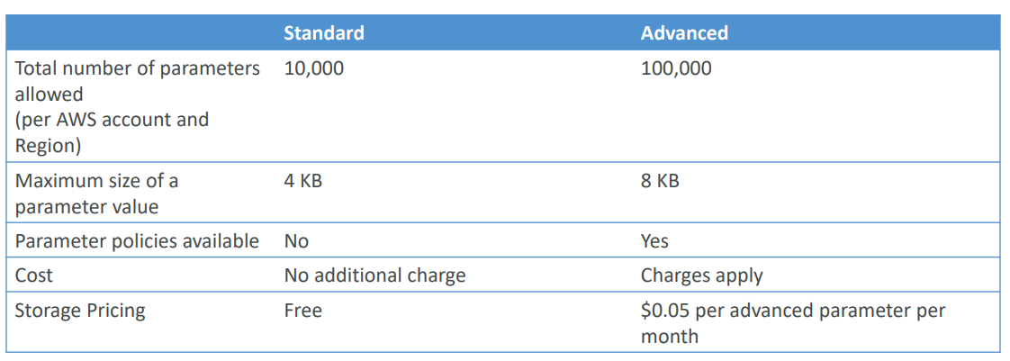

**Parameters Policies (for advanced parameters)**

* Allow you to assign a TTL to a parameter (expiration date) to force updating or deleting sensitive data such as passwords
* Can assign multiple policies at a time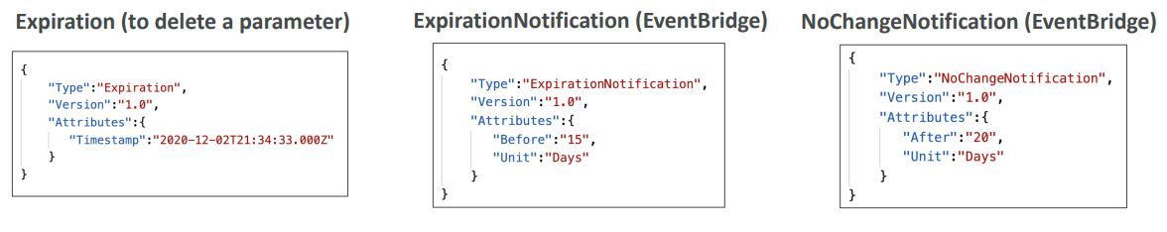

So this is an expiration policy to delete a parameter and you say, "Hey, on this time stamp you must delete these parameter." And then through the EventBridge integration, EventBridge is going to get notifications of it. So in this example, 15 days before the parameter expires we'll receive notification in EventBridge which gives us enough time to actually update it and make sure the parameter is not getting deleted because of the TTL. Or maybe sometimes you wanna make sure the parameters change once in a while. So you can have a no change notification in EventBridge so that if a parameter has not been updated for 20 days, then you will be notified as well.

## AWS Secrets Manager

* Newer service, meant for storing secrets
* Capability to force rotation of secrets every X days
* Automate generation of secrets on rotation (uses Lambda)
* Integration with Amazon RDS (MySQL, PostgreSQL, Aurora)
* Secrets are encrypted using KMS
* Mostly meant for RDS integration

**AWS Secrets Manager – Multi-Region Secrets**

* Replicate Secrets across multiple AWS Regions
* Secrets Manager keeps read replicas in sync with the primary Secret
* Ability to promote a read replica Secret to a standalone Secret
* Use cases: multi-region apps, disaster recovery strategies, multi-region DB…

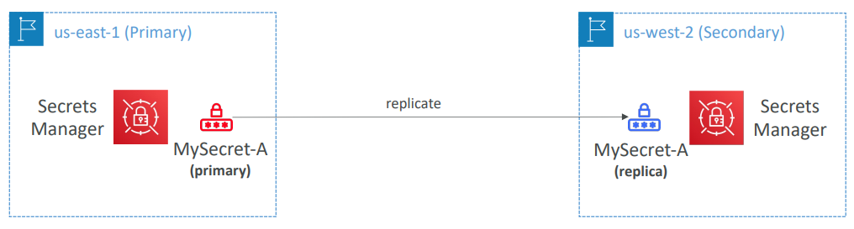

## AWS Certificate Manager (ACM)

|  |  |
| --- | --- |
| * Easily provision, manage, and deploy TLS Certificates * Provide in-flight encryption for websites (HTTPS) * Supports both public and private TLS certificates * Free of charge for public TLS certificates * Automatic TLS certificate renewal * Integrations with (load TLS certificates on)   + Elastic Load Balancers (CLB, ALB, NLB)   + CloudFront Distributions   + APIs on API Gateway * Cannot use ACM with EC2 (can’t be extracted) |  |

**ACM – Requesting Public Certificates**

* List domain names to be included in the certificate
  + Fully Qualified Domain Name (FQDN): corp.example.com
  + Wildcard Domain: *.example.com
* Select Validation Method: DNS Validation or Email validation
  + DNS Validation is preferred for automation purposes
  + Email validation will send emails to contact addresses in the WHOIS database
  + DNS Validation will leverage a CNAME record to DNS config (ex: Route 53)
* It will take a few hours to get verified
* The Public Certificate will be enrolled for automatic renewal • ACM automatically renews ACM-generated certificates 60 days before expiry

**ACM – Importing Public Certificates**

|  |  |
| --- | --- |
| • Option to generate the certificate outside of ACM and then import it  • No automatic renewal, must import a new certificate before expiry  • ACM sends daily expiration events starting 45 days prior to expiration  • The # of days can be configured  • Events are appearing in EventBridge  • AWS Config has a managed rule named acm-certificate-expiration-check to check for expiring certificates (configurable number of days) |  |

**ACM – Integration with ALB**

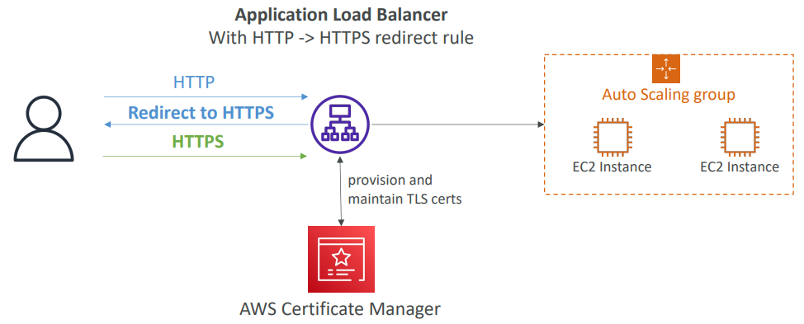

**API Gateway - Endpoint Types**

* Edge-Optimized (default): For global clients
  + Requests are routed through the CloudFront Edge locations (improves latency)
  + The API Gateway still lives in only one region
* Regional:
  + For clients within the same region
  + Could manually combine with CloudFront (more control over the caching strategies and the distribution)
* Private:
  + Can only be accessed from your VPC using an interface VPC endpoint (ENI)
  + Use a resource policy to define access

**ACM – Integration with API Gateway**

|  |  |
| --- | --- |
| * Create a Custom Domain Name in API Gateway * Edge-Optimized (default): For global clients   + Requests are routed through the CloudFront Edge locations (improves latency)   + The API Gateway still lives in only one region   + The TLS Certificate must be in the same region as CloudFront, in us-east-1   + Then setup CNAME or (better) A-Alias record in Route 53 * Regional:   + For clients within the same region   + The TLS Certificate must be imported on API Gateway, in the same region as the API Stage   + Then setup CNAME or (better) A-Alias record in Route 53 |  |

## WAF

**AWS WAF – Web Application Firewall**

* Protects your web applications from common web exploits (Layer 7)
* Layer 7 is HTTP (vs Layer 4 is TCP/UDP)
* Deploy on
* Application Load Balancer
* API Gateway
* CloudFront
* AppSync GraphQL API
* Cognito User Pool

**AWS WAF – Web Application Firewall**

* Define Web ACL (Web Access Control List) Rules:
* IP Set: up to 10,000 IP addresses – use multiple Rules for more IPs
* HTTP headers, HTTP body, or URI strings Protects from common attack – SQL injection and Cross-Site Scripting (XSS)
* Size constraints, geo-match (block countries)
* Rate-based rules (to count occurrences of events) – for DDoS protection
* Web ACL are Regional except for CloudFront
* A rule group is a reusable set of rules that you can add to a web ACL

**WAF – Fixed IP while using WAF with a Load Balancer**

* WAF does not support the Network Load Balancer (Layer 4)
* We can use Global Accelerator for fixed IP and WAF onthe ALB

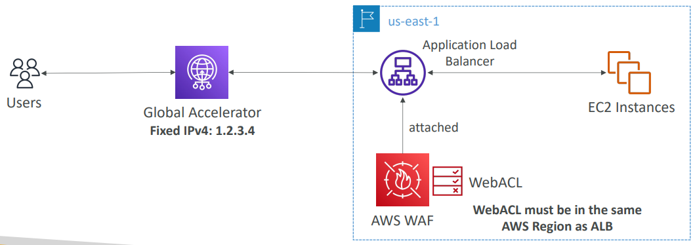

## AWS Sheild

**AWS Shield: protect from DDoS attack**

* DDoS: Distributed Denial of Service – many requests at the same time
* AWS Shield Standard:
  + Free service that is activated for every AWS customer
  + Provides protection from attacks such as SYN/UDP Floods, Reflection attacks and other layer 3/layer 4 attacks
* AWS Shield Advanced:
  + Optional DDoS mitigation service ($3,000 per month per organization)
  + Protect against more sophisticated attack on Amazon EC2, Elastic Load Balancing (ELB), Amazon CloudFront, AWS Global accelerator, and Route 53
  + 24/7 access to AWS DDoS response team (DRP)
  + Protect against higher fees during usage spikes due to DDoS
  + Shield Advanced automatic application layer DDoS mitigation automatically creates, evaluates and deploys AWS WAF rules to mitigate layer 7 attacks

## AWS Firewall Manager

* Manage rules in all accounts of an AWS Organization
* Security policy: common set of security rules
  + WAF rules (Application Load Balancer, API Gateways, CloudFront)
  + AWS Shield Advanced (ALB, CLB, NLB, Elastic IP, CloudFront)
  + Security Groups for EC2, Application Load BAlancer and ENI resources in VPC
  + AWS Network Firewall (VPC Level)
  + Amazon Route 53 Resolver DNS Firewall
  + Policies are created at the region level
* Rules are applied to new resources as they are created (good for compliance) across all and future accounts in your Organization

**WAF vs. Firewall Manager vs. Shield**

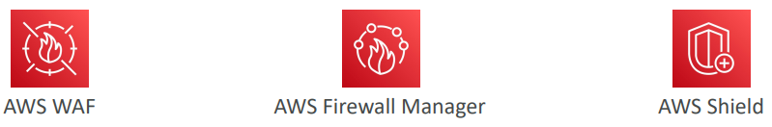

* WAF, Shield and Firewall Manager are used together for comprehensive protection
* Define your Web ACL rules in WAF
* For granular protection of your resources, WAF alone is the correct choice
* If you want to use AWS WAF across accounts, accelerate WAF configuration, automate the
* protection of new resources, use Firewall Manager with AWS WAF
* Shield Advanced adds additional features on top of AWS WAF, such as dedicated support from the Shield Response Team (SRT) and advanced reporting.
* If you’re prone to frequent DDoS attacks, consider purchasing Shield Advanced

## Best Practice

**AWS Best Practices for DDoS Resiliency Edge Location Mitigation (BP1, BP3)**

Let's assume that you have this kind of architecture. We have an auto scaling group with EC2 instances. It's fronted by a Elastic Load Balancer, and then your load balancer can be either exposed by a Global Accelerator as fixed IPs, or it could be fronted, by CloudFronts. CloudFronts can be linked to WAF, a web application firewall, and so on. You can have Route 53 for DNS routing. And finally, you could also have another architecture where you have CloudFront and the API gateway.

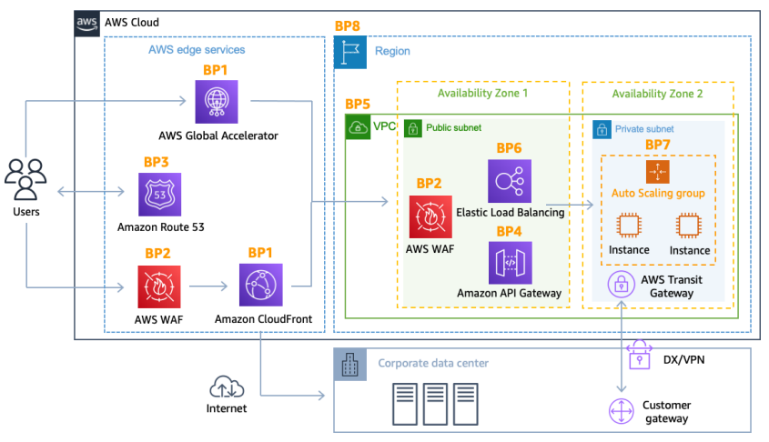

Let’s look at all the best practices denoted by BP in the diagram

* BP1 – CloudFront
  + Web Application delivery at the edge
  + Protect from DDoS Common Attacks (SYN floods, UDP reflection…) due to shield
* BP1 – Global Accelerator
  + Access your application from the edge
  + Integration with Shield for DDoS protection
  + Helpful if your backend is not compatible with CloudFront. I n this case, you would have Global Accelerator in front of it, and so that means that no matter what backend you have, either using CloudFront or the Global Accelerator, you will be fully distributed at the Edge of AWS and the Edge location will be DDoS protected
* BP3 – Route 53
  + Domain Name Resolution at the edge
  + DDoS Protection mechanism
* Infrastructure layer defense (BP1, BP3, BP6)
  + Protect Amazon EC2 against high traffic
  + That includes using Global Accelerator, Route 53, CloudFront, Elastic Load Balancing
* Amazon EC2 with Auto Scaling (BP7)
  + Helps scale in case of sudden traffic surges including a flash crowd or a DDoS attack
* Elastic Load Balancing (BP6)
  + Elastic Load Balancing scales with the traffic increases and will distribute the traffic to many EC2 instances
* Detect and filter malicious web requests (BP1, BP2)
  + CloudFront cache static content and serve it from edge locations, protecting your backend
  + AWS WAF is used on top of CloudFront and Application Load Balancer to filter and block requests based on request signatures for example, you can block specific IPs, specific request types and so on.
  + WAF rate-based rules can automatically block the IPs of bad actors
  + Use managed rules on WAF to block attacks based on IP reputation, or block anonymous Ips
  + CloudFront can block specific geographies
  + The idea is that CloudFront and WAF are managed services, and so they will take care of filtering some requests for you, so you can be protected against DDoS attack.
* Shield Advanced (BP1, BP2, BP6)
  + Shield Advanced automatic application layer DDoS mitigation automatically creates, evaluates and deploys AWS WAF rules to mitigate layer 7 attacks
* Obfuscating AWS resources (BP1, BP4, BP6)
  + The backend AWS resources are used to serve our application, are hidden. So, we have BP1, BP4, and BP6. If we use CloudFront, the API Gateway, or Elastic Load Balancing, we can hide our backend resources. The attacker will never know if it's a lambda function or EC2 instances or ECS tasks, and so on, because we have used other things in front of them.
* Security groups and Network ACLs (BP5)
  + Use security groups and NACLs to filter traffic based on specific IP at the subnet or ENI-level
  + Elastic IP are protected by AWS Shield Advanced
* Protecting API endpoints (BP4)
  + Hide EC2, Lambda, elsewhere
  + Edge-optimized mode, or CloudFront + regional mode (more control for DDoS)
  + WAF + API Gateway: then you can get filtering of any HTTP request. And if you set up the API gateway correctly, you can have burst limits, you can do headers filtering, and you can use and force API keys for your users, therefore protecting yourself from a DDoS attack.

## Amazon Guard Duty

* Intelligent Threat discovery to protect your AWS Account
* Uses Machine Learning algorithms, anomaly detection, 3rd party data
* One click to enable (30 days trial), no need to install software
* Input data includes:
  + CloudTrail Events Logs – unusual API calls, unauthorized deployments
    - CloudTrail Management Events – create VPC subnet, create trail, …
    - CloudTrail S3 Data Events – get object, list objects, delete object, …
  + VPC Flow Logs – unusual internal traffic, unusual IP address
  + DNS Logs – compromised EC2 instances sending encoded data within DNS queries
  + Optional Features – EKS Audit Logs, RDS & Aurora, EBS, Lambda, S3 Data Events…
* Can setup EventBridge rules to be notified in case of findings
* EventBridge rules can target AWS Lambda or SNS
* Can protect against CryptoCurrency attacks (has a dedicated “finding” for it)

**Amazon GuardDuty1**

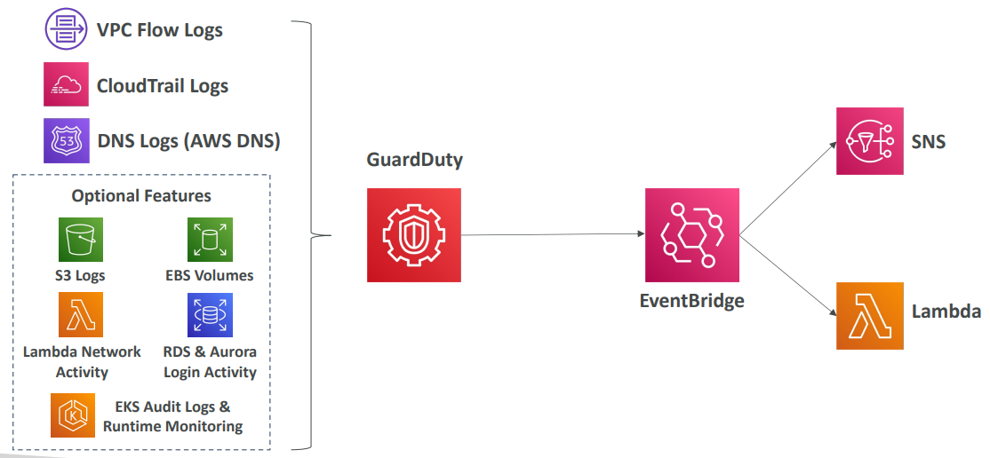

## Amazon Inspector

|  |  |
| --- | --- |
| * Automated Security Assessments * For EC2 instances   + Leveraging the AWS System Manager (SSM) agent   + Analyze against unintended network accessibility   + Analyze the running OS against known vulnerabilities * For Container Images push to Amazon ECR   + Assessment of Container Images as they are pushed * For Lambda Functions   + Identifies software vulnerabilities in function code and package dependencies   + Assessment of functions as they are deployed * Reporting & integration with AWS Security Hub * Send findings to Amazon Event Bridge |  |

**What does Amazon Inspector evaluate?**

* Remember: only for EC2 instances, Container Images & Lambda functions
* Continuous scanning of the infrastructure, only when needed
* Package vulnerabilities (EC2, ECR & Lambda) – database of CVE
* Network reachability (EC2)
* A risk score is associated with all vulnerabilities for prioritization

## AWS Macie

* Amazon Macie is a fully managed data security and data privacy service that uses machine learning and pattern matching to discover and protect your sensitive data in AWS.
* Macie helps identify and alert you to sensitive data, such as personally identifiable information (PII)

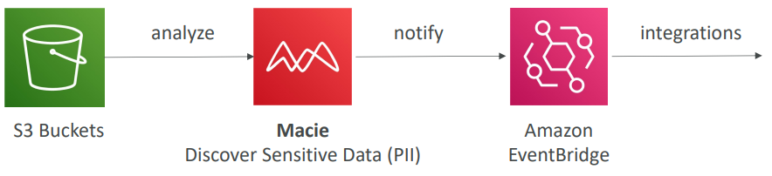

## Questions

**Top of Form**

**To enable In-flight Encryption (In-Transit Encryption), we need to have ........................**

* **an HTTP endpoint with an SSL certificate**
* **an HTTPS endpoint with an SSL certificate**
* **a TCP endpoint**

**Bottom of Form**

Ans B correct In-flight Encryption = HTTPS, and HTTPS can not be enabled without an SSL certificate.

**Top of Form**

**Server-Side Encryption means that the data is sent encrypted to the server.**

* **True**
* **False**

**Bottom of Form**

Ans B Correct Server-Side Encryption means the server will encrypt the data for us. We don't need to encrypt it beforehand.

**Top of Form**

**In Server-Side Encryption, where do the encryption and decryption happen?**

* **Both Encryption and Decryption happen on the server**
* **Both Encryption and Decryption happen on the client**
* **Encryption happens on the server and Decryption happens on the client**
* **Encryption happens on the client and Decryption happens on the server**

**Bottom of Form**

Ans A correct In Server-Side Encryption, we can't do encryption/decryption ourselves as we don't have access to the corresponding encryption key.

**Top of Form**

**In Client-Side Encryption, the server must know our encryption scheme before we can upload the data.**

* **False**
* **True**

**Bottom of Form**

Ans A correct With Client-Side Encryption, the server doesn't need to know any information about the encryption scheme being used, as the server will not perform any encryption or decryption operations.

**Top of Form**

**You need to create KMS Keys in AWS KMS before you are able to use the encryption features for EBS, S3, RDS ...**

* **True**
* **False**

**Bottom of Form**

Ans A You could also create your own keys for AWS to do the encryption, but it's not mandatory.

B Correct You can use the AWS Managed Service keys in KMS, therefore we don't need to create our own KMS keys.

**Top of Form**

**AWS KMS supports both symmetric and asymmetric KMS keys.**

* **True**
* **False**

**Bottom of Form**

Ans A correct KMS keys can be symmetric or asymmetric. A symmetric KMS key represents a 256-bit key used for encryption and decryption. An asymmetric KMS key represents an RSA key pair used for encryption and decryption or signing and verification, but not both. Or it represents an elliptic curve (ECC) key pair used for signing and verification.

**Top of Form**

**When you enable Automatic Rotation on your KMS Key, the backing key is rotated every .................**

* **90 days**
* **1 year**
* **2 years**
* **3 years**

**Bottom of Form**

Ans B

**Top of Form**

**You have an AMI that has an encrypted EBS snapshot using KMS CMK. You want to share this AMI with another AWS account. You have shared the AMI with the desired AWS account, but the other AWS account still can't use it. How would you solve this problem?**

* **The other AWS account needs to logout and login again to refresh its credentials**
* **You need to share the KMS CMK used to encrypt the AMI with the other AWS account**
* **You can't share an AMI that has an encrypted EBS snapshot**

**Bottom of Form**

Ans B Correct

**Top of Form**

**You have created a Customer-managed CMK in KMS that you use to encrypt both S3 buckets and EBS snapshots. Your company policy mandates that your encryption keys be rotated every 6 months. What should you do?**

* **Re-configure your KMS CMK and enable Automatic Key Rotation, and configure the Retention Period with 180 days**
* **Use AWS Managed Keys as they are automatically rotated by AWS every 3 months**
* **Rotate the KMS CMK manually. Create a new KMS CMK and use Key Aliases to reference the new KMS CMK. Keep the old KMS CMK so you can decrypt the old data**

**Bottom of Form**

Ans A

C It is better to use Automatic Key Rotation and configure Retention Period

**Top of Form**

**What should you use to control access to your KMS CMKs?**

* **KMS Key Policies**
* **KMS IAM Policy**
* **AWS GuardDuty**
* **KMS Access Control List (KMS ACL)**

**Bottom of Form**

Ans A correct

**Top of Form**

**You have a Lambda function used to process some data in the database. You would like to give your Lambda function access to the database password. Which of the following options is the most secure?**

* **Embed it in the code**
* **Have it as a plaintext environment variable**
* **Have it as an encrypted environment variable and decrypt it at runtime**

**Bottom of Form**

Ans C This is the most secure solution amongst these options.

**Top of Form**

**You have a secret value that you use for encryption purposes, and you want to store and track the values of this secret over time. Which AWS service should you use?**

* **AWS KMS Versioning feature**
* **SSM Parameter Store**
* **Amazon S3**

**Bottom of Form**

Ans A AWS KMS can rotate stored KMS keys, but it can not help audit the values of an encrypted value over time.

B Correct SSM Parameters Store can be used to store secrets and has built-in version tracking capability. Each time you edit the value of a parameter, SSM Parameter Store creates a new version of the parameter and retains the previous versions. You can view the details, including the values, of all versions in a parameter's history.

C Amazon S3 has both versioning and encryption features, but it is not the best fit for storing secrets.

**Top of Form**

**Your user-facing website is a high-risk target for DDoS attacks and you would like to get 24/7 support in case they happen and AWS bill reimbursement for the incurred costs during the attack. What AWS service should you use?**

* **AWS WAF**
* **AWS Shield Advanced**
* **AWS Shield**
* **AWS DDoS OpsTeam**

**Bottom of Form**

Ans B Correct

**Top of Form**

**You would like to externally maintain the configuration values of your main database, to be picked up at runtime by your application. What's the best place to store them to maintain control and version history?**

* **Amazon DynamoDB**
* **Amazon S3**
* **Amazon EBS**
* **SSM Parameter Store**

**Bottom of Form**

Ans D

**Top of Form**

**AWS GuardDuty scans the following data sources, EXCEPT ................**

* **CloudTrail Logs**
* **VPC Flow Logs**
* **DNS Logs**
* **CloudWatch Logs**

**Bottom of Form**

Ans D

**Top of Form**

**You have a website hosted on a fleet of EC2 instances fronted by an Application Load Balancer. What should you use to protect your website from common web application attacks (e.g., SQL Injection)?**

* **AWS Shield**
* **AWS WAF**
* **AWS Security Hub**
* **AWS GuardDuty**

**Bottom of Form**

Ans B Correct

**Top of Form**

**You would like to analyze OS vulnerabilities from within EC2 instances. You need these analyses to occur weekly and provide you with concrete recommendations in case vulnerabilities are found. Which AWS service should you use?**

* **AWS Shield**
* **Amazon GuardDuty**
* **Amazon Inspector**
* **AWS Config**

**Bottom of Form**

Ans C correct

**Top of Form**

**What is the most suitable AWS service for storing RDS DB passwords which also provides you automatic rotation?**

* **AWS Secrets Manager**
* **AWS KMS**
* **AWS SSM Parameter Store**

**Bottom of Form**

Ans A

**Top of Form**

**Which AWS service allows you to centrally manage EC2 Security Groups and AWS Shield Advanced across all AWS accounts in your AWS Organization?**

* **AWS Shield**
* **AWS GuardDuty**
* **AWS Config**
* **AWS Firewall Manager**

**Bottom of Form**

Ans D AWS Firewall Manager is a security management service that allows you to centrally configure and manage firewall rules across your accounts and applications in AWS Organizations. It is integrated with AWS Organizations so you can enable AWS WAF rules, AWS Shield Advanced protection, security groups, AWS Network Firewall rules, and Amazon Route 53 Resolver DNS Firewall rules.

**Top of Form**

**Which AWS service helps you protect your sensitive data stored in S3 buckets?**

* **Amazon GuardDuty**
* **Amazon Shield**
* **Amazon Macie**
* **AWS KMS**

**Bottom of Form**

Ans C Amazon Macie is a fully managed data security service that uses Machine Learning to discover and protect your sensitive data stored in S3 buckets. It automatically provides an inventory of S3 buckets including a list of unencrypted buckets, publicly accessible buckets, and buckets shared with other AWS accounts. It allows you to identify and alert you to sensitive data, such as Personally Identifiable Information (PII).

**Top of Form**

**An online-payment company is using AWS to host its infrastructure. The frontend is created using VueJS and is hosted on an S3 bucket and the backend is developed using PHP and is hosted on EC2 instances in an Auto Scaling Group. As their customers are worldwide, they use both CloudFront and Aurora Global database to implement multi-region deployments to provide the lowest latency and provide availability, and resiliency. A new feature required which gives customers the ability to store data encrypted on the database and this data must not be disclosed even by the company admins. The data should be encrypted on the client side and stored in an encrypted format. What do you recommend to implement this?**

* **Using Aurora Client-side Encryption and KMS Multi-region Keys**
* **Using Lambda Client-side Encryption and KMS Multi-region Keys**
* **Using Aurora Client-side Encryption and CloudHSM**
* **Using Lambda Client-side Encryption and CloudHSM**

**Bottom of Form**

Ans A correct

**Top of Form**

**You have an S3 bucket that is encrypted with SSE-KMS. You have been tasked to replicate the objects to a target bucket in the same AWS region but with a different KMS Key. You have configured the S3 replication, the target bucket, and the target KMS key and it is still not working. What is missing to make the S3 replication work?**

* **This is not a supported feature**
* **You have to raise a support ticket for AWS to start this replication process for you**
* **You have to configure permissions for both Source KMS Key kms:Decrypt and Target KMS Key kms:Encrypt to be used by the S3 Replication Service**
* **The source KMS Key and the target KMS key must be the same**

**Bottom of Form**

Ans C correct

**Top of Form**

**You have generated a public certificate using LetsEncrypt and uploaded it to the ACM so you can use and attach to an Application Load Balancer that forwards traffic to EC2 instances. As this certificate is generated outside of AWS, it does not support the automatic renewal feature. How would you be notified 30 days before this certificate expires so you can manually generate a new one?**

* **Configure ACM to send notifications by linking it to 3rd party certificate provider LetsEncrypt**
* **Configure EventBridge for Daily Expiration Events from ACM to invoke SNS notifications to your email**
* **Configure EventBridge for Monthly Expiration Events from ACM to invoke SNS notifications to your email**
* **Configure CloudWatch Alarms for Daily Expiration Events from ACM to invoke SNS notifications to your email**

**Bottom of Form**

Ans B Correct

**Top of Form**

**You have created the main Edge-Optimized API Gateway in us-west-2 AWS region. This main Edge-Optimized API Gateway forwards traffic to the second level API Gateway in ap-southeast-1. You want to secure the main API Gateway by attaching an ACM certificate to it. Which AWS region are you going to create the ACM certificate in?**

* **us-east-1**
* **us-west-2**
* **ap-southeast-1**
* **Both us-east-1 and us-west-2 worksBottom of Form**

Ans A Correct As the Edge-Optimized API Gateway is using a custom AWS managed CloudFront distribution behind the scene to route requests across the globe through CloudFront Edge locations, the ACM certificate must be created in us-east-1.

**Top of Form**

**You are managing an AWS Organization with multiple AWS accounts. Each account has a separate application with different resources. You want an easy way to manage Security Groups and WAF Rules across those accounts as there was a security incident the last week and you want to tighten up your resources. Which AWS service can help you to do so?**

* **AWS Guard Duty**
* **Amazon Shield**
* **Amazon Inspector**
* **AWS Firewall Manager**

**Bottom of Form**

Ans D correct

# Amazon VPC

VPC Components Diagram a sample

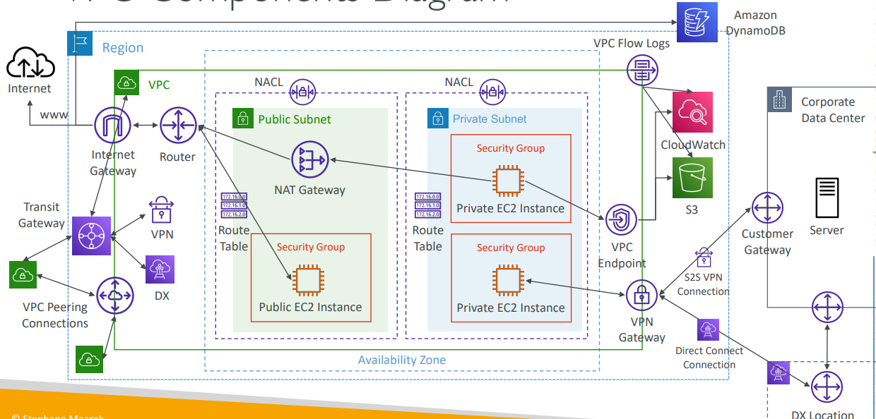

## CIDR, Private vs Public IP

**Understanding CIDR – IPv4**

Okay, so now let's talk about CIDR or CIDRs or Classless Inter-Domain Routing, which I will call CIDR for the rest of this course. So, it's a method for allocating IP addresses and we've seen them before in this course, because when we look at security group rules for example and networking in AWS, we saw something like this. So, these are my security group rules and if we look at the source column, here we remember we had an IP address / and then a number and this was our first touch with CIDRs. So, CIDRs help define IP ranges that we've seen some very, very simple one. So, when we have an IP address /32, this actually represents only one IP. And when we saw 0.0.0.0/0 then this is represented all IPs, but there are a lot of different possibilities. For example, if we define 192.168.0.0/26 then this represents a range of 64 IP addresses as you see in this slide. So, how does CIDR work? Well, CIDR has two components. There's the base IP and this is an IP that is contained in the range. Usually it is the beginning of the range, but it could be that it's contained in the range. And then, so this is example, so 10.0.0.0 or 192.168.0.0. And then the other thing is the subnet mask and the subnet mask will define how many bits can change in the IP. So, we have the /0, /24 all the way to /32 and this can take two different forms. So, if we have /8 this is equivalent to subnet mask of 255.0.0.0 and /16 is 255.255.0.0 and so on, okay. But the most common form we see in this course and in AWS is the / form, okay? So, for the rest of this course we'll be using /8, /16 and so on. Now, let's have a detailed look at subnet masks. So, this is how we can define which values can change from the base IP. So, if we have an IP address /32, this allows for one IP, 2 to the power of 0 and this is the IP that we have on the left hand side. Now, if we have an IP /31, then we allow for two different IPs. And so we'll allow for 192.168.0.0 and then .0.1. If we have the same IP /30, now this goes exponentially as you can see, we allow for 4 IPs. So, we'll have a bigger range from .0 to .3, then /29 allows for 8 IPs so .0 to .7. /28 allow for 16 IPs, so .0 to .15, then we can look at the table, okay. So, it goes from 4, 8, 16, 32, 64, 128, 256 IPs to change. So, the /24 is 256 IPs, which is 2 to the power of 8 and this is from .0 to .255. Then if we go one step deeper, so we go to /16, so I skipped some in the middle. Then we allow for 2 to the power of 16 IP to change, so 65,536. So, as we can see the last two parts of the IPs have changed and then /0 allows for all IPs, so from the very beginning to the very end. So, how do we know? As a quick memo we know an IP is made of 4 Octets, so the first part, the second part, the third part and the fourth part. And /32 means no octets can change, /24 means the last octet can change, /16 means the last 2 octets can change and take different values. /8 is the last three octets can change and /0 is all octets can change. So, hopefully they started making a little bit more sense into how CIDRs work. So, now here comes a little exercise, feel free to pause the video if you need to answer. So, what is 192.168.0.0/24? So, /24 so that means the last octet can change and so therefore we have 256 IPs, because the last number it can go from the number 0 to the number 255 included. Now, what is 192.168.0.0/16? Well, this is /16, so the last two octets can change, so we have a 65,536 IPs. And what is 134.56.78.123/32? Well, /32 so it's only one IP, so just one IP. And then 0.0.0.0/0 we know this one, it is all IPv4 space, okay? When in doubt, there is this little website that I can show you that is very, very handy. So, on this website we have two options, we can have a CIDR to an IP range or an IP range to a CIDR, so let's try both. So, if you have 10.0.0.0/ let's say a 16, we calculate it as you can see we see the first IP and the last IP in here. How many IPs are including to the range and so on? Okay. If we do /17, which is a little bit less obvious. In this one, we have 32,000 or so IPs. We can have a look at the first bit so this is the first IP and this is the last IP, so it's quite handy and again you can play. And reversely if you wanted to for example, take an IP range, so this IP range and figure out what CIDR this corresponds to, then click on calculate and this will give us a result of 10.0.0.0/17. So it's quite handy, if you start doing some networking to use a website like this to help you out. So, why are we talking about all these things? Well, because we want to discuss public versus private IP in the IPv4 space. So, there is the Internet Assigned Numbers Authority the IANA that established certain blocks of IPv4 addresses that will be used only for private LAN networks, so local network or public internet addresses. So, the private IPs can only allow for certain values. So we have this range for 10.0.0.0/8 which represents, you know a huge amount of IPs. So, this is a private IP range you can use and this is your least something you use in big networks, because it allows for lot of different values. Then we have the 172.16.0.0/12, which is another sets of private IP addresses. And when you create an account it will provide you with a default VPC and it turns out the default VPC will be included in that networking space. And then finally, another one you may have seen before is 192.168.0.0/16, which represents your home network. So, this is very common when you have an internet router to have your own devices, have an IP that starts with 192, okay? So, all the other IP addresses out there in the world are going to be on the internet and they're going to be public IP addresses. So, that's it for these basics of IPv4s and CIDRs,

* Classless Inter-Domain Routing – a method for allocating IP addresses
* Used in Security Groups rules and AWS networking in general

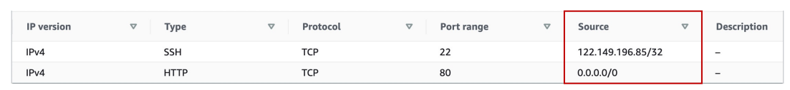

* They help to define an IP address range:
  + We’ve seen WW.XX.YY.ZZ/32 => one IP
  + We’ve seen 0.0.0.0/0 => all IPs
  + But we can define:192.168.0.0/26 =>192.168.0.0 – 192.168.0.63 (64 IP addresses)
    - 26 = 32-26 =6
    - So 2 ^6 = 64

**Understanding CIDR – IPv4**

A CIDR consists of two components

* Base IP
  + Represents an IP contained in the range (XX.XX.XX.XX)
  + Example: 10.0.0.0, 192.168.0.0, …
* Subnet Mask
  + Defines how many bits can change in the IP
  + Example: /0, /24, /32
  + Can take two forms:
    - /8 <-> 255.0.0.0
    - /16 <-> 255.255.0.0
    - /24 <-> 255.255.255.0
    - /32 <-> 255.255.255.255

**Understanding CIDR – Subnet Mask**

The Subnet Mask basically allows part of the underlying IP to get additional next values from the base IP

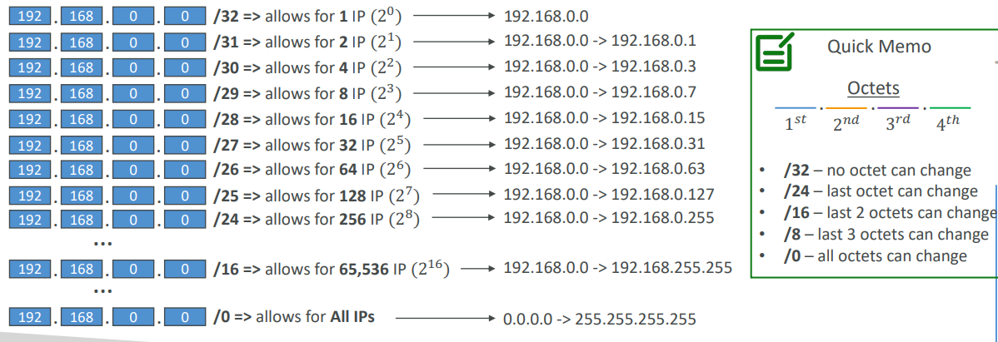

**Understanding CIDR – Little Exercise**

* 192.168.0.0/24 = … ?
  + 192.168.0.0 – 192.168.0.255 (256 IPs)
* 192.168.0.0/16 = … ?
  + 192.168.0.0 – 192.168.255.255 (65,536 IPs)
* 134.56.78.123/32 = … ?
  + Just 134.56.78.123
* 0.0.0.0/0
  + All IPs!
* When in doubt, use this website <https://www.ipaddressguide.com/cidr>

**Public vs. Private IP (IPv4)**

* The Internet Assigned Numbers Authority (IANA) established certain blocks of IPv4 addresses for the use of private (LAN) and public (Internet) addresses
* Private IP can only allow certain values:
  + 10.0.0.0 – 10.255.255.255 (10.0.0.0/8) ç in big networks
  + 172.16.0.0 – 172.31.255.255 (172.16.0.0/12) ç AWS default VPC in that range
  + 192.168.0.0 – 192.168.255.255 (192.168.0.0/16) ç e.g., home networks
* All the rest of the IP addresses on the Internet are Public

## VPC

**Default VPC Walkthrough**

* All new AWS accounts have a default VPC
* New EC2 instances are launched into the default VPC if no subnet is specified
* Default VPC has Internet connectivity and all EC2 instances inside it have public IPv4 addresses
* We also get a public and a private IPv4 DNS names

So, now let's do a quick walkthrough of the VPC that is created with your account called the default VPC. So, now all new AWS accounts will have a default VPC, and this is so that you can start, you know, using it this right away. So, new EC2 instances that are launched into the default VPC if you don't specify any subnets. And obviously when you start in your accounts, you only have one VPC anyway. So, the default VPC will by default have internet connectivity, so this is why our instance are being able to access the internet and each EC2 instance within it will get a public IPv4 address and this is why we've been able to connect to our EC2 instances right away when we created them. We will also get a public and a private IPv4 DNS name for our EC2 instances. So, let's go in to the console to have a look at this default VPC. So, I'm in the console and we're going to have a look at the VPC service. So, the reason why we have a default VPC is that if we didn't have one, it will be very, very complicated for newcomers in the cloud to start using AWS, okay? But it is best practice if you know a bit it was a networking that you create your own VPCs in your production accounts instead of using the default VPC. So, this is the dashboard and on the left hand side, there is your VPCs. Now, as we can see one VPC is created, there is no name, but it's called the default VPC, because it's created by default, okay? And as you can see there's an IPv4 CIDR block here that is defined. And what I can do is go to my website and then calculate this range. And as we can see, we can see where the first IP of my range is. Where is the last IP sets a /16 that means that the last two octets of my IP can change. So, the last two can change so all the way to .255.255 and we have 65,536 IPs possible in that range. Okay, very handy. And if we have a look at CIDRs, so again, only one IP for CIDR has been created and associated with that VPC. No IPv6 CIDRs, flow logs are not enabled and there are no tags, okay? So, this is pretty good. Now, if you look at all the options, we have a look at main route table, main network ACLs and so on, so we'll have a look in the course into what these are at one at the time, okay. But let's just explore the menu for now. So, we have three subnets already and these subnets are linked to the VPC that is the default VPC. Now, each of these subnets by default has its own IPv4 CIDR, okay. And so if you have a look at on the right hand side the availability zones as we can see each subnet is in a different AZ. And the reason is well, by default we got three subnets across three AZ to have a highly available architecture if we needed to. So, these subnets turns out have these IPv4 CIDRs. So, let's have a look at one of these for example, this one and then I will calculate this new CIDR. And so here's the first IP and here is the last IP. And the total number of hosts is 4,096, but it turns out that if you go back into the subnets console, the number of available IPv4 addresses is 4,091. So, we'll have a look at why this is the case and obviously it would be a lesser number if you are already using this subnets, okay? So, we'll try to understand why this is the case, but there are five IPs are missing and we'll learn about it in this course. So, looking all the way to the right, each subnet has a route table and a network ACL. And as you can see there is a default subnet and we have the setting auto-assign public IPv4 enable that means that any EC2 instance created into these default subnets will have a public IPv4, okay? So, let's have a look at now the settings, so the flow logs are not enabled for the subnets. The route table is available, so there is this route table that exists and we'll have a look at it in the second. And then there is network ACL and this is again, we'll see in details where this is in this section, okay. But it turns out that's all traffic on all protocols from everywhere is allowed for inbound and for outbound. So, that means that anything launched into these subnets, okay. Will be having network connectivity, which is good. Now, for CIDR reservations, there are none of them sharing, so this subnet is not shared and there are no tags. So, let's have a look at the route table. So, the route table is helping your traffic being routed through your VPC. So, this is called a default route table, a main route table and it turns out that there are two rules, will have a look at what this means later on. But this one right here, this one is pointing to all traffic, okay. Outside of this CIDR, all traffic goes to this internet gateway. So, if we click on this internet gateway and go here, so it's on the left hand side. This internet gateway is attached to my VPC and whether it does that it gives internet access to my EC2 instances within my VPC. So again, this is why are our EC2 instances did gets internet access. Now, we'll have a look at it again in the later stage in details. And if you look at the subnet association, this route table is not explicitly associated with any subnets, but it is implicitly associated, because these subnets do not have a route table assigned to it. So, the main route table is by default going to be assigned to them implicitly, okay? And then we're good to go. So, we've seen VPCs subnets, route tables, internet gateway at a very high level, but hopefully it gives you a little bit on understanding as to why we were able to launch EC2 instances, why they were getting specific kind of IPs and so on. Now in this section, we're gonna spend a lot of time having a look at all these options and recreate our own VPC. So, we'll understand exactly what VPC, subnet, route table, internet gateway and everything else here actually are made of.

**VPC in AWS – IPv4**

* VPC = Virtual Private Cloud
* You can have multiple VPCs in an AWS region (max. 5 per region – soft limit)
* Max. CIDR per VPC is 5, for each CIDR:
  + Min. size is /28 (16 IP addresses)
  + Max. size is /16 (65536 IP addresses)
* Because VPC is private, only the Private IPv4 ranges are allowed:
  + 10.0.0.0 – 10.255.255.255 (10.0.0.0/8)
  + 172.16.0.0 – 172.31.255.255 (172.16.0.0/12)
  + 192.168.0.0 – 192.168.255.255 (192.168.0.0/16)
* Your VPC CIDR should NOT overlap with your other networks (e.g., corporate)

**VPC hand On**

Now we could launch the VPC Wizard, but that would defeat the point of learning. So what we'll have to do is create everything one-by-one. So let's go into VPC. I have one VPC available, but I'm going to create a new VPC. And the name tag is going to be DemoVPC. Here we need to choose an iPv4 CIDR block. So I will choose 10.0.0.0/16, which is allowed. So, if we look at the CIDR here and calculate it, that means that my First IP is this one, and my Last IP is this one. We have 65,000, or so, IPs in this range. So, if I did /15, this would not work because this would be a too big of a network, okay? /16 is the limit for your CIDR site. So for now we are not going to assign any iPv6 CIDR block. We'll see this later on in the section. In terms of tenancy, we have Default or Dedicated. And this is to define how EC2 instances launch within this VPC. We'll have either dedicated hardware or shared hardware. Now, dedicated hardware is very expensive. So we are going to have shared hardware by default. So tenancy is Default. So Tags is named DemoVPC. This is good. Now we'll create this VPC. And my VPC is created. So if we look at this VPC, as we can see we have one iPv4 CIDR, zero iPv6 CIDR, okay? We have already a main route table and a main network ACL associated with it. So some stuff was created behind the scenes, when we created the VPC. And something we should notice is that we are able to add other iPv4 CIDRs. So in the creates dialogue, we could only specify one, But if I do Action and then Edit CIDRs, and then here, I could add a new IPv4 CIDR. So I could have 10.0.0, sorry, .1.0/, excuse me, 10.1.0.0/16, which is the next CIDR after this one. And then click on Save. So we could have two different CIDRs in here. And you could also add different IPv6 CIDRs. Now to keep it very simple, I'm not going to have two IPv4 CIDRs. I'm just going to have one. But I'm going to show you that you can have up to five IPv4 CIDRs within your VPC, which is quite handy. Okay, so we have this DemoVPC being created. This is our first step to our demo.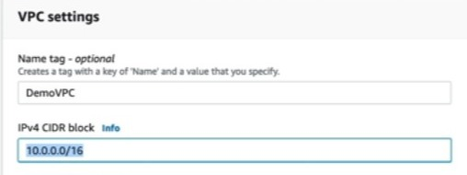

## Subnets

**Adding Subnets**

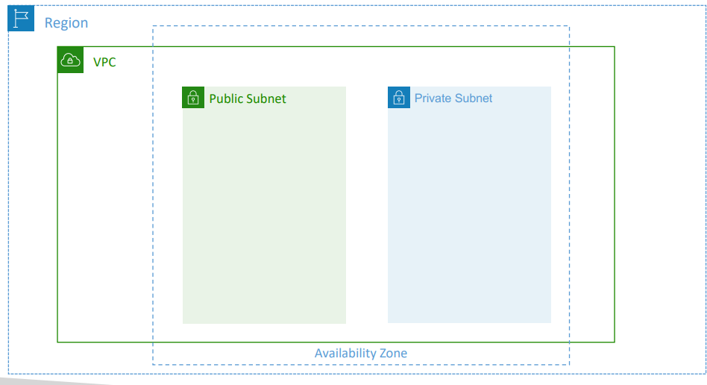

**VPC – Subnet (IPv4)**

* AWS reserves 5 IP addresses (first 4 & last 1) in each subnet
* These 5 IP addresses are not available for use and can’t be assigned to an EC2 instance
* Example: if CIDR block 10.0.0.0/24, then reserved IP addresses are:
  + 10.0.0.0 – Network Address
  + 10.0.0.1 – reserved by AWS for the VPC router
  + 10.0.0.2 – reserved by AWS for mapping to Amazon-provided DNS
  + 10.0.0.3 – reserved by AWS for future use
  + 10.0.0.255 – Network Broadcast Address. AWS does not support broadcast in a VPC, therefore the address is reserved
* Exam Tip, if you need 29 IP addresses for EC2 instances:
  + You can’t choose a subnet of size /27 (32 IP addresses, 32 – 5 = 27 < 29)
  + You need to choose a subnet of size /26 (64 IP addresses, 64 – 5 = 59 > 29)

**Subnets Hands ON**

So let's go ahead and create our subnets. So on the left hand side, I will go to Subnets, and as we can see, there are three subnets and they belong to the previous VPC. So what I can do is I can filter my views by a specific VPC. So I need to refresh this page first, so it will click on Select a VPC, and I will choose the DemoVPC just to filter all my views by VPC and not have any noise in my UI. Okay, so now, as you can see, we have zero subnets associated with that specific VPC. So we'll create a subnet, and then we just select a VPC, so this DemoVPC subnet. And then, we need to specify the subnet settings. So, the subnet name. The first one is going to be PublicSubnetA, and this is because we put a subnet in AZ A. So, we'll specify a specific AZ, so eu-central-1a, so AZ number A. And then, we need to select an IPv4 CIDR block. So to get started, let's go with 10.0.0.0/24. This is because, in a public subnet, you wanna choose not too many IP addresses. Usually, this is reserved for your load balancers or your front-facing infrastructure. So, a smaller subnet size is good. And again, if you wanna check what this is, this is 256 addresses. And because we have a slash 24, only the last octet can change. And so therefore, it goes from .0 all the way to .255. Okay, so we have this name tag, PublicSubnetA. And here, we can actually add a second subnet, okay? So it could be PublicSubnetB, and this one is going to be an AZ eu-central-1b. And, so we need to choose an IPv4 CIDR block. Now, the last IP address that we had in here was .0.255, so what I would choose is 10.0.1.0/24, okay? And this is the next range after the one we've defined right here, okay? So again, you can check out what this range means in this website. And as you can see, the first IP is 10.0.0.1.0, and the second is 10.0.1.255. Perfect, so we have defined two public subnets and now we're going to have some private subnets. So PrivateSubnetA, and we need to choose an IPv4 CIDR block. Now, let's choose something like 10.0.16.0/20, and this is a bigger subnet size, okay? And if you have a look at the range about what this is, so we have 4,096 IP addresses in it. So, it starts at 10.0.16.0, and then it ends at 10.0.31.255. Okay, so this is good. And now, let's add one last subnet, so PrivateSubnetB, and the AZ is going to be an eu-central-1b. No, I didn't set up the AZ here, so let's make sure we do. Okay, perfect. And, the IPv4 CIDR block is going to be the next logical one, so .32.0/20. Okay, so we have four subnets being created. I will create them four. And because there's no overlapping IP addresses, as we can see, the creation was successful. So now, if we have a look on the right hand side, we can see that there are different amount of IP addresses available. So, this one is 251, and this one is 4,091. So again, there are five IP addresses, remember, that were reserved by your subnets. And this is something that you remember. So what you're going to get is the size of the CIDR minus five, so this explains these numbers right here. Also, we did define these segments across two AZ, so eu-central-1a and 1b, and the reason we do so is you get high availability if we were to put resources in it. But we haven't done anything yet to define what makes subnets public, or what makes a subnet private. Right now, they all look the same, so we'll see how to do this in the future lectures. For now, we're good to go in this setup.

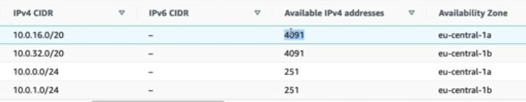

## Internet Gateway (IGW)

* Allows resources (e.g., EC2 instances) in a VPC connect to the Internet
* It scales horizontally and is highly available and redundant
* Must be created separately from a VPC
* One VPC can only be attached to one IGW and vice versa
* Internet Gateways on their own do not allow Internet access…
* Route tables must also be edited!

So currently we have a VPC. We have two subnets in one EC, so I didn't represent the other two subnets to make this diagram as simple as possible. We're going to create an Internet Gateway in this VPC, and this enough will not give internet access to our subnets. What we need to do is to also edit the Route Tables. So we'll create a Public EC2 Instance in our Public Subnet and then we will have to edit a Route Table so that the EC2 Instance can connect to the Router, then connect to the Internet Gateway, and then from the Internet Gateway connect to the internet.

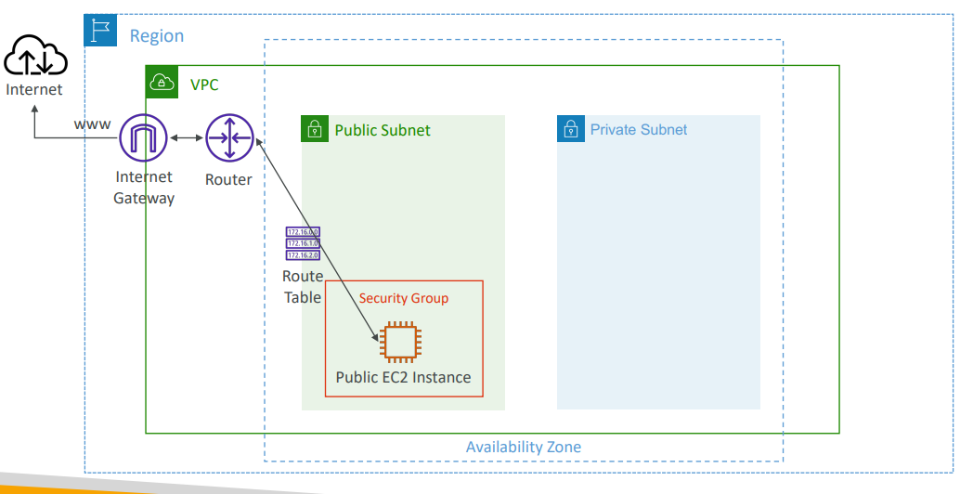

**IG Hands ON**

So first let's be certain that our EC2 instances in these subnets do not have access to the internet. So to do so, let's go into the EC2 console and we're going to be launching an instance into these subnets. To do so, I'm clicking on launch instances. And in here I scroll down Amazon Linux 2. T2.micro, this is good. I will not select the key pair. And for network settings, I will edit them. In here, I will choose the VPC address created named DemoVPC. And from there, I'm able to choose whatever subnet I want. For example, I can use public subnet A. We have 251 IP addresses in there so I can launch my instances here. And as you can see, the setting auto assigned public IP is currently disabled. This is because we need to, if we wanted to get a public IPv4 address to enable this, of course. But why is it disabled by default? Whereas when I go and select a subnet from before, it is actually enabled by default, if you try it. So the idea is that if you go into your subnet settings, you're going to see that and let's go in here, the public subnet A right here. If I do action and then edit subnet settings. In here I'm able to enable the auto-assigned public IPv4 address which is something we do want for our public subnets. So I have to enable it for the public subnet A, and then also I need to enable it for the public subnet B. So action and then edit subnet settings and then save. And so what's going to happen is that if I now refresh this page entirely to create a new instance again, but this time I go into the network settings and say, edit. I will go to DemoVPC. I will choose public subnet A. And as you can see now, by default, the auto-assigned public IP setting is set to enable. So we modified the default in our subnets and it got reflected into the EC2 instance launch console. This is good. So we get to create a new security group and we add the SSH rule on port 22, because we will SSH into our EC2 instance. The rest looks good so let's go ahead and launch this instance, and we're good to go. And now my instance is running. As we can see it has been assigned a public IPv4 address. So it turns out that it has a public IPv4 address but does not have internet connectivity. How do we make sure? Well, for example, let's try to connect to this instance using EC2 Instance Connect and then click on connect. So remember we did open the SSH rule on our instance yet there was a problem connecting to our instance. It turns out that's maybe the instance network settings are not correctly configured. So this is where the internet gateway comes in. So let's go ahead and add an internet gateway. So this is my VPC. And as you can see, there's no matching internet gateway. By the way, if I remove the filter, we can see there's already internet gateway attached to my default VPC. So let's create an internet gateway and I'll call this one DemoIGW, so internet gateway's IGW and click on create internet gateway. So very, very simple. It's been created and it's in detached states. So what we need to do is to attach it to a VPC and obviously the VPC we're going to attach it to is our DemoVPC. So now my internet gateway is attached into a VPC which provides internet access into our VPC. So if we try again, the EC2 Instance Connect, is this going to work? So let's try to connect again. And as we can see, yet again, there is a problem connecting to your instance. So what is happening? Well, even though we have an internet gateway, we need to give it a route. And so we need to edit the route table. So if we have a look at this route table right here, this is a default route table. And the default route table is going to be associated with subnets that don't have an explicit route-table association. So currently this default route table, main route table, is associated with four subnets, but I don't like it. I think there's much better to have explicit subnet associations. So what I'm going to do and I'm going to create two route tables. So I'll call it PublicRouteTable and then we'll assign it to this VPC. This is going to be assigned to my public subnets. And then I'm going to create a second route table called the PrivateRouteTable. And again, assigned to my DemoVPC. And the reason we do so is that I want to assign my subnets to the right route table. So the public route table should have subnet associations. We're going to edit then. And we're going to add all the public subnets into my public route table. So I click on save. And then my PrivateRouteTable, again, I will edit the subnet associations and I will assign them the private subnets, A and B. So let's save these associations. Okay, we're good. So as we can see my public and my private route tables both have two subnets associated with them. And it turns out that my main route table, this one, does not have any subnet association because all subnets have been assigned. So this is better. We've solved some problem. Now let's go into our public route table. Remember our EC2 instance was launched into this public subnet. So it's associated with the public route table. And so what we want to do is to edit the routes in our public route table. So if you have a look at the route right now in our route table, it turns out that we have a traffic rule for 10.0.0.0/16 to go to local. That means that any IP within our VPC, so this is the VPC CIDR, already corresponds to the VPC. So it should be routed from within the VPC hence the target is local. But we can edit the routes and saying, hey, I want to have a second route and I'll take the first one. So any IP, so this represents any IP. So any IP that does not match this rule, the target should be going to, and as you can see there are a lot of different options but for now it's an internet gateway and we'll choose the internet gateway we just created. So we're saying, hey, if this is a local IP in our CIDR, just please make sure you route locally. But if this is anything else, including obviously public IPs, then target is going to be the internet gateway. So send traffic to the internet gateway. We'll save these changes. And now that we've done that, we should have given access to the internet to our EC2 instance. So let's retry. So I'm going to take my EC2 instance, click on EC2 Instance Connect and then connect. And as we can see, now I am in my EC2 instance and it is connected to the internet. For example, I can do ping google.com. And as you can see, we get some data back from Google. So we are connected to the internet. Everything is working great. And currently what we've been doing is giving internet access into our public subnets with the public route table. We don't know yet how to give internet access into the private EC2 instances, and we'll see how to do this in the next lectures.

## Bastion Hosts

the idea is that our users want to access an EC2 instance that is in a private subnet, but we as users, we are on our computer on the public internet. So obviously because our EC2 instance is in a private subnet we don't have direct internet access to it. So the trick, or one trick at least, is to use a bastion host. The bastion host is an EC2 instance, that's named bastion host, okay? And that EC2 instance is special because it is in a public subnet. It has its own security group called the bastion host security group, then we also have a security group, of course, for our EC2 instance in the private subnet. Now, the idea is that the EC2 instance in the public subnet, our bastion host, does have access to the EC2 instance in our private subnet, well, because everything is in our VPC. So now to access our EC2 instance in the private subnet, what we do is that we first connect through SSH to the bastion host and then connect from the bastion host, again with SSH, to the EC2 instance in the private subnet. And it could be one but it could be as well, many EC2 instances. So to summarize a bastion host is a way for us to SSH into our private EC2 instances. And we must put the bastion host in the public subnet. So in terms of security group rules, this is something that can come up with the exam, we need to understand what we can define. So for a bastion host perspective, the security group must allow access from the internet, okay? But instead of allowing everywhere from the internet access, because that could be a security risk, we can only restrict, for example, access from the public CIDR of your corporation or your internet access and so on. So that we have to restrict the EC2 security group of the bastion host as much as possible to guarantee that only a few select IPs can access it, because if somehow a random attacker has access to our EC2 instance as the bastion host, it could be a security risk for our infrastructure. Now, in terms of the security group of the EC2 instances in the private subnets, well, they must allow the SSH access, so on the port 22 again, from this time the private IP of the bastion host or the security group of the bastion host, this is equivalent. And this is because the traffic these EC2 instances are seeing are originating from this bastion host.

|  |  |
| --- | --- |
| * We can use a Bastion Host to SSH into our private EC2 instances * The bastion is in the public subnet which is then connected to all other private subnets * Bastion Host security group must allow inbound from the internet on port 22 from restricted CIDR, for example the public CIDR of your corporation * Security Group of the EC2 Instances must allow the Security Group of the Bastion Host, or the private IP of the Bastion host |  |

**Bastion Host Hans ON**

So it turns out that this EC2 instance we've created in our public subnet could have a name and the name could be Bashian host. This is because we are able to SSH into this fashion host and from it, we'll be able to connect to an EC two instance in a private subnet. So to do so well, let's go ahead and create an EC two instance in a private subnet, but first, if you don't have a key pair, yet sometimes I reuse accounts or create new ones or transfusions. So I don't necessarily have key pairs. You can just enter a key pair. So I'll have a, a demo key pair right here, and then in the PM format. And then I will create my key pair. So I will save this file and this is going to be very handy for us to SSH into the EC two instance in my private subnet. So let's have a look at how we can do it. So now let's go into EC two instances And I'm going to launch an EC two instance. I will scroll down Amazon Linux 2, two micro. We will use the key pair named demo key pair we just created. And then for network settings, we will make sure to launch this into our demo VPC. And so far as subnet association. So we want to be into a private subnet, for example the private subnet a, and we're going to create a security group. I'm going to name it private SG because it is a private security group and we are going to allow SSH but actually not from anywhere from custom and this time it will choose a security group we have created from before, which is called a launch wizard one, which is not a great name. I'm going to rename it very, very soon but what it means that we allow SSH from the Bashian host. And this is how through a hub, through the Basian host, we're going to be able to SSH into this private instance. Okay, so this looks good. Now let's go ahead and actually launch that instance, and we are good to go. So here we have our private instance and because it is in a private sublet, as you know, we cannot use the EC two instance connect into it because that will not work. Okay. We will need to edit the root tables at the internet gateway, but that would make the subnet public. So what we have to do is to SSH through the Bashian host. Okay. So let's go ahead and see how we can do it. So we're going to connect into our Bashian host. So I will click on connect and then EC two instance connect. So effectively what we're doing is that we're doing SSH into our Bashian host. So you could use either EC two instance connect, or you know, your SSH command line through your terminal. And from this fashion host we wanna connect into our private instance. Now our private instance as we can see has a private IP four address. So this is what we need to do. So we need to do SSH easy two user at, and then the private IP, and then we need to specify a key pair. Okay. So yes, and this is not going to work because we haven't specified a key pair. So we need to actually create that key pair and then have it on my EC two instance. So what I'm doing is I'm going to have a VI or nano and then I'll call it demo key pair.pm and then I will have to paste the content of the key pair I just downloaded. So I open my file that PM with a text editor and then I paste exactly what I have in here, and I wanna make sure this is going to be good. So I think it's missing a new line right here. Okay. This looks good, actually. Let's see. And then exit and then save. Okay. So let's clear the screen. Let's just make sure that this has been properly saved. So this hopefully looks good. Let's see. I'm not too...I'm not a bit confused by the formatting, but let's see. And we need to make sure we change the permission. So I will change the permissions on this demo key profile. Okay. And now let's do this SSH command and minus I demo key pair.pm, and there's a pass rise and this is definitely an issue with the formatting of my files. So what I'm going to do is that I'm going to remove demo key pair. Yes. Please remove it. And I will use another text editor to see if that works. So VI demo, key pair that PM. And I'm gonna keep this on video because this is a super important to see what can go wrong. And in case you have these issues, then at least, you know so this looks a lot better. And then I will save this file. Okay. So now if we run the SSH command again, okay. This is unprotected so that we are needing to running the shma command. So here we go. And then with such again, and here we go. This has worked. So now we are SSH'd into my Amazon index two AMI in my private subnet. So this is really good. We went from the Bashian host into the private instance and this works, and this is quite cool. But now if we try to ping Google account as you can see, well, this doesn't work. The private EC two instance does not have internet access outgoing. And so we're going to see how to resolve this in the next lecture.

## NAT Instances

**NAT Instance (outdated, but still at the exam)**

* NAT = Network Address Translation
* Allows EC2 instances in private subnets to connect to the Internet
* Must be launched in a public subnet
* Must disable EC2 setting: Source /destination Check
* Must have Elastic IP attached to it
* Route Tables must be configured to route traffic from private subnets to the NAT Instance

|  |  |
| --- | --- |
| So we have a server, and it's a public server with a public IP, 50.60.4.10, and we want to access it from our private subnets, okay. So how do we establish connectivity from the private subnets to the server? Well, to do so, we're going to launch a NAT instance with its own security group in a public subnet, then what we're going to do is attach an Elastic IP to this NAT instance, and then we're going to edit the route tables from the private subnet to the public subnet to be allowed to send traffic from the EC2 instances between the two subnets to the NAT instance. So then the IP at the instance wants to access the server, the public server, but it has to go through the NAT instance. So the request is seeing that the source IP is 10.0.0.20, which is true, which is a private IP, and the destination is 50.60.4.10 which the NAT instance is smart enough to say, hey, I know you're trying to send traffic to something else, so let me send the traffic over to that server. But that server has something different. So the destination is still this IP, but now the source IP is 12.34.56.78, which is corresponding to the public IP of the NAT instance. So as you can see, this network packet gets rewritten by the NAT instance, this is what NATs do, they rewrite network packets, and the source IP has changed. The server now says, hey, I know how to reply to you because the source is me and the destination is the public IP of your NAT instance, and then the NAT instance will reply back the traffic to the EC2 instance, it's smart enough to know which one to go to, and say, hey, the source is the public server and the destination is your private IP. And this is why, because there's some IPs are being rewritten, this is why the source and destination check must be disabled on the EC2 instance for your NAT instance. So this is how NAT instances work at a high level. |  |

So again, we're going to create a NAT instance within a public subnet, and next I attach an Elastic IP to it, and then we're going to have a route table which allows the private instances to talk to the NAT instance all the way to the internet gateway and so on

**NAT Instance**

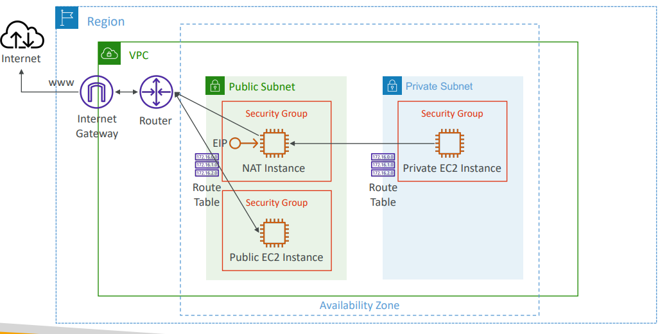

**NAT Instance – Comments**

* Pre-configured Amazon Linux AMI is available
  + Reached the end of standard support on December 31, 2020
* Not highly available / resilient setup out of the box
  + You need to create an ASG in multi-AZ + resilient user-data script
* Internet traffic bandwidth depends on EC2 instance type
* You must manage Security Groups & rules:
  + Inbound:
    - Allow HTTP / HTTPS traffic coming from Private Subnets
    - Allow SSH from your home network (access is provided through Internet Gateway)
  + Outbound:
    - Allow HTTP / HTTPS traffic to the Internet

**Hands On**

So let's go and create a NAT instance to give internet access to our private subnets. So I click on Launch instance and I'm going to type NAT instance, and now we need to find the Amazon image that is for NAT instance. So to do so I'm going to browse more AMI's right here and then I need to enter a search term such as NAT, N-A-T, and then press enter. And as we can see there are 40 some results in the community AMI. So I click on community AMI and now I can see that we have some NAT instances from AWS. So you can find one of these as long as it says, X 86 64. And you can look at the published date to try to find a newer kind of instance. So I can find this one published date of 2022, as long as it says Amazon AMI VPC NAT 2018, something like this then you're good to go. Of Architecture X 86 64. Okay, so let's choose this one. Looks recent enough. But you know, whatever you choose really is good enough NAT instances are somewhat deprecated. We'll see by what's next. So don't worry too much about this, but here we go. I'm using my community AMI from AWS to deploy a NAT instance. I use a T2 micro. For Key pair I will just use a demo key pair. And then for network settings, we're going to add, edit this and we're going to create a new security group. So rules wise, we're going to create a few things. So SSH from anywhere, yes. Then we have to add more rules. So HTTP, and then the source is a CIDR and the CIDR block is the same as our VPC. So 10 0 0 0 slash 16. And then we're going to do the same, but for HTTPS so to allow HTTPS traffic out as well from the same CIDR block. And then the last thing to do is to, of course edit the VPC setting to be in my demo VPC. And we deploy this NAT instance in the public subnet for example, public subnet A. So we have to redo this. So NAT instance, SG is the name of the security group. And actually my roles are kept. So make sure to name it, NAT instance SG. Okay, so we are good to go. Now let's go ahead and launch that instance. And we're done. And what we want to do is to have the private instance send internet traffic out through the NAT instance. Okay, so now that my NAT instance is created what I need to do is to edit a networking setting called the source destination check. So I need to stop this, okay. And this is because if this is NAT instance you must stop the source destination checking because the NAT instance must be able to receive and send traffic when the source or destination is not itself. So this is very important. We click on save and somehow it was somewhat knew that we're gonna use this for NAT instances. So this is really good. And next, what we have to do is to send some traffic to the NAT instance. So first let's verify right now. So I'm going to re SSH into my private instance so to do so I have to go through the Bastion Host. So I will use EC 2 instance connect. Great. I'm connected into Bastion Host and then I will use the SSH command. So EC2 user @, and then I need to have the private IP of my private instance in here. So I will copy this and I will paste it minus I demo keypair.PEM. Okay, so I am in my private instance. And again, remember if we did PING Google.com we're not getting any reply. So this doesn't have internet access. Now let's give internet access to the private subnets. And to do so in my private route table, on the routes we need to edit the route. So let's edit them. And currently we have this one for local rules but we're going to have one that says, if you want to talk out to the internet, then please go through your instance. And the instance has to be the NAT instance, save. And what we've done effectively is saying, 'Hey for any EC 2 instance within this subnets because it's associated with this route table if you send traffic to the internet so anywhere then go through my EC 2 instance which is exactly what a NAT instance is for.' So now if we try again to PING Google.com, this is not working. And I know why because we need to also enable one specific port on the NAT instance. So let's go to security and the security group rules and we need to enable a specific port for PING. So let's edit the inbound rule and I will add a rule for PING. So it's ICMP. So all ICMP, IPV4, from this subnets from the CIDR that we have right here. Okay, and then click on save. Now, if we try again, the PING command. So let's clear the screen and PING again. Now we are getting some result back. So this is working and if we wanted to choose, for example curl google.com, as we can see, we get some result back. So this is the HTML page from Google.com or more, clearly. If I did curl example.com this would be a easier page to look at. Okay, so everything is working. We have PING working, we have curl working we have HTTP access, HTTPS access. We have ICMP. So this is for PING and so on. So what we've done effectively is that we've given internet access to the instances in my private subnet without exposing them to the internet. As we can see my private subnet instance still doesn't have a public IP. We need to use the, the Bastion okay? So that's it for this lecture really, really good. But in the next lecture, we're going to use NAT's gateways and it's going to be much better. So what I'm going to do now is go back into my instances. We don't need that NAT instance anymore and I'm going to stop it. Okay, or you can terminate as well. We will not be using it anyway. So to say for this lecture, I hope you liked it.

## NAT Gateway

* AWS-managed NAT, higher bandwidth, high availability, no administration
* Pay per hour for usage and bandwidth
* NATGW is created in a specific Availability Zone, uses an Elastic IP
* Can’t be used by EC2 instance in the same subnet (only from other subnets)
* Requires an IGW (Private Subnet => NATGW => IGW)
* 5 Gbps of bandwidth with automatic scaling up to 100 Gbps
* No Security Groups to manage / required

**NAT Gateway**

So the way it works that right now we have this setup, okay. We have a private instance and a private subnets, and it can not access the internet. So we're going to create the NAT gateway in the public subnets. And the public center is already connected to the internet gateway. Then, then that gateway will have internet connectivity. And then we can, we're going to edit the roots of the private subnets. And by editing them, we are going to be able to connect our Institute instance into our NAT gateway.

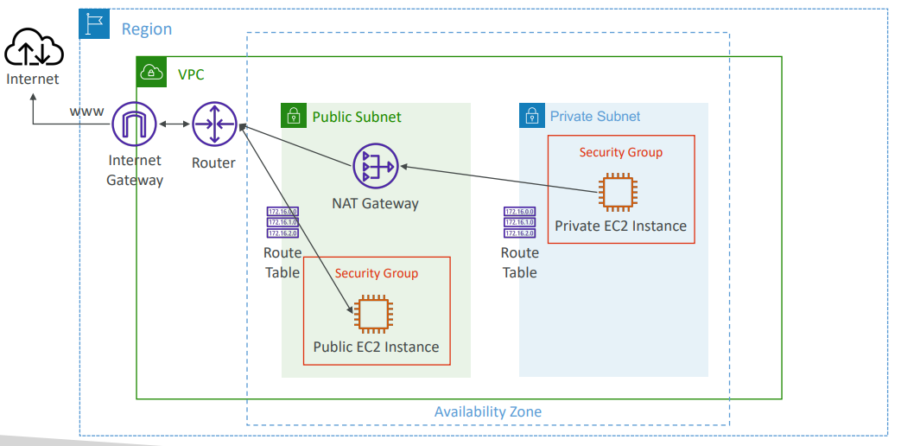

**NAT Gateway with High Availability**

|  |  |
| --- | --- |
| * NAT Gateway is resilient within a single Availability Zone * Must create multiple NAT Gateways in multiple AZs for fault-tolerance * There is no cross-AZ failover needed because if an AZ goes down it doesn't need NAT * If an AZ that goes down, then we'll still have the AZ-B working because a NAT gateway in AZ-B also exists. And there's no need to connect the AZ together through the route tables, because well, if an AZ goes down, then all the instances in that are un accessible. |  |

**NAT Gateway vs. NAT Instance**

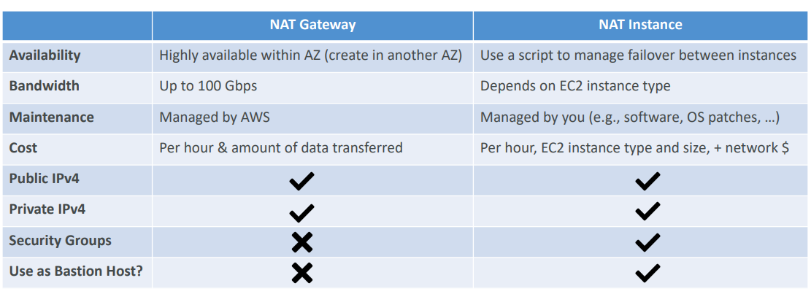

[**https://docs.aws.amazon.com/vpc/latest/userguide/vpc-nat-comparison.html**](https://docs.aws.amazon.com/vpc/latest/userguide/vpc-nat-comparison.html)

**HandsOn**

Okay. So now that my NAT instances stopped or terminated, we do not have access to the internet. So if I do curls.com ah, is not going to work. Okay. So let's fix this and go ahead with NAT Gateway. So first let me refresh this private route table. And as we can see now, this destination targeting this ENI is a black hole and black hole means that this rule is not active anymore. Why? Because where we have stopped our NAT instance and therefore I will see this route does not lead to anything.

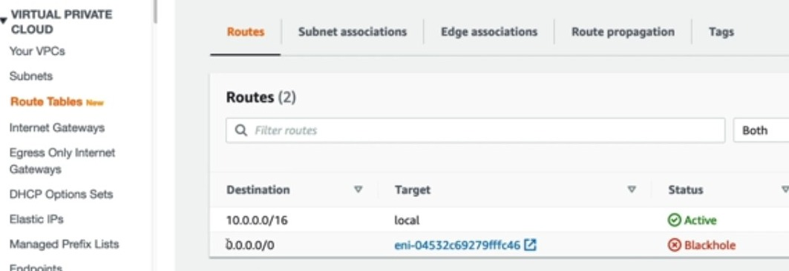

So this is why also it's really good to use managed services and not, NAT instances. So we are going to create a NATs Gateway and I call it 'DemoNATGateway'. Now, when you choose a subnet for the NAT Gateway which should be in so for high availability, we need to use multiple subnets. But right now we'll start with one PublicSubnetA and the connectivity type is going to be public. And then we need to allocate an elastic IP to this NAT gateway. So let's allocate one. Okay. These us to get IP has been allocated, and then we'll just click on create NAT gateway. So this is NAT gateway has been created. So while then that gateway is being created. What I can do is edit my route table. So I will go back into my route table, look at my private route table, and then I will edit them. So let's edit the routes in it. And this route that was a black hole obviously will not, we don't need anymore. So instead we want to send internet traffic out to a NAT Gateway and we'll use the 'DemoNATGW' we've created from before. So let's save this. So now we don't have black holes. We have two active rules and one of them is sending it to our NAT Gateway. Now we can take a little bit of time for a NAT Gateway to be active, as you can see, the state is still pending. So what I'm going to do is pause the videos and get back to you when this is done. And here we go, it is active. And so let's go back into our Institute instance. This one, yes, I'm still connected. This is perfect. So if I do curl a google.com, then it's working and ping, google.com, is working as well. So the NAT Gateway is active and are EC2 instance is sending traffic into it. And we didn't have to specify any security group rules. We didn't have to specify many things just to create this Nat Gateway, but send it into a subnet and then edit the route table. And here we go. My instance in this... private subnets can get access to the internet. That means that's. For example, we can do sudo yum, and then updates, for example, our operating system, without making this instance public, which is really good. So just to finish, we have created one NAT Gateway in one specific... abilities zone, but we could create a second yet NAT Gateway that in another abilities zones, and then edit the route tables to make it highly available. Now, this is not something we're going to do in this lecture, but remember the architecture diagram from before. Again, if you want it to make it a highly available setup, you would need to set up multiple, NAT Gateways for be able to resist a disaster affecting an entire AC.

## NACLs

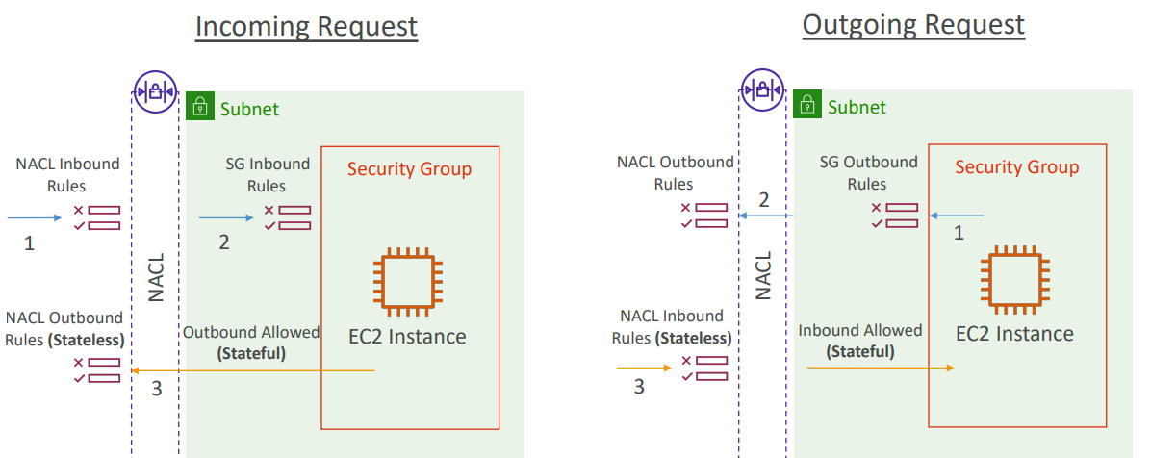

**Incoming request**

But there is an extra level of protection on the subnet that we haven't seen yet, which is your network ACL or NACL. And let's take an example to really understand the role of a NACL in an incoming request. So a request goes to your EC2 instance, now what is happening from a network perspective? Well, first the request is going to make it to the NACL before going into the subnets. And so there are going to be some inbound rules on the NACL that are going to be defined. And if the request is not allowed, then the request doesn't go in. And if it is allowed, then it will go in, right? So the NACL is stateless. So we'll see what that means in a second. So the first request goes through the NACL and then it reaches inside the subnets and it goes through the security group inbound rules, okay. So we know how this works. So again, if the request is not allowed explicitly then it is denied. Now something about security group is that they are stateful. So remember NACLs are stateless and security groups are stateful. So what does that mean? That means that if the request makes it through the inbound rules of the security group and makes it to the EC2 instance, the EC2 instance will then reply with whatever reply there is to do for the application perspective. And then the outbound is automatically going to be accepted at the security group level. This is because the security group is stateful. That means whatever is accepted in can go also out. So here, there is no rules being evaluated. And the security group outbound rules are not mattering in this example. So now that we know that the outbound at the security group level is always allowed because it's stateful, what happens still? Well the NACL is not stateful, it is stateless, and therefore, because it is stateless then the NACL outbound rules are going to be evaluated. And again, if they are not passing, then the request will not make it through. So this is for an incoming request.

**Outgoing Request**

So the security group this time, so the EC2 instance is making an outbound request. So it's doing a request to the outside. And so the EC2 instance will first maybe use, for example, connect to www.google.com, and so therefore the first rules that are going to be evaluated are the security group outbound rules. So is the traffic allowed out from the EC2 instance to the web? Then if the rules are good and the request is allowed, then the request goes through the NACL outbound rules as well. So they're evaluated. Then the request reaches www.google.com, it comes back to Amazon web services, and obviously the NACL is stateless and therefore the NACL inbound rules are going to be evaluated. And finally, while the inbound within the subnet at the security level is also going to be allowed no matter what, because of the statefulness of your security group rules. So here the inbound rules of your security group do not make a difference because the admin roles was already accepted and your security group is stateful. So hopefully that is a very clear explanation between stateful and stateless.

**Network Access Control List (NACL)**

* NACL are like a firewall which control traffic from and to subnets
* One NACL per subnet, new subnets are assigned the Default NACL
* You define NACL Rules:
  + Rules have a number (1-32766), higher precedence with a lower number
  + First rule match will drive the decision
  + Example: if you define #100 ALLOW 10.0.0.10/32 and #200 DENY 10.0.0.10/32, the IP address will be allowed because 100 has a higher precedence over 200
  + The last rule is an asterisk (*) and denies a request in case of no rule match
  + AWS recommends adding rules by increment of 100
* Newly created NACLs will deny everything
* NACL are a great way of blocking a specific IP address at the subnet level

**NACLs**

So we have this diagram we know about, but NACLs again are at the subnet level. And so we can have NACLs at the public subnet, private subnet level and so on.

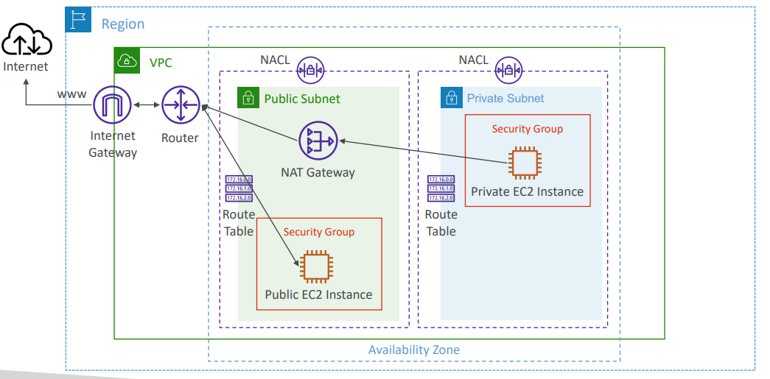

**Default NACL**

* Accepts everything inbound/outbound with the subnets it’s associated with
* Do NOT modify the Default NACL, instead create custom NACLs

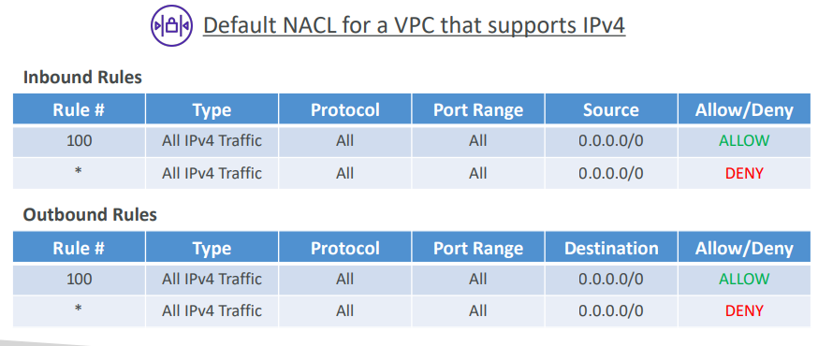

**Ephemeral Ports**

So when you have a client and a server connecting together, they must use port. So we have IP address and ports, and the clients connect to the server on the defined port. So we know for example, that the HTTP port is 80, the HTTPS port is four, four, three, the SSH port is 22 and so on. So when we have a server that exposes a service, then the client connects to a defined ports, except though that the clients needs a reply back from the server. So the server also needs to connect to the clients to send a response. And the client does not have any open port by default. So what it does that when the client is connecting to a server, the client will open a specific ports on itself. And this port is ephemeral because it's just a port that will be as long lived as the connection is between the clients and the server. And so what is that ephemeral ports? Well, based on the OS you have, the operating system you have, you have different port ranges, for example, if you're using Windows 10, for example, then you get to 49,152 all the way through 65,535, the port ranges that will be chosen for a random ephemeral ports. If you use Linux, then a good range will be 32,768 to 60,999, okay. So based on the different OS, you have different port ranges.

* For any two endpoints to establish a connection, they must use ports
* Clients connect to a defined port, and expect a response on an ephemeral port
* Different Operating Systems use different port ranges, examples:
  + IANA & MS Windows 10 è 49152 – 65535
  + Many Linux Kernels è 32768 – 60999

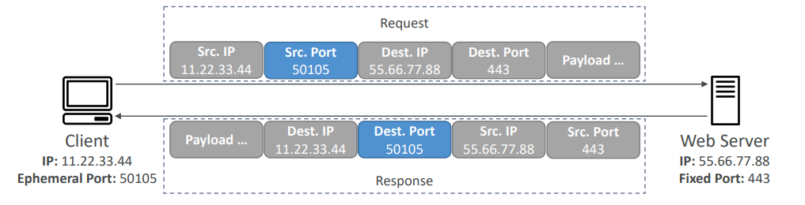

So let's go through concrete example to understand how that works. So the clients connects to a web server, the web server has a fixed IP and a fixed ports. So the client is saying, hey, here's my IP, and I will open for this one request or this one connection, an ephemeral port of five, zero, one, zero, five. So the request sent from the client to the server is, Hey, here is the destination IP, here is the destination port of the server that you connect to, here's the payload of my request, so what I'm requesting, and here is my source IP, by the way, for the reply, and here is my source ephemeral ports for the replay as well, which is five, zero, one, zero, five. And then the web server, when connecting back to the client to send back of the response, will send the response and say, Hey, so here's the source IP, here's a source port. So, the server port, and then the destination IP is 11.22.33.44, here is the response payload. And finally, where we'll also need a port it will reuse the ephemeral port that the client has sent. And this is why it's called ephemeral port it's because it's a random port that is assigned just for the connection life.

**NACL with Ephemeral Ports**

So now, why do I mention ephemeral ports? Well, because they're very important in terms of NACLs. So if you consider a client's connecting to a database and we have a private subnet and a public subnet, we have one NACL associated with each subnet. So a web NACL and a DB NACL. Now, when the client initiates a connection to the database instance, what are the rules that need to be allowed when you think about it, right? Well, if you consider the first NACL we need to allow outbound TCP on port 3306 to the database subnet CIDR, that makes sense. Otherwise, the request will not leave the subnets. And then from a database perspective, then the DB NACL says, Hey, I need to allow inbound TCP on 3306, six from the web submit CIDR. All this makes sense, right? Now, here's the tricky part. When the database sends back the request to the clients, what do you think needs to happen? Well, the client has an ephemeral port, right? And so as such, they will be a random ports being assigned for this request. And so therefore, the DB NACL must allow outbound TCP on ports and, on ephemeral port, so, maybe from 1024 to 65,535 to web subnet CIDR, and then the web NACL also needs to allow inbound TCP on this range of ephemeral ports from the DB subnet CIDR. And this is why ephemeral ports are super important to configure well. So if you want to learn more, there's a link to the documentation.

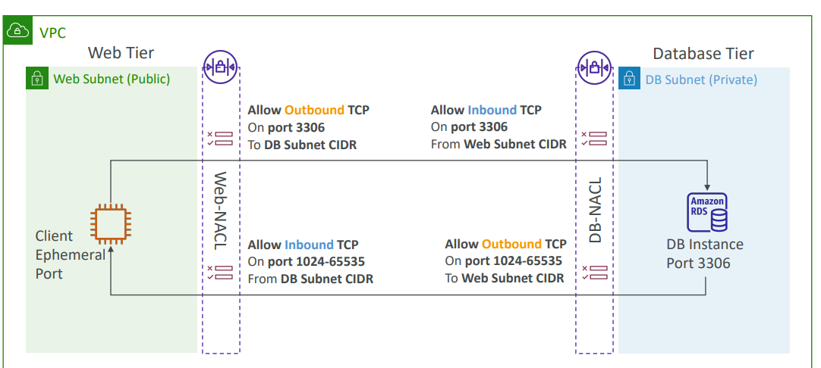

[**https://docs.aws.amazon.com/vpc/latest/userguide/vpc-network-acls.html**](https://docs.aws.amazon.com/vpc/latest/userguide/vpc-network-acls.html)

**Create NACL rules for each target subnets CIDR**

Another thing about NACLs you need to know is that if you have multiple NACLs and multiple subnets, then each NACL combination needs to be allowed within the NACL, because you're using CIDRs and each subnet will have its own CIDR. So it's super important for you to realize that, if you add subnets into a NACL, you need to also update all the NACL rules to make sure that the combination of connections is possible.

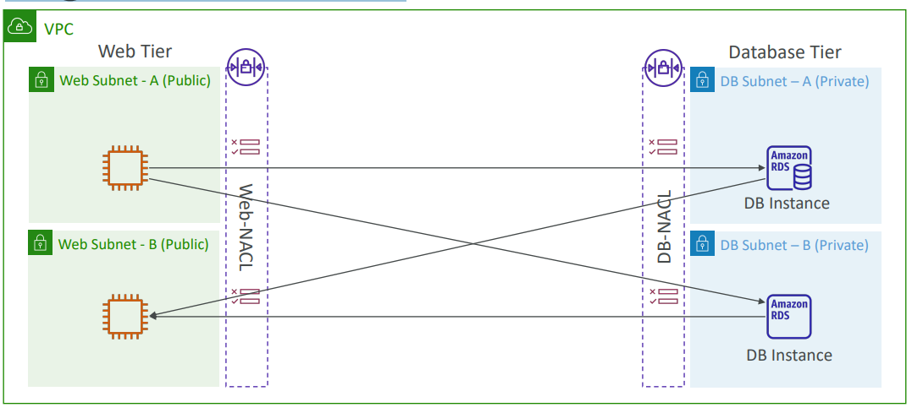

**Security Group vs. NACLs**

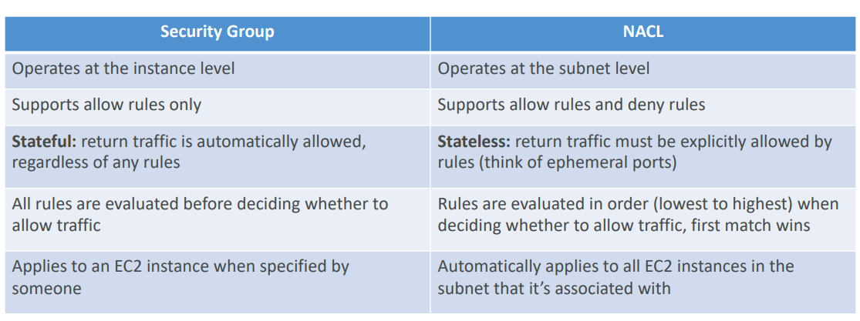

[**https://docs.aws.amazon.com/vpc/latest/userguide/vpc-network-acls.html**](https://docs.aws.amazon.com/vpc/latest/userguide/vpc-network-acls.html)

**Hands ON**

So, let's have a look at our network ACL's. To do so, I will go on the left hand side and there's network ACL's. And for our sub for VPC, we have a network ACL here. This is the default, NACL. So, it's very important to notice this. And currently it's default. So, it's associated with four subnets. So, we have inbound rules and outbound rules. And then if we look at the inbound rules, we allow all traffic on all parts everywhere. And then there's the last row which was denied, but it doesn't ever get to effect because this one goes into effect before. And then for the outbound rules the same. So, remember the default, NACL, always has all traffic, inbound and outbound authorized, and the default is going to be associated with any subnets you're going to create, hence the name default NACL. So, now let's go ahead and have a place or to do so, I'm going to go into my EC2 instances, my NAT instance. Sorry, my Bastion host. And I'm going to start a HTTP server on it to connect to it. So, to do so let's connect into our instance, let's connect, and I'm going to install HTTPD. So sudo, yum, install, minus Y, HTTPD. Then we're going to start the web server. So I will do, system, CTL, sudo, system CTL, enable HTTPD, and then sudo, system CTL, start HTTPD. Let's clear the screen. And then we're going to echo "hello world" into our var/www/html/index.html and we'll have sudo for this command. So let's do sudo, su, echo, hello world into again, this file. So, this should work right now, so let's try it. Okay. So, now the other thing we have to do is we need to make sure that the Bastion host has this public instance has HTTP enabled for the security group. So, right now we only have 4 22. So, therefore in the security group rules, I'm going to edit the inbound rules and I'm going to add a rule for HTTP and then from anywhere, save this rule. Perfect. So back into our instance, this is our bastion host, and I can just click on this IP address right here. Copy it, open it in a new tab and I get, "hello world." So, this is good. We are able to connect into our server and it replies "hello world" to us. So, let's have a look at network ACL's now. So, if I look into this default NACL, and look at the inbound rules, what I'm going to do is I'm going to edit these rules. And currently we allow all traffic from anywhere, okay, but we're going to add a new rule. And the rule number is going to be rule 80 and the type is going to be HTTP, and it's going to come from anywhere and we are going to deny it. So, let's save these changes and we can sort them by rule number. So, as you can see, this rule has precedence over that rule. So, what do you think is going to happen? Well, now that we have enabled this inbound rule, that blocks HTTP traffic. If I go back to my EC2 instance and refresh this page, I'm getting, you see, an infinite loading. So, that means that yes, there's a timeout and the NACL acted as a firewall and blocked my request. But if I edit my inbound rules and now the rule number is 140. Okay, and save this again. And look again at the inbound rules, as you can see now, rule 140 happens after rule 100 and there's a denial. So, what do think is going to happen? Well, if I go back and refresh, I'm accessing my EC2 instance. So, what's happening is that even though there was an explicit deny rule, happening here, because the rule number 100 had higher precedence and allowed that specific traffic in, then it works. Okay. So, as we can see, this shows the very important aspects around the rule numbers. Okay. And similarly, I want to show the statelessness of the NACL. So, if I go into outbound rules and there's this rule right here, that allows everything right now, if I edit it and instead do deny, well, what is going to happen? The inbound rule is going to allow my traffic, but the outbound rule shouldn't. So, let's go back into my instance, refresh this, and you can see I'm getting this infinite loading, because well, my NACL does not allow return traffic, because it was not explicitly specified in my NACL, that return traffic was allowed. So, what's really important to notice is that this is true, regardless of if the security group of my EC2 instance did, in fact, allow port 80 in, okay. So, NACL's and security groups work hand-in-hand together. And if the security group rules look fine, that doesn't mean that the network ACL's are fine. So, this is something else to check in case of network issues. So, let me revert this to allow and do another demo. Okay, so I'm back into my instance. This is working now. And so if we look at the security group rules here, as we can see, port 80 is allowed on everywhere. And for outbound rules, it says allow from everywhere as well, but let's edit this security group. So, for the inbound rules, I will not change them. So, I will keep HTTP on, but for the outbound rules, I'm going to edit this rule and I'm going to just remove it. And as you can see, now, we don't allow any outbound from the security group, but the security group is stateful. That means that if the traffic is initiated from the outside and is allowed inbound, then the return traffic will be authorized as well. So, let's prove it, even though there is no outbound rule. If I refresh this page, as you can see, this is working, I can access my EC2 instance. But if my EC2 instance was trying to initiate a connection, for example, not here. If my EC2 instance was trying to initiate a connection to Google account, for example, it would be denied because, well, there's no outbound rule that specifically allows it. But if it did allow it, then the return traffic would be allowed because again, security groups are stateful, whereas NACL's are stateless. So, to make things, everything work again. And once you have all HTTP from anywhere allowed, and this is going to restore these outbound rules on my EC2 instance, okay. So, it's very important for you to notice the difference between EC2 security groups and network ACL's. But hopefully this was a good demo.

## VPC Peering

So the idea is that we can create VPCs and in different regions, different accounts and we want to connect them together using the AWS network.

|  |  |
| --- | --- |
| * Privately connect two VPCs using AWS’ network * Why need it ?Make them behave as if they were in the same network * Must not have overlapping CIDRs * VPC Peering connection is NOT transitive (must be established for each VPC that need to communicate with one another) So if you have a look at three VPCs right now, A, B, and C, then we can create a peering connection between A and B. And this is allowing you to connect them together. And we can create another peering connection between VPC B and C, and again, they can communicate together. But even though A and B, and B and C, are connected, you still need to enable a VPC peering connection between A and C, to have them communicate. * You must update route tables in each VPC’s subnets to ensure EC2 instances can communicate with each other |  |

**VPC Peering – Good to know**

* You can create VPC Peering connection between VPCs in different AWS accounts/regions
* You can reference a security group in a peered VPC (works cross accounts – same region)

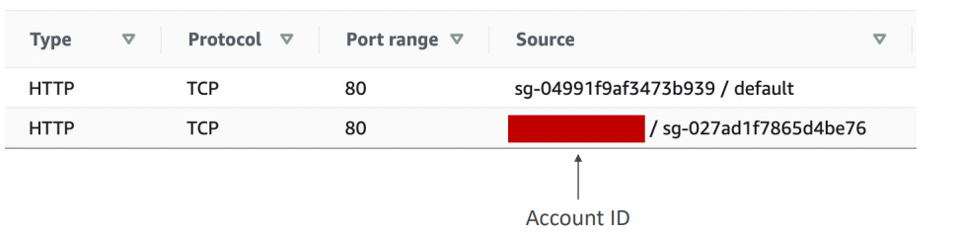

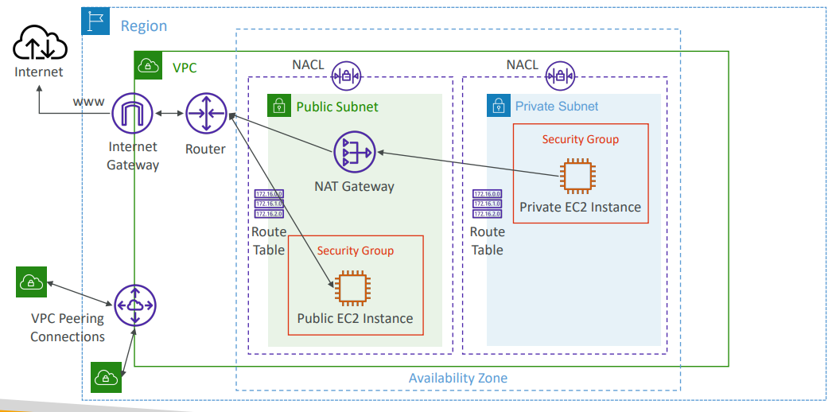

**Hands On**

Okay, so let's have a play with peering VPCs. So what we wanna do is to peer our 2 VPCs together. So the demo VPC and this one I will call it the default VPC which was the VPC that was created with my accounts. So we want to peer them together, okay? This is good. And to do so, I'm going to prove first that's the VPCs are not connected. And so to do so I'm going to go into my EC2 management console under instances I'm going to launch an instance and then I will scroll down. I will scroll down. Key pair will choose demo key pair, but will not need it. And then we'll do network settings will launch this one in a default VPC and we'll create a security group launch-wizard-2 that has the SSH rule added in. So that's good. Let's launch that instance and we are good to go. Okay. So now we have our BastionHost. Remember that has this website available and then we have this instance I'll call it default VPC instance, okay? And what I want to do is to connect and make sure this default instance VPC can connect to the instance in my BastionHost. Now, if I have a look at the IPS, okay? We can see that the private ipv4 is more interesting. So we can have a look at probably not here. So, if we look at the private ipv4 address this one is 172.31.36.159. And this one before was 10.0.0/72. We can tell there they're in different VPC because the IP addresses that are private are very different. So let's connect to this one, using EC2 instance connect. Okay, we're connected. And let's also connect into my BastionHost. So my instance in my other public subjects. Okay. So if we do a curl and then we do 10.0.0.0.72:80, which is my IP. So we get a hello world. So this is working fine, okay? But if we do the exact same curl command so we go here and we do curl on this IP, okay? So this is from the 172.31 type of instance. So, we're going to curl this instance right here and press enter. Well, this is not working. We get a time out. Well, because there is no way for our EC2 instance right now in this VPC to connect to the two instance in another VPC. That's why it's called virtual private Cloud IaaS because they're isolated from a network perspective. So we're going to connect them. And to do so, well we need to go and create a peering connection. So on the lifeline side, there is peering connections. I'm going to create a peering connection and I'll call it demo peering connection, and we need to select a local VPC to peer with. So we're going to say that the requester is my demo VPC, and then we're going to select another VPC to connect to. So it's in my accounts, but it could have another account and it's in this region, but it could be another region. And the acceptor of VPC is going to be the default VPC with this CIDR. So as we can see, this CIDR and that CIDR do not overlap and therefore this VPC peering connection is possible to create, okay. So let's create this peering connection and it's pending acceptance. So this is not working until we have accepted it now because both the VPCs are in our accounts. We can accept this request ourselves, so we can accept it. But if it wasn't of other accounts obviously we could deny it. So the requester owner ID and the acceptor or ID are the same in this example. So let's accept this request. And now it says to send and receive traffic across this VPC peering connection you must adder route to the VPC period in one or more of your VPC, route tables. So again, this is very important, even though there's VPC peering connections we need to still modify the route table. So again, if I try to do a curl, not from this one but a curl from this instance, still not working, okay? So let's go ahead and fix this. So we go and modify my route tables now. And so we have one public route table, and here we have I will find the right one. So this is this one right here. This is my default VPC default main route table, main route table. Okay, now we know where we are. Okay, so we want to connect this and that's. So let's start with a public route table and I will go to routes and then edit routes and I will have a destination. So in this one, we need to select a CIDR, which corresponds to the CIRD of my VPC that was created the default VPC. So to do so let's go into your VPCs, find the default VPC and the IP four CIRD is right here. So I'm copying it, I'm pasting it. And we're saying, Hey, any traffic that is going into this range of IP addresses should be sent to a peering connection called the demo peering connection. And click on safe changes, and what we've done effectively is that we've created a route from my creative VPC into the default VPC. So if we try again though and do a curl, still not working, and the reason is, well we need to also modify the other route table for it to work. And so let's do it. Let's modify the other route table. So to do so, I'm going to go into the VPC main route table and I will edit this route and I will add a route. And this time it's for 10.0.0.0.0.0/16 which is now the CIRD of the VPC we've created alongside this course. And again, the peering connection. And then we'll say step changes. So now we have routes going both ways. And so if I curl again and press enter, here we go. We'll get a hello world. That mean that the VPC peering connection is working and it was established.

## VPC Endpoints

The idea is that you have services on AWS, for example, such as DynamoDB and they are accessible publicly. So that means that your whole infrastructure through your NAT gateway and then your internet gateway or just directly through your internet gateway does access DynamoDB. But all this traffic goes through the public internet and you may have other services such as CloudWatch and Amazon S3 that you also wanna access without going through the internet. You wanna access them privately. So the idea is that you're going to use VPC endpoints so that your instances don't have to go through the public internet, they can just go directly through the private AWS network to these services.

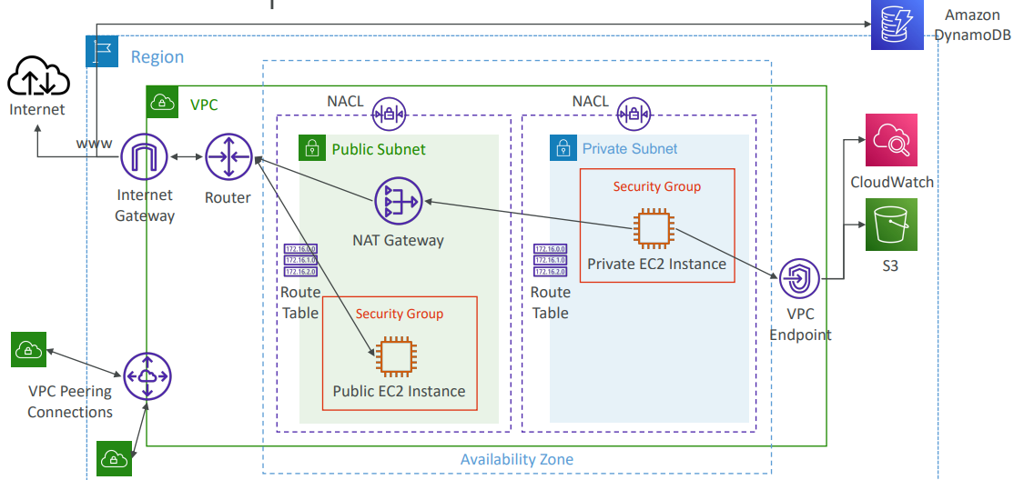

**VPC Endpoints (AWS PrivateLink)**

So let's consider this architecture that we know already, so we have public subnets with a NAT gateway and it's EC2 instance, a private subnet, and then we're going to have an internet gateway so that we know we can access the Amazon SNS service for example, through different ways. So if we look at the private subnet and the EC2 instance in it, to access the Amazon SNS service, the EC2 instance can go through the NAT gateway which then goes to the internet gateway and then accesses publicly the Amazon SNS service and this is the same for the EC2 instance in the public subnet, it goes directly through the internet gateway to the Amazon SNS service. And this option is fine but it costs just a lot of money because, well, we have to go through NAT gateway, which has a cost, and then we have to go through the internet gateway which doesn't have a cost but still there is obviously many hops and it's not very efficient.

So instead, I'm just representing the same Amazon SNS service, but somewhere else on the diagram, we can use a VPC endpoint. And the idea is that the VPC endpoint is deployed within your VPC and by doing some networking, we can actually make the EC2 instance in the private subnet go through the VPC endpoint directly into the Amazon SNS service and the network has never left AWS, which is really good. So, every AWS service is publicly exposed, it has public a URL, and if you use VPC endpoints, they are powered by something called AWS PrivateLink because you access these services privately. Then you can connect to any of these services by AWS using a private network instead of going over the public internet. These VPC endpoints are redundant and they scale horizontally, and they're going to remove the need for an internet gateway or a NAT gateway to access AWS services, thus simplifying your network infrastructure by a lot. So in case of issues, you need to check the DNS settings resolution in your VPC and your route tables.

|  |  |
| --- | --- |
| * Every AWS service is publicly exposed (public URL) * VPC Endpoints (powered by AWS PrivateLink) allows you to connect to AWS services using a private network instead of using the public Internet * They’re redundant and scale horizontally * They remove the need of IGW, NATGW, … to access AWS Services * In case of issues:   + Check DNS Setting Resolution in your VPC   + Check Route Tables |  |

**Types of Endpoints**

|  |  |
| --- | --- |
| **Interface Endpoints (powered by PrivateLink)**   * So the Interface Endpoints provision an ENI, so it's a private IP address in your VPC and this ENI is an entry point to your private AWS service. And so for this, we must attach a security group * Supports most AWS services * $ per hour + $ per GB of data processed   we have an EC2 instance and a private subnet and thanks to a PrivateLink VPC endpoint of type interface then we can access through the ENI to the service. And this works for every single service out there |  |
| **Gateway Endpoints**   * Provisions a gateway and must be used as a target in a route table (does not use security groups) * Supports both S3 and DynamoDB * Free   it is Amazon S3 and DynamoDB, but the advantage that this is free and this scales automatically because it's only a route table access. So, it's only for Amazon S3 and DynamoDB, remember this. And in this instance, we provide a VPC endpoint of type gateway and we have access to Amazon S3 or DynamoDB. |  |

**Gateway or Interface Endpoint for S3?**

should I use the Gateway or the Interface Endpoint for Amazon S3 or DynamoDB? Well, we have indeed two ways of accessing Amazon S3, right? Either with the Gateway Endpoint or with an Interface Endpoint. And at the exam, the Gateway is most likely going to be the preferred solution at the exam, why? Well, because we just have to modify a route table. So, and your apps can access Amazon S3 free of charge, so the cost is free for a Gateway, it scales more, and for the Interface Endpoint, you have a cost associated with it. The only time where an Interface Endpoint may be preferable over a Gateway Endpoint is if you require access from on-premises, for example you want private access from your on-premise data center and we haven't seen it yet, but we can connect it through something called site to site VPN or direct connect or it's maybe preferable if you want to connect from another VPC through this Interface Endpoint. So these are advanced use cases, right? And this is what is represented on this graph. But most of the time the Gateway Endpoint is going to be preferred for Amazon S3.

|  |  |
| --- | --- |
| * Gateway is most likely going to be preferred all the time at the exam * Cost: free for Gateway, $ for interface endpoint * Interface Endpoint is preferred access is required from onpremises (Site to Site VPN or Direct Connect), a different VPC or a different region |  |

**Lambda in VPC accessing DynamoDB**

|  |  |
| --- | --- |
| * DynamoDB is a public service from AWS * Option 1: Access from the public internet   + Because Lambda is in a VPC, it needs a NAT Gateway in a public subnet and an internet gateway * Option 2 (better & free): Access from the private VPC network   + Deploy a VPC Gateway endpoint for DynamoDB   + Change the Route Tables |  |

**Hands ON**

So let's go ahead, and practice using VPC endpoints. First what I wanna show you is that, and I'm going to stop this default VPCs instance, 'cause we don't really need it. So I'm going to terminate that instance, and yes, be done. So if we go into our bastion host, which is also a public instance, we're going to connect to it. And then from this EC2 instance, I'm going to connect into my private EC2 instance, so again, this is the IP of my private EC2 instance, that we have here, so what we can do, is do the SSH command from within, so EC2 user at the IP, minus i demoKeyPair.pm. Okay, let's clear this. So now we want to access the S3, okay? So to access S3, what we need to do, is to create a role for this instance. Okay, so we're going to go under security, there's no IM role attached right now. So what I have to do is to right click, and then I will go into security, and then modify the IM role. We need to create a new role, and I will just create a quick role for EC2 instances, so, let's create a role. And this is for EC2 instances, next, permissions. And then for the policy that we have, we'll use the Amazon S3 read only access, okay? Tags, review, and then I'll call it DemoRoleEC2-S3ReadOnly, okay. Create role, and it has been created. So now back in it, I can refresh this page, and look at this demo role EC2 S3 read only, and save it. So invalid instance, I am providing, so here we go, it was just a little lag that we needed to wait for. Okay, so my private instance now as an IM role attached to it, so if I go back into here, and do AWS S3 LS. As we can see, we get the answer of our four buckets, of our accounts. So our instance is connected to the internet, and again, we can do curl google.com. And again, we get an answer, okay? So this is working, but now what I'm going to do, is under the route table of my private subnets, I'm going to edit the routes, and this one that was connecting to the internet through the NAT gateway, I'm going to remove it. So effectively what I'm going to do, what I'm doing right now, is that I'm preventing this instance right here, to access the internet. So if we do S3 LS, this is not working, and if we do curl google.com, this is not working either, so we've removed internet access from this EC2 instance, because we want to connect to Amazon S3 privately, through a VPC endpoint. So let's go ahead and create a VPC endpoint, so I will click on endpoints, not endpoint services, and then click on create endpoint. And here I can choose the type of endpoint I want. So I want an end point for an AWS service, and then we have a list of all the services, and the type of VPC endpoint we have. So we have either an interface type of endpoint, or if I type, for example, dynamodb in here, it is a gateway type of endpoint. So if we take a interface type of endpoint, I'll just take the first one I see. What I have to do is select a VPC in which this endpoint will be deployed. Then we need to make sure that DNS name is enabled, and for this we need to modify some VPC settings regarding DNS, but we have done that from before. And then we specify in which AZ will this endpoint be deployed, this interface endpoint be deployed. So you can say in these two subnets, because we're not with the third subnet, because we didn't create a subnet for this, for the last AZ. But anyway, you choose the end points you want, you choose the associated subnet ID with it, for example, it is going to be in private subnet A, and then private subnet B, of IPv4. And then you select a security group to attach to this endpoint, and this will define the security of how this endpoint is accessed from your other type of instances, okay? So the other option, instead of creating an interface endpoint, is to create a gateway endpoint. And for this we'll use Amazon S3. So as we can see, we have different kinds of endpoints, we have a gateway and interface, but to go through this example, the most common is going to be a gateway endpoint into Amazon S3. In which case we have to choose a VPC, the demo VPC, we have to choose then to update route table. And so therefore we're going to update the private route table, so that any request made within my private subnet in this route table, is going to be routed to this gateway endpoint. So we'll use full access for this gateway endpoint, and then click on create endpoint. So the endpoint has been created, and if you look at route tables, we can see that it is associated with my private route table. So we can verify that by going into the route tables, in my private route table, look at the routes and then edit them. As we can see we have this route right here that get added directly, and that means that some traffic is going to go directly into my VPC endpoint. So we're good to go, and we cannot delete it, because it's actually linked to the endpoint itself. And so now this is done, let's have a look at our bastion instance, and see if things work. So if I do curl and right now this is not working, I got disconnected, so let's go back into it, by going through the bastion host. then we SSH again, so we use the demo key pair, and then we add in the IP of our private instance, which is right here. Okay, now if you do curl google.com, as we can see, it still does not work, because we still have a route out to the internet. And if you do AWS S3 LS, it doesn't work either. And you may say, but we have a gateway endpoint, so it should work. Yes, actually this is because of a CLI problem. So what you have to do is that by default, the region of the CLI will be US East one, and so we need to edit it, and for this, we're gonna do AWS S3 LS, and then region is EU central one, or whatever region you are in when you do this hands on. Press center, and as you can see now, this traffic is redirected to the VPC endpoint of my region, and therefore I have the list of all the buckets on Amazon S3, even though my instance does not have internet access. So this is the whole power of VPC endpoints,

## VPC Flow Logs

* It allows you to capture information about IP traffic going into your interfaces:
  + VPC Flow Logs
  + Subnet Flow Logs
  + Elastic Network Interface (ENI) Flow Logs
* Helps to monitor & troubleshoot connectivity issues
* Flow logs data can go to S3, CloudWatch Logs, and Kinesis Data Firehose
* Captures network information from AWS managed interfaces too like, ELB, RDS, ElastiCache, Redshift, WorkSpaces, NATGW, Transit Gateway…

So this is what a VPC Flow Log looks like. So there is a format associated with it, but there is a version, account ID, interface ID, source address, destination address, source port, destination port, protocol packets by start and action and log status. So this is metadata about the network packets going into your VPC.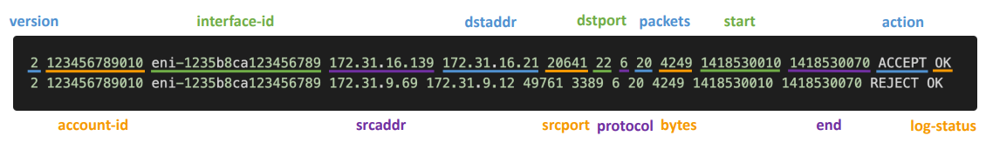

* srcaddr & dstaddr – help identify problematic IP
* srcport & dstport – help identity problematic ports
* Action – success or failure of the request due to Security Group / NACL
* Can be used for analytics on usage patterns, or malicious behavior
* Now to query these Flow Logs, you have two ways of doing it. The best ways to do Athena on S3, or if you wanted to do a streaming analysis, you could use CloudWatch Logs insights

Flow Logs examples: [https://docs.aws.amazon.com/vpc/latest/userguide/flow-logs- records-examples.html](https://docs.aws.amazon.com/vpc/latest/userguide/flow-logs-%20records-examples.html)

**VPC Flow Logs –Troubleshoot SG & NACL issues**

So how do we use flow logs to troubleshoot security group and NACL issues? Well, we look at the action field. So let's have a look at the typical incoming request for your NACL and your subnet. So remember, your NACL's are stateless and your security groups are stateful. So what happens, well, if we get an inbound reject, so we see that the inbound request from from the outside to our EC2 instance is rejected, that can means that either from this graph, the NACL is refusing the request, or the security group is refusing the request. And this makes sense, right? But if we have a inbound accept and an outbound reject, it can only mean a NACL issue, why? Or because your security group is stateful, and if the inbound is allowed because of the accept, automatically the outbound will be allowed thanks to the statefulness of your security group. So after outgoing request, similar analysis, right? This is the diagram we know already. And so if you get an outbound reject, then you have a NACL or a security group issue, but if you get an outbound accept and an inbound reject, then it must mean a NACL issue.

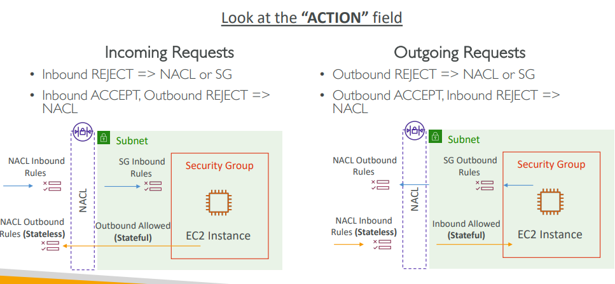

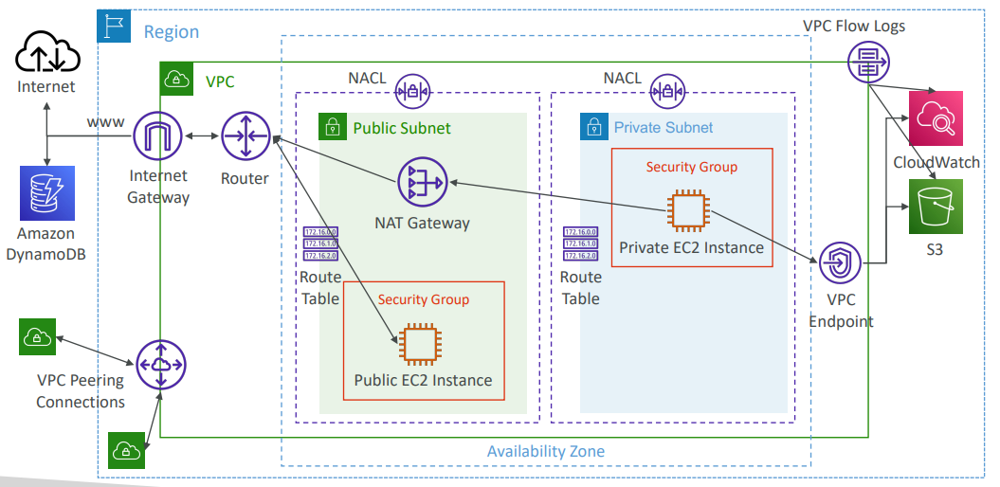

**VPC Flow Logs – Architectures**

So let's have a look at a few architectures for your VPC flow logs, so they can flow into CloudWatch Logs as we know. And then we can use something called CloudWatch Contributor Insights, for example, to find the top 10 IP addresses that contribute to the most amount of network on your VPC, or on ENI or whatever you want. You can also use VPC flow logs to send them again into CloudWatch logs. Here we can set up a metric filter to look for example for the SSH or the RDP protocols. And if we realize that there's a lot more SSH, or RDP than usual, then trigger a CloudWatch alarm, and send an alert into an Amazon SNS topic because something fishy may be happening on your network. Or we can use a VPC Flow Log. And then we send everything into an S3 bucket for storage, and we use Amazon Athena to analyze the VPC Flow Logs with SQL, and we can even visualize that with Amazon QuickSight. So that's it for VPC Flow Logs,

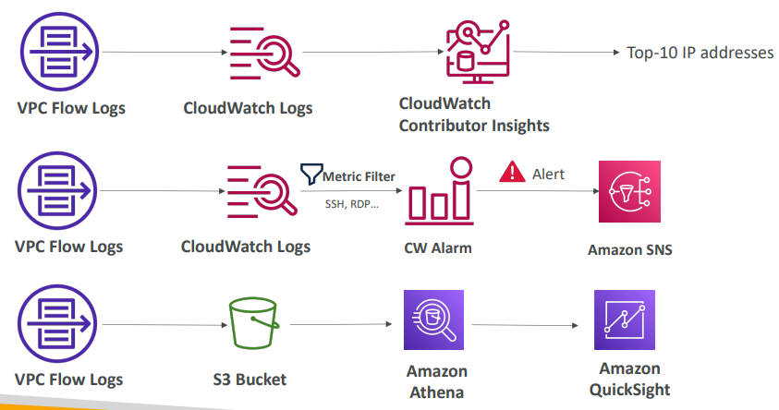

**Hands On**

Okay, so now we're going to practice VPC flow logs. And to do so well, we'll go into our demo VPC under Flow Logs and we can create a flow log. So we have a few types of flow logs. So I'll call this one DemoS3FlowLog. And we have a filter, do we want the accept type, reject type or all kind of traffic? So if you're trying to debug why some traffic is not going through, maybe reject is more relevant. Otherwise, all or accept are good as well. The maximum aggregation interval. So how long you need to wait to aggregate. And you can look at the info. So you can optionally specify a one minute aggregation, but if you do so then there's gonna be more records being created, because it's possible that you have lots of records getting created over time and obviously every one minute written to S3 or CloudWatch Logs can be very expensive. So let's just do one minute just for the sake of the demo to go quicker. But 10 minutes is usually a better option if you're looking at it, especially after a little bit of time. So a few options. We can send the destination to CloudWatch Logs And we need to specify a log group, we need to we can also send it to an Amazon S3 bucket. We need to specify the S3 bucket ARN or we can send it to Kinesis Data Firehose in the same account or in a different account. But we'll use Amazon S3. So to do so, I'm going to go into the S3 service in here and I will create a bucket and create demo-stephane-vpc-flow-logs-v2, okay? In the same region where my VPC is obviously. And then I will create this bucket. Now view the details of the bucket and now we need to get the bucket ARN. So to do so, here it is I can just copy it from the Properties. So let's paste this in. And as we can see, a resource-based policy will be created for you and attached to the target bucket. So bucket policy will be created for us automatically so that the VPC service can send data into our S3 buckets. Now the format looks like this. This is the default format of AWS. And next I will click on Create Flow Log. Okay, so this first flow log has been created, perfect. And I will go ahead and create a second flow log now. So I'll create flow log. And this one is going to be DemoFlowLog CloudWatch Logs all kind of traffic, one minute interval, to CloudWatch logs. And we need to create a log group and an IAM role. Okay, so let's do both of these things. So to do so when you click on Set Up Permissions so let's create a role. So we are going to create a role this is a custom trust policy. And in here for principle, just go to the new line. You're going to enter Service in between quotes, then colon and then Service is vpc-flow-logs.amazonaws.com. So make sure you have this in between quotes as well. So this is going to say that this role can be assumed by VPC flow logs. Click on Next. Now for permissions policy we need CloudWatch Logs full access. So we're going to have this one CloudWatch Log full access which is enough. Then click on Next. And this role name is going to be flowlogsrole. Then create this role. And now this role is created. So if I refresh this and look for flow log roles, here we go. It is created. And now we need a log group. So let's go into the CloudWatch Logs console. So let's click on it here. And under Logs, Log Groups, I'm going to create a log group. I'll call it VPCFlowLogs. And I will set the retention to one day and click on Create, click on this log group here. Now refresh this and the VPCFlowLogs is appearing. So we're good to go. Now let's create this flow log. And yet again, so now we have two flow logs. One flowing into Amazon S3 and one flowing into CloudWatch Logs. So into Amazon S3 under my Objects, I can refresh this and as we can see some AWSLogs have already been created. I can click on it, look at the VPC flow logs for eu-central-1. And then we have a timestamp, and we have here the VPC flow logs available to us. So now let's go into the CloudWatch Logs and refresh this and have two log streams. And these log streams correspond to the enis within my accounts. So if we ever a look at the eni of my BastionHost, this one, and we have a look at the eni number. So we go under Networking, and what I'm going to do is put this up a little bit and look for the eni id. So the eni id is 0835. So let's go into here and look for 0835, this one, perfect. So this is showing us the kind of traffic that is happening onto my EC2 instance. And if you look at it, well, it seems that some people are trying to access my EC2 instance, but it's getting rejected. So this is the version, this is like all these fields, okay the eni id and this IP address, which is the public IP address is trying to access my EC2 instance. And this is really like this kind of attackers were attacking your instance and just scanning the web for holes and so on. So you're gonna have a lot of this kind of traffic. And if I wanted to get some defense, I could for example, if this IP address was annoying me too much, I could block it at the that code level, for example and not have this traffic. But as we can see, a lot of traffic is appearing in here and it's all Reject. But if I were to do some activity on my S3 instance and connect to Google for example, we would see some traffic with Accept as well. And the same kind of data is going to appear on Amazon S3. So if I go here, you will have a lot of data, okay? So you use CloudWatch Logs, if you want to have some kind of metrics filter to do some real-time analysis in case you're being attacked and a lot of traffic is being rejected and so on. So this is very helpful and you'll use Amazon S3 if you wanted to do some more bigger analysis for example, using Athena. So let's go ahead and practice using Athena to query this data into my S3 bucket. So in Athena, what I'm going to do is to first set up a query result location in Amazon S3. So I'm going to click on New Settings, Manage and then I need to specify an S3 bucket where I'm going to store my results. So back into Amazon S3 what I'm going to do is just quickly create an S3 bucket, because this wasn't set up for this account. So I call this one demo-athena-stephane-v2, and this should work. Now let's click on Create these buckets, View Details, and I can just use this S3 bucket, so Properties, I will copy the ARN, back into Athena and then click on Save. So I need to just do slash and then Athena. And then something like, ah, S3://, here we go. Okay, this is good. So let's click on Save. And now we have this query location being saved and I need to go ahead and start creating a database and then create some data. So what I need to do is to go in here and I will type AWS VPC flow logs Athena and this is going to take me into a tutorial on how to do it. So to do so, we need to create a table. And this whole statement right here shows you how. So let's go ahead and paste this in my Athena UI. So here we go. And we need to specify where the data is. So the log bucket, the prefixed logs and then account id VBC flow logs and region code. So let's find it. So let's go back in here. This is my Athena bucket. No, this is my VPC flow logs bucket. Here we go. So let's go to the top of it. Just to go back. So logs, account id, VPC flow logs, region. Okay, we got it. Now we're going to copy this S3 URI directly back into Athena and I'm going to paste this in. Okay, perfect. And let's run this statement. So this completed, and now we have a VPC flow log table in here. Okay, and it is partitioned. So we can see we have all the information in here. Now the second thing we need to do is to run another statement. So let's go here and find this alter table, to create partitions to read this data. So let's copy this, paste this in. And again, we need to specify a date and as well as the entire replacement for month, year, and day. Okay, so let's go ahead and do this. So back into Amazon S3, into my Objects I will click, click and click, go back to Properties and paste this, copy and paste this in. So we're good to go. And then we need to add a partition. So 2021-10-06. And this is quite manual, but Glue can help with automating this. Now let's run this statement. And the statement was successfully completed. So now we have added one partition into our table. And then finally we can query the flow logs just by doing a select. So let's do this to find all the reject traffic and then click on Run. And this is worked. And now we have 46 results and we can have a look. So day, date, interface id, source address, action reject, protocol 6. So we can get a lot of information from Athena and we can start doing some complex queries to try to group for example, by IP addresses, see who is attacking us the most where we're attacked the most, and so on. So this could be quite helpful for doing some batch analysis, okay? But that's it, we've seen how to set VPC flow logs. We send to CloudWatch Logs. And to Amazon S3, we've used Athena to query these logs in Amazon S3. So very complete demo. And what I'm going to do now is just disable all these logs. I'm going to delete them, just not to run any ongoing cost.

## AWS Site-to-Site VPN

So the idea is that, now we have a VPC but we may have also a structure within the corporate data center, and we wanna connect AWS to our corporate data center using a private connection. So for this, we'll have a customer gateway on the corporation side, and a VPN gateway on the VPC side. And we're going to establish, through the public internet, a private site-to-site VPN connection. So it's a VPN connection, so it's encrypted. It goes over the public internet, though. And using this, we have linked effectively the network of our VBC to the network of our corporate data center

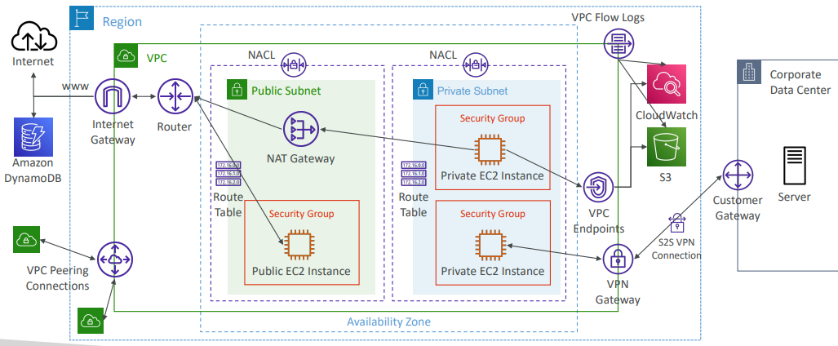

So, as such, the VPNs need two things. First, they need a virtual private gateway, VGW. It's a VPN concentrator on the AWS side of the VPN connection, and the VGW is created and attached to the VPC from which you want to create the site-to-site VPN connection. It's possible for you to customize the ASN number,

The customer gateway is a CGW, and it's an actual software or a physical device on your side, so on the data center side of the VPN connection, And there's a bunch of these that will have been tested by AWS, so we can have a look at the list here

* Virtual Private Gateway (VGW)
  + VPN concentrator on the AWS side of the VPN connection
  + VGW is created and attached to the VPC from which you want to create the Site-to-Site VPN connection
  + Possibility to customize the ASN (Autonomous System Number)
* Customer Gateway (CGW)
  + Software application or physical device on customer side of the VPN connection
  + <https://docs.aws.amazon.com/vpn/latest/s2svpn/your-cgw.html#DevicesTested>

**Site-to-Site VPN Connections**

So, how do we set up the customer gateway device that is on premises? Which IP address should we use? Well, if your customer gateway is public, there is a public internet-routable IP address for your customer gateway device. Then you would use this one, and you would establish the connectivity between your VGW and your CGW using the public IP of the customer gateway. But it's possible for your customer gateway to also be private and have a private IP. In which case, then it is very common for it to be behind a NAT device that has NAT-T enabled. And then, that NAT device has a public IP, in which case, the IP address you should use for the CGW is the public IP of the NAT device. And then, the site-to-site VPN connection can be established. I'm saying this because this can come into the exam. And then, the second question that can come up to the exam is that, even though this is set up, this site-to-site VPN connection will not work until you enable route propagation in your VPC within your subnets. And then, when this is done, then the connectivity will work. Finally, another exam question that can come up regarding site-to-site VPN. If you need to ping your EC2 instances from on-premises to AWS, then make sure that the ICMP protocol on the inbound of the security group is enabled. Otherwise, I would say the connection will not work. This is just a security group question, obviously. But they mix it up with the site-to-site VPN and that can be confusing, so here is some help.

|  |  |
| --- | --- |
| * Customer Gateway Device (On-premises)   + What IP address to use?     - Public Internet-routable IP address for your Customer Gateway device     - If it’s behind a NAT device that’s enabled for NAT traversal (NAT-T), use the public IP address of the NAT device * Important step: enable Route Propagation for the Virtual Private Gateway in the route table that is associated with your subnets * If you need to ping your EC2 instances from on-premises, make sure you add the ICMP protocol on the inbound of your security groups |  |

**AWS VPN CloudHub**

Now, there's one last thing to know about a site-to-site VPN. It's called AWS VPN CloudHub. So the idea is that you have your VPC with your VGW and you have multiple customer networks, multiple data centers, each with their own customer gateway. So CloudHub is to provide secure communication in between all these sites, using multiple VPN connections. It's a low-cost hub-and-spoke model for primary or secondary network connectivity between different locations, but only using the VPN. So you would establish a site-to-site VPN between the CGW and the one single VGW within your VPC. And then, thanks to this connection, then your customer networks can now communicate with one another through that VPN connection. Now, because it's a VPN connection, all the traffic goes over the public internet. So they're not connected through a private network. They're connected through public network but the VPN connection is encrypted, obviously. And to set it up, super simple, you set up multiple site-to-site VPN connection on the same virtual private gateway, and then you enable dynamic routing and you configure your route tables, and you're good to go.

|  |  |
| --- | --- |
| * Provide secure communication betweenmultiple sites, if you have multiple VPN connections * Low -cost hub -and -spoke model for primary or secondary network connectivity between different locations (VPN only) * It’s a VPN connection so it goes over the public Internet * To set it up, connect multiple VPN connections on the same VGW, setup dynamic routing and configure route tables |  |

**Hands On**

So let's have a look at how you can create a site to site VPN connection in AWS. So scroll down and under VPN, you go and click on "Customer Gateways." So the first step to having a site-to-site VPN connection is to have a customer gateway that you host on-premises. So you create it on-premises. You can name this AWS. Okay? And then you can specify a BGP ASN for your gateway device. This is advanced. You don't need to know it. Okay? You need to specify the IP address of your customer gateway device external interface. So how it can be reached from AWS into your on-premises infrastructure. And then you would specify a Certificate ARN which allows AWS to connect into your VPN device on-premises and establish a secure connection. So this is to create a customer gateway but I won't do this because I don't have an on-premises infrastructure to show you. Next, we have a Virtual Private Gateway. So you would create a Virtual Private Gateway. And then you would use a ASN number and it will be created on the side of AWS. Okay? So this is now the site of AWS. And then we need to connect these two things and therefore we need to create a site-to-site VPN connection. To do so we click on "Create VPN Connection." It is of type "Virtual private gateway." Then you specify the virtual private gateway that you would have created from before. You specify the customer gateway you would have created from before. Then you specify a lot of options that you don't need to know about regarding routing, regarding IPV4, regarding tunneling and so on. And then you would create that VPN connection. All this is out of scope in terms of hands-on. For the exam, all you need to know is that to establish a site-to-site VPN connection between on-premises and AWS, you need to first create a customer gateway, then a virtual private gateway on AWS, and then connect the two using a site-to-site VPN connection. Okay? So that's it. I hope you liked it.

## Direct Connect (DX)

* It Provides a dedicated private connection from a remote network to your VPC
* Dedicated connection must be setup between your DC and AWS Direct Connect locations
* You need to setup a Virtual Private Gateway on your VPC to make the connectivity between your on-premise data center and AWS. The idea is that on the same connection you can access both public resources such as Amazon S3 and private resources, such as EC2 Instances using the the public VIF and the private VIF.
* Use Cases:
  + Increase bandwidth throughput - working with large data sets – lower cost
  + Also, if you have connectivity issues using the public internet, we'll using Direct Connect you get a more consistent network experience, again because it is private. So this is especially helpful if you have applications using real time data feeds.Hybrid Environments (on prem + cloud)
* Supports both IPv4 and IPv6

**Direct Connect Diagram**

So let's look at a diagram of Direct Connect. So we have a region and we want to connect it into our corporate data center. So for this, we're going to commission an AWS Direct Connect location, their physical locations that you have to find but it's all obviously on the website of AWS, and there's going to be a Direct Connect endpoints, and there's going to be a customer or partner router that you have to rent from a customer or partner cage. So you have two cages in this Direct Connect location, and then on your on-premise data center, you're going to set up a customer router with a firewall. Now you're going to set up a private virtual interface, so private VIF first to access your private resources into your VPC. So to do so, you set up the private VIF in between all these locations into a virtual private gateway. And this virtual private gateway is attached to your VPC. And through the private VIF, you are able to access your private subnets with your EC2 Instances. And as you can see, all these things happen privately, so you need to set up that connection manually, it can take a month to set up, but none of this goes over the public internet, it is all a private connectivity. The alternative is to connect to public services within AWS such as Amazon Glacier, Amazon S3. And for this, you're going to set up a public virtual interface or public VIF. And so it goes through the same path but it doesn't connect into a virtual private gateway, it connects directly into AWS.

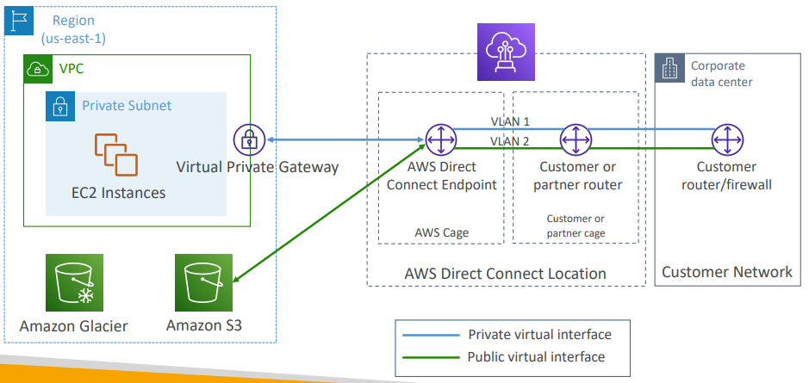

**Direct Connect Gateway**

• If you want to setup a Direct Connect to one or more VPC in many different regions (same account), you must use a Direct Connect Gateway

So we have an example where we have two regions, and they have two different VPC, we have two different CIDRs and we want to connect our on-premise data center into both VPC. So we're going to establish a Direct Connect connection, then using the private VIF, you're going to connect it to Direct Connect gateway. And this gateway will have a private virtual interface into a virtual private gateway in the first region and another one in the second region. So using the setup, we can start connecting to multiple VPCs and multiple regions.

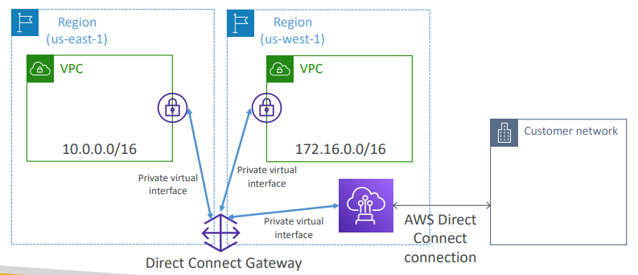

**Direct Connect – Connection Types**

* Dedicated Connections: 1Gbps,10 Gbps and 100 Gbps capacity
  + We get Physical ethernet port dedicated to a customer
  + First Request made to AWS first, then completed by AWS Direct Connect Partners
* Or we make a Hosted Connections with speeds of 50Mbps, 500 Mbps, to 10 Gbps
  + Connection requests are made via AWS Direct Connect Partners
  + Capacity can be added or removed on demand
  + We can get 1, 2, 5, 10 Gbps available at select AWS Direct Connect Partners
* And to set up either a dedicated or a hosted connection, Lead times are often longer than 1 month to establish a new connection

So in the exam, they will ask you questions around, hey we want you to transfer some data within a week and we want it to be fast. So an answer can not be Direct Connect because Direct Connect takes often more than one month to establish. So you need to look into question whether or not there's already a Direct Connect established, and whether or not the time to transmit the data is less or greater than one month.

**Direct Connect – Encryption**

|  |  |
| --- | --- |
| * Data in transit is not encrypted but is private * If you want encryption AWS Direct Connect + VPN provides an IPsec-encrypted private connection * Good for an extra level of security, but slightly more complex to put in place   So to set up is to get the Direct Connect location, but then on the connection, you're going to set up a VPN connection on top of it, to have encryption for your Direct Connect and therefore all the traffic between your corporate data sensor to AWS is going to be encrypted. |  |

**Direct Connect – Resiliency**

Now, one last thing that can come up in the exam, is around resiliency for Direct Connect. So we have two modes of resiliency and architectures and you need to know them both because they will be coming up at the exam. You have a high resiliency for critical workloads where we set up multiple Direct Connects. So we have two corporate data centers and we have two different Direct Connect location, and this gives us some redundancy. So in the first case, we have a private VIF here and we have a private VIF here. And so here we get one connection and multiple locations, and so if one of the Direct Connect location goes down, then at least we have some backup Direct Connect location somewhere else and so this gives us high resiliency, and this is good for critical workloads. But if you want to get to maximum resiliency for critical workloads and I emphasize the word maximum because it can come up in the exam, then you're going to have to set up again two Direct Connect locations, but this time each Direct Connect location will have two connections independence to give you maximum resiliency. So in this use case, we have four connections across two locations, sorry, going into AWS. And so a maximum resilience is achieved by using separate connections, terminating on separate devices in more than one location.

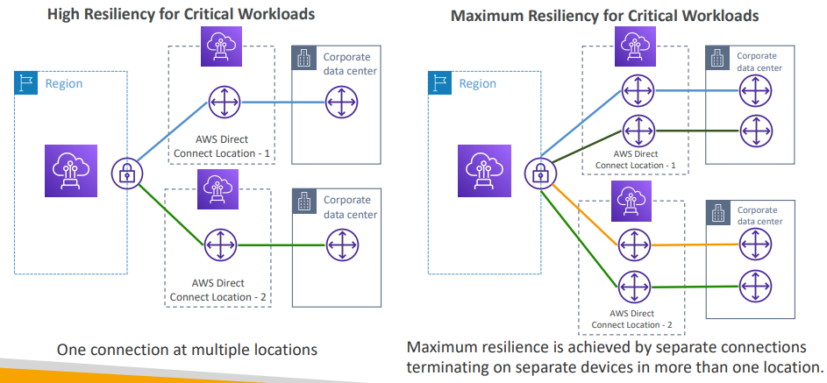

**Site-to-Site VPN connection as a backup**

• In case Direct Connect fails, you can set up a backup Direct Connect connection (expensive), or a Site-to-Site VPN connection

So the idea is that you have your corporate data center and it's connected to your VPC using Direct Connect. And that's your primary connection and it's expensive, but maybe sometimes you will have an issue with your Direct Connect connection, and of course, you do not want to have no internet connection into your VPC. Therefore, you can use a Direct Connect as a secondary connection, but that would be quite expensive. Or you can set up a site to site VPN connection as a backup connection and set it up so that if the primary connection fails, then it kicks in, and now you are connected through the public internet using site to site VPN, which can be a bit more reliable because the internet, public internet, may always be accessible, okay? So this is an architecture that can come up in the exam and I just wanted to show it to you once, so that you know what to expect.

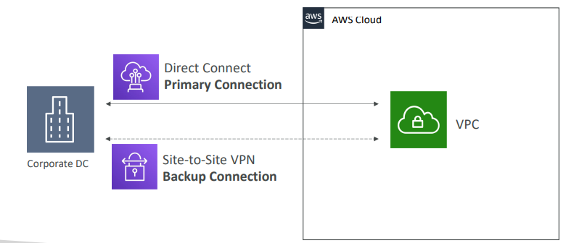

## Transit Gateway

Okay, so if we look at common network topologies in AWS it can become quite complicated. For example, you have many VPC and you want to peer them together, then you want to establish some VPN connections and direct connect, and then you have a direct connect gateway to connect to multiple VPC at a time, and this can become very, very complicated in terms of network topology.

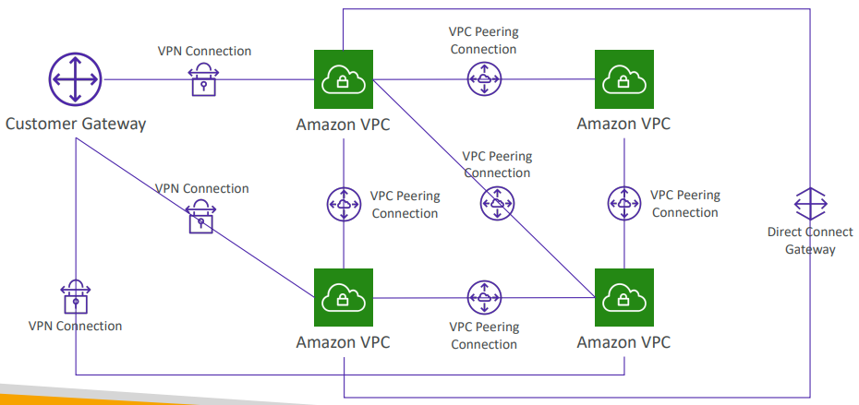

**Transit Gateway**

So, AWS came up with the transit gateway to solve that problem, and you're going to have a transitive peering connection between thousands of VPC, your on-premises data center, your site-to-site VPN, direct connects in a hub-and-spoke star connection. So let's have a diagram. We have transit gateway in the center and you can connect multiple VPCs through the transit gateway. So in this example, we don't need to peer the VPCs together, they are connected transitively through the transit gateway. So in this example, all the VPCs can talk to each other. But also, you can connect a direct connect gateway to the transit gateway, so it shows you have a direct connect connection directly in to many different VPC. Or if you are preferring site-to-site VPN and VPN connections, you can connect your customer gateway and your VPN connection into your transit gateway. Again, one more time, giving you access to all these VPC as part of the transit gateway.

|  |  |
| --- | --- |
| * For having transitive peering between thousands of VPC and on-premises, hub-and-spoke (star) connection * Regional resource, can work cross-region * Share cross-account using Resource Access Manager (RAM) * You can peer Transit Gateways across regions * Route Tables: limit which VPC can talk with other VPC * Works with Direct Connect Gateway, VPN connections * Supports IP Multicast (not supported by any other AWS service) |  |

**Transit Gateway: Site-to-Site VPN ECMP**

So, another use case for transit gateway is to increase the bandwidth of your site-to-site VPN connection using ECMP. So, it's quite technical but the question can come up in the exam.

So when you establish a site-to-site VPN connection there are actually two tunnels, one going forward and one going back. When you are connecting such a VPN into a VPC directly, both of these tunnels are used as part of one connections, but when using the transit gateway two tunnels can be used at a time, so this is why you see two lines in this diagram. But with transit gateway, you can have multiple site-to-site VPN so you can create a second site-to-site VPN attachment and into your transit gateway, so this creates four tunnels. And so, when you have four tunnels of site-to-site VPN, you are increasing the throughput of your connection which is something you cannot do if you were to connect your corporate data center directly into a VPC.

|  |  |
| --- | --- |
| * ECMP = Equal-cost multi-path routing * Routing strategy to allow to forward a packet over multiple best path * Use case: create multiple Siteto-Site VPN connections to increase the bandwidth of your connection to AWS |  |

**Transit Gateway: throughput with ECMP**

So, if you do a VPN to a virtual private gateway, you get one tunnel, in fact one connection into one VPC, and this connection gives you 1.5 Gbps as the maximum throughput, and you are limited. And in this case, a VPN connection is made of two tunnels. But if you are using a VPN into a transit gateway, you get one site-to-site VPN into many VPC because they're all connected transitively to the same transit gateway. And also, one site-to-site VPN connection gives you 2.5 Gbps thanks to ECMP, because the two tunnels are going to be used through that strategy. But also, you can add more site-to-site VPN connections into transit gateway, for example two or three, to double or triple your throughputs through ECMP. So this is an exam question you need to know. Obviously when you do the setup, you're going to have to pay for each GB of data going through the transit gateway, so there's an added cost to this performance optimization.

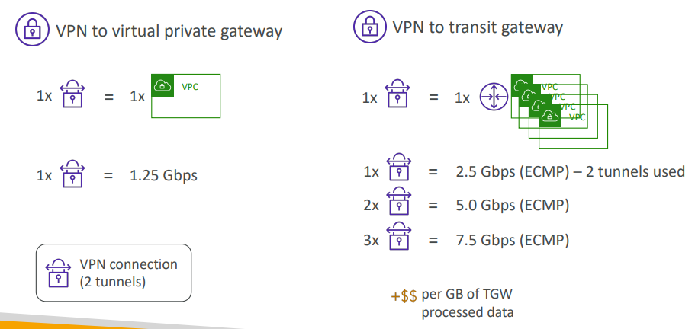

**Transit Gateway – Share Direct Connect between multiple accounts**

Finally, you can share your direct connect connection between multiple accounts, again, using the transit gateway. How do we do this? Well, we're going to establish a direct connect connection between your corporate data center and a direct connect location, and then we're going to set up a transit gateway into both VPCs in two different accounts, okay? So this is something we can do with the transit gateway. And then, we connect the direct connect location into direct connect gateway and connect that gateway into the transit gateway. And what this just allowed us to do is to share a direct connect connection between multiple accounts and multiple VPC, which is very handy thanks to the transit gateway. Okay? So all these sort of architectures can come up in the exam so make sure you're familiar with understanding how they work, and that's it for me,

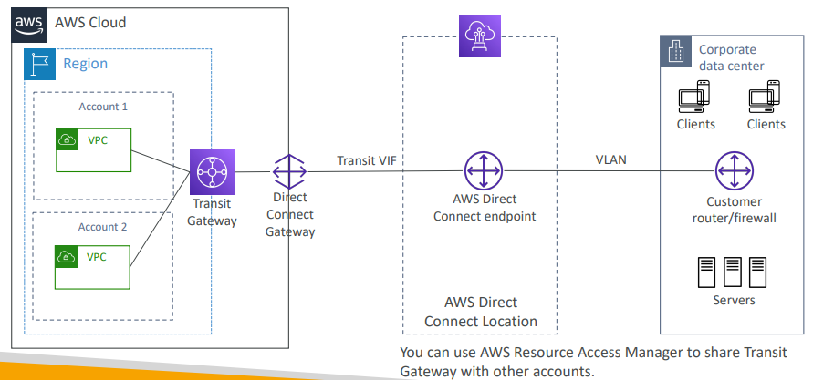

## VPC –Traffic Mirroring

So we have an EC2 instance and we have an Elastic Network Interface, so an ENI attached to it and works really well. Our EC2 instance is accessing the internet and is being accessed. And so we get a lot of inbound and outbound traffic on the ENI to the EC2 instance. But we wanted to analyze our traffic. So to do so we're going to set up a Load Balancer and behind this Network Load Balancer, we're going to have an auto scaling group of EC2 instances that will have some security software on it. Now we want to be able to capture all the traffic from Source A without disrupting the functioning of Source A. So to do so, we're going to set up a VPC traffic mirroring, and optionally, we can have a filter, if you want you to get just some information, not everything. And with this traffic mirroring feature, all the traffic sent to the ENI or Source A is also going to be sent to our Network Load Balancer. So our Source A, our EC2 instance is still working fine. It still doesn't know what's happening, but on top of it, the traffic is being mirrored. So hence the name, Traffic Mirroring, into our Network Load Balancer. And from there, we can analyze the traffic itself. And this applies not just to one source, but to multiple sources. So if you had a second EC2 instance with another ENI, yet again, we can mirror the traffic into our Network Load Balancer. So how does that work? We need to have the source and the targets to be in the same VPC, or it could be across different VPC, and if we have enabled VPC Peering. So the use cases for VPC traffic mirroring is going to be around content inspection, threat monitoring, or troubleshooting from a networking perspective, okay. It's very hard to demonstrate this in a demo, but this diagram should be enough.

|  |  |
| --- | --- |
| * Allows you to capture and inspect network traffic in your VPC in a non-intrusive manner. * To do so we need to route the traffic to security appliances that you manage * For this we need to capture the traffic   + From (Source) –Have to defines source ENIs   + To (Targets) – an ENI or a Network Load Balancer * Capture all packets or capture the packets of your interest (optionally, truncate packets) * Source and Target can be in the same VPC or different VPCs (VPC Peering) * Use cases: content inspection, threat monitoring, troubleshooting, … |  |

## IPV6

**What is IPv6?**

* IPv4 designed to provide 4.3 Billion addresses (they’ll be exhausted soon)
* IPv6 is the successor of IPv4
* IPv6 is designed to provide 3.4 × 10^38 unique IP addresses
* Every IPv6 address in AWS is public and Internet-routable (no private range)
* Format 🡪 x.x.x.x.x.x.x.x (x is hexadecimal, range can be from 0000 to ffff)
* Examples:
  + 2001:db8:3333:4444:5555:6666:7777:8888
  + 2001:db8:3333:4444:cccc:dddd:eeee:ffff
  + :: 🡪 all 8 segments are zero
  + 2001:db8:: 🡪 the last 6 segments are zero
  + ::1234:5678 🡪 the first 6 segments are zero
  + 2001:db8::1234:5678 🡪 the middle 4 segments are zero

**IPv6 in VPC**

|  |  |
| --- | --- |
| * IPv4 cannot be disabled for your VPC and subnets * You can enable IPv6 (they’re public IP addresses) to operate in dual-stack mode * Your EC2 instances will get at least a private internal IPv4 and a public IPv6 * They can communicate using either IPv4 or IPv6 to the internet through an Internet Gateway |  |

**IPv6 Troubleshooting**

|  |  |
| --- | --- |
| * IPv4 cannot be disabled for your VPC and subnets * So, if you cannot launch an EC2 instance in your subnet * It’s not because it cannot acquire an IPv6 (the space is very large) * It’s because there are no available IPv4 in your subnet * Solution: create a new IPv4 CIDR in your subnet |  |

**Hands On**

So we're just going to practice with IPv6. And so we have our VPC here and we have our demo VPC. And so to enable IPv6 report, we need to add an IPv6 CIDR range. So let's go right click on this. And then we edit the CIDRs. And then I'm going to add a new IPv6 CIDR range. So now we can either use an Amazon-provided CIDR block or a CIDR provided by me. So I will use one generated by AWS and then we'll have one that is advertised as a group of eu-central-1. So let's select the CIDR and here we go, it is associated and here is my IPv6 CIDR. So next, let me go to my subnets and I will take my public subnet A, action, and then I will edit the IPv6 CIDRs. So as you can see, I need to assign an IPv6 CIDR with my subnet. So I will just use 00 just to be easy and click on save. So here is an IPv6 CIDR with my subnets. And then I can edit these subnet settings to allow auto assign IPv6 address. So I'll just do for one subnet and I'll do it for all of them obviously, but you can assign IPv6 addresses for any of these subnets. So next, if I go to my EC2 instances, I can right click on this one, go to networking and then manage IP addresses. So currently the interface eth0 does not have an IPv6 address but we can assign a new IPv6 address which is going to be auto assigned. And then I click on save, confirm. And if you look at my BastionHost now, it has an IPv6 address. And so if we had an IPv6 address on our machine and we edited the security group of this instance to allow not just 0.0.0/0 which is the IPv4 range but also we add the IPv6 range CIDR. So if we go into the security group right here and then edit the inbound rules, and then we add SSH but this time from anywhere IPv6. Then we can do an SSH into our BastionHost directly using the IPv6 address provided at our own computer, of course has an IPv6 address. And IPv6 addresses are not necessarily like common for your internet providers. So there is a website called Test-IPv6 and it will run some tests. And then it turns out that's if you have an IPv6, it will appear right here. And so you have IPv6 address and you can access the EC2 instance. But if you don't have an IPv6, then don't worry, you cannot do anything about it. You just need to wait for your internet provider to be upgraded to the IPv6 scheme. So this is cool because now I have one. And so if I wanted to, I could connect EC2 instance using IPv6. So the one last thing I want to show you is around the route tables. So if we have a look at the public route table, for example, and look at the routes, as you can see, there has been a rule added into my route table which is saying that anything that is using this CIDR of IPv6 should be local. So that means that my EC2 instances, if they have IPv6 addresses can communicate with each other using their IPv6 address. And if in the CIDR, then all the traffic is going to remain local. It's not gonna go through the public internet. So that's it for IPv6. I hope you liked it. And also one last thing to notice, excuse me, is that in your subnet, as we can see, there are 248 IPv4 addresses left. So even though I have many, many IPv6 available in my subnet, if I go and use all the IPv4 addresses in my subnet, then I would need to assign a new CIDR block to my subnet to be able to keep on creating EC2 instances within it because each EC2 instance will no matter what have an IPv4 address.

## Egress-only Internet Gateway

|  |  |
| --- | --- |
| * Used for IPv6 only * (similar to a NAT Gateway but for IPv6) * Allows instances in your VPC outbound connections over IPv6 while preventing the internet to initiate an IPv6 connection to your instances * To do so must update the Route Tables   We have the internet, our VPC with a public subnet or private subnet. And so this EC2 instance can access the internet through the internet gateway and can also have the internet initiate a connection to the instance using IPv6, because it's connected to the internet gateway and it's in the public subnet. Now we don't want that. What we want is just outbound connections. So let's consider an EC2 instance in a private subnet, so it doesn't have an internet gateway, that makes the subnet private. And we're going to create an egress-only internet gateway. So what's going to happen is that now the EC2 instance in the private subnet will be able to access the internet over IPv6 through the egress-only internet gateway, but the internet will not be able to initiate a connection from the internet to the EC2 instance. |  |

**IPv6 Routing**

So to summarize, here is a diagram of how IPv6 routing works. So let's consider a VPC with IPv6. We have a public subnet, we have a private subnet, so they both have IPv4 and IPv6 obviously in them. And so again, if we consider a web server accessing the internet, it can do it over IPv4 and IPv6 through an internet gateway. And so the route table for your public subnet is going to have the first line to be local for the local IPv4 and the local IPv6 traffic. Okay, these are within the CIDRs of your subnets or your VPC, and then anything else, so 0.0.0/0, this is the everything IPv4, and the ::/0 is the everything IPv6, go through the internet gateway, which allows your web server to access the internet. So this should make sense. And this is how we enable IPv6 and IPv4 both ways in a public subnet.

But if you consider a private subnet, your server again has a private IPv4 and also an IPv6. And so how do we make sure that this server can access the internet, but not be accessed? Well, you know already that for IPv4 we need to use a NAT gateway. So the server connects to the NAT gateway, okay, and the NAT gateway then connects to the internet gateway and then accesses the internet over IPv4. And for IPv6, we know we need to use an egress-only internet gateway. So IPv6, the server connects to the egress-only internet gateway to the internet over IPv6. Now your route table looks a little bit different. Again, the first two lines are the same, but then your NAT gateway ID is a target for 0.0.0.0/0. So this is all IPs' IPv4. And then the fourth line is ::/0, which represents a target to the egress-only internet gateway, because this is a target for the IPv6 type of traffic, okay?

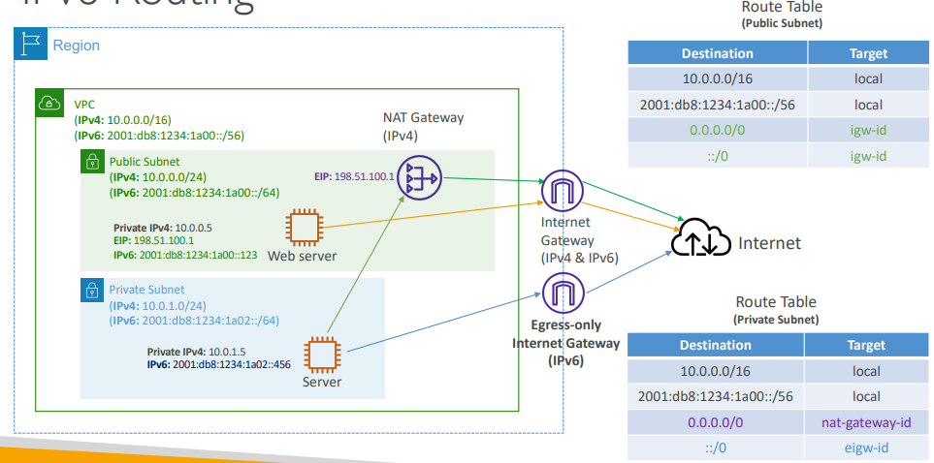

**Hands On**

So I am in my VPC and on the left-hand side of Egress Only Internet Gateways. Now I can create one, and I'll call it DemoEIGW. And then we need to attach it to your VPC. So my DemoVPC. And then create this egress only internet gateway. So it's created and attached already. So this is good. But now just to make it work, well, we need to go ahead and edit a route table. So let's go in here. It needs to be for the private sub-net, okay? It doesn't make sense for the public subnets. So for the private subnets. Let's go and edit the route table for the private subnets, and edit these routes. And we're going to say that's.. Yeah, You know what? Anything that is going to be ::/0. So any IPv6, please be redirected to the egress only internet gateway. Save the changes. And now, all good. My easy two instances in my private subnets can access the internet over IPv6 but are not reachable. Super easy demo, but I hope you liked it.

## Clean UP

Done a lot in this section. And we created a lot of things that can cost us a lot of money if we leave them running. So, first of all, for the easy two instances, make sure to terminate them or to stop them. I will stop them because I may need to get back to them for more demos, obviously, but you, I would recommend on terminating everything. Okay. Other things that can cost you money are going to be around your VBC. So let's have a look at what is created. So we cannot do the PC right away. We would need to delete the subnets and delete the first route table. There's an internet gateway. We need to detach and deletes the egress only internet gateway. Again, we can delete it and detach it. Elastic IPS is a very, very, very important. So we did create an elastic IP that was attached. Remember to our net gateway. Okay. That gateway ID. So it's attached to it. So once you delete the nugget way ID, please make sure to also remove the elastic IP. We did create some VPC endpoints. So remember to delete these end points because they can cost you money over time. They're definitely, there's a per hour fee. We didn't create any infant services in the end nugget way. Again, we can delete it and then release the elastic IP, and then any peering connection, you can delete it as well. Before you can remove that VBC altogether network is yells again, make sure you remove the knuckles if need be, but they won't cost you any money. And the rest is good. So please make sure to delete and clean everything up. Otherwise you may have a funky surprising in the end of the month. And again, the best way for you to really look at your bill in AWS is to go to your billing dashboard, look at the bill. So as you can see how there's some bill from me over the virtual private cloud. Okay. And so to just address that bill, when they need to do is go to bills, go to my month. And then in here I'm able to see, Hey, there is elastic compute cloud has been working and cost me one point 25. So the net gateway is actually going to cost me, cost me $1 and 25 already. So it's good to know. And then if I scroll down a route with you, three did cost me 70. Of course. So again, I forgot, but going to route with the three and delete that hosted zone. This is costing you 50 cents per month. Do you have the hosted zone? And then for your VPC, let's have a look at what costs. So the VPC reach ability analyzer did cost me some money as well. Okay. So that's it for this lecture. I hope you liked it. And I will see you in the next lecture.

## VPC Section Summary

* CIDR – IP Range
* VPC – Virtual Private Cloud => we define a list of IPv4 & IPv6 CIDR
* Subnets – tied to an AZ, we define a CIDR
* Internet Gateway – at the VPC level, provide IPv4 & IPv6 Internet Access
* Route Tables – must be edited to add routes from subnets to the IGW, VPC Peering Connections, VPC Endpoints, …
* Bastion Host – public EC2 instance to SSH into, that has SSH connectivity to EC2 instances in private subnets
* NAT Instances – gives Internet access to EC2 instances in private subnets. Old, must be setup in a public subnet, disable Source / Destination check flag
* NAT Gateway – managed by AWS, provides scalable Internet access to private EC2 instances, when the target is an IPv4 address

**VPC Section Summary (2/3)**

* NACL – stateless, subnet rules for inbound and outbound, don’t forget Ephemeral Ports
* Security Groups – stateful, operate at the EC2 instance level
* VPC Peering – connect two VPCs with non overlapping CIDR, non-transitive
* VPC Endpoints – provide private access to AWS Services (S3, DynamoDB, CloudFormation, SSM) within a VPC
* VPC Flow Logs – can be setup at the VPC / Subnet / ENI Level, for ACCEPT and REJECT traffic, helps identifying attacks, analyze using Athena or CloudWatch Logs Insights
* Site-to-Site VPN – setup a Customer Gateway on DC, a Virtual Private Gateway on VPC, and site-to-site VPN over public Internet
* AWS VPN CloudHub – hub-and-spoke VPN model to connect your sites

**VPC Section Summary (3/3)**

* Direct Connect – setup a Virtual Private Gateway on VPC, and establish a direct private connection to an AWS Direct Connect Location
* Direct Connect Gateway – setup a Direct Connect to many VPCs in different AWS regions
* AWS PrivateLink / VPC Endpoint Services:
* Connect services privately from your service VPC to customers VPC
* Doesn’t need VPC Peering, public Internet, NAT Gateway, Route Tables
* Must be used with Network Load Balancer & ENI
* ClassicLink – connect EC2-Classic EC2 instances privately to your VPC
* Transit Gateway – transitive peering connections for VPC, VPN & DX
* Traffic Mirroring – copy network traffic from ENIs for further analysis
* Egress-only Internet Gateway – like a NAT Gateway, but for IPv6 targets

## Network Costs

**Networking Costs in AWS per GB – Simplified**

* Use Private IP instead of Public IP for good savings and better network performance

So now let's talk about networking cost in AWS per gigabyte. And this is a simplified version to make things as easy as possible and to explain to you a few important concepts. Now, networking costs enables can get very complicated, but here is a high-level overview and that should helps you going into the exam. So we have a region and I've drawn two availability zones in this region. Let's assume we have an EC2 instance in the first AZ. And so the first thing you should know is that any traffic going into your EC2 instances is going to be free. So any incoming traffic onto EC2 is free. Now let's assume we have a second EC2 instance and it is in the same availability zone, then in that case, because an availability zone represents a set of multiple data centers that are geographically located within one another, then any traffic between your two EC2 instances will be free assuming that there are using their private IP to communicate, by using the private IP they will go over the network that they are connected with. So this is great. So far everything is free. But now that's include an EC2 instance in another AZ. And this time we want you have these two EC2 instances across two different AZ within the same region to communicate with one another. One approach would be to use a public IP or an elastic IP. And if we do so, we're going to pay 2 cents per gigabytes if using a public IP or elastic IP. Why? Well, because the traffic has to leave via AWS network and go back in for our two instances to communicate and so AWS will charge us for that. Instead, if we are using a private IP, then we're going to be charge half as less, because we're now using the internal AWS network to link between these two availability zones. So a takeaway here is that if you want to make your instances communicate one, faster and two, at a lesser price, then use as much as possible the private IP versus using the public IP.

* Use same AZ for maximum savings (at the cost of high availability)

Next, let's consider another region with another availability zone. In which case the traffic to go from one region to another is going to be $0.02 on the gigabytes. So that means that the entire region traffic can be quite expensive. So what do we get as a takeaway from this very simplified slide? The first thing is that you should use a private IP instead of a public IP, if you want to have good savings, okay, and better network performance, because you will automatically be onto the private network. So one reason is do not use the public IP to communicate between two instances in the same region into AZ. The second thing is that if you have a cluster that does some computation and does require a lot of communication between your EC2 instances from one another, then you may want to use the same availability zones for a maximum amount of savings, okay? That obviously these cost savings come at a cost and the cost is that you're not highly available anymore. That means that if your AZ goes down, then you don't have any fell over available. So here you have to balance between the high availability and cost. And based on the question you will be ask in the exam, you have to choose the right balance.

So typical example of that would be, hey, we have an RDS database and we want you to create a read replica and do some analytics on top of this read replica. How do we create a read replica for the cheapest amount of money? Well, if you create that read replica in the same AZ, then you're not going to be charged anything to replicate the one database to another in terms of network costs. But if you create that read replica in another AZ, then you're going to pay 1 cents per gigabyte of data transfer between the two databases.

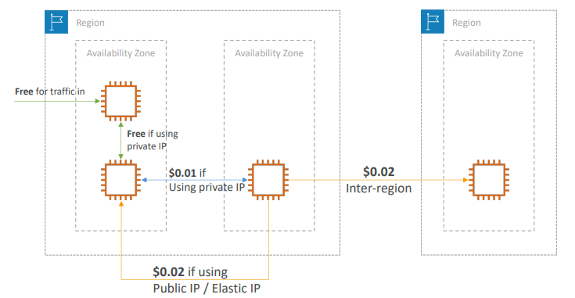

**Minimizing egress traffic network cost**

• Egress traffic: outbound traffic (from AWS to outside)

• Ingress traffic: inbound traffic - from outside to AWS (typically free)

• Try to keep as much internet traffic within AWS to minimize costs

• Direct Connect location that are co-located in the same AWS Region result in lower cost for egress network

So now let's talk about how we can optimize our networking costs by making some smart architectural decisions. So egress traffic is outbound traffic. That means from AWS to the outside. An ingress traffic is inbound traffic. That means from the outside to AWS which is typically free. So sending data to AWS is usually free, but taking data outside of AWS, you have to pay. So your goal is going to be to try to keep as much internet traffic as possible within AWS to minimize the costs. So let's say we have a database and then we have a user in a corporate data center and we run an application in our corporate data center. That application is doing a query to the database and retrieving 100 megabytes of data from the database. And then it will do some aggregation, some computations and then finally, returned the query results, only 50 kilobytes to the user. In that case, the egress traffic is going to be really, really high. And the cost associated with it as well is going to be really high. Because we took 100 megabytes of data from AWS and we took it into our corporate data center, maybe over the internet, right? But if we make a smart choice, we could move our application directly into the AWS cloud on an EC2 instance. In this case, if we're very smart and we keep the data within the same availability zone, then the DB query data transfer is going to be free. And so 100 megabytes will not be built at all for accounts. And then the query results themselves of only 50 kilobytes will be sent to us and it will be a much cheaper cost. And in this case, the egress cost is minimized.

Another thing you need to know to minimize egress traffic network costs is that if you're using Direct Connect, you need to choose a Direct Connect location that is co-located in the same AWS region to result in the lower cost for egress network.

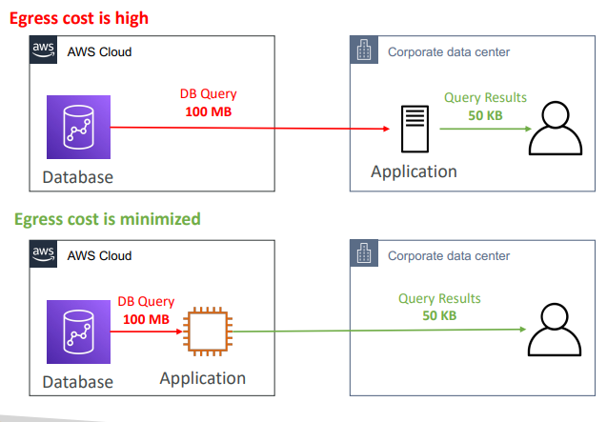

**S3 Data Transfer Pricing – Analysis for USA**

Okay. What about S3 data transfer pricing? Let's do an analysis for the USA. So we have an S3 bucket and any data going into the S3 bucket is going to be free, because this is ingress traffic. But if we download the data from Amazon S3 to our computers through the internet, then we're going to pay an egress traffic cost of 9 cents per gigabytes. This is represented right here. If we want to use S3 transfer acceleration to get faster transfer times from 50 to 500% better, then we're going to get an additional cost on top of the data transfer pricing, which is going to be anywhere between 4 cents to 8 cents per gigabytes. So using transfer acceleration has a cost. Now S3 to CloudFront is going to be free traffic. So if you set up a CloudFront distribution on top of your S3 bucket, any data transfer that happens between S3 and CloudFront is free. But from CloudFront to the internet is going to cost you 8.50 cents per gigabyte, which is slightly cheaper than Amazon S3. On top of it, you're going to get caching capabilities. So lower latency for the access of the data and the reduced cost is going to be also whenever you have requests being made. So when someone makes a request to your S3 bucket, you're going to pay for that requests, but a request made into Amazon CloudFront is much cheaper. It is seven times cheaper. So you're going to save a lot of money by using CloudFront

And then finally, if you do a Cross Region Replication for your Amazon S3 buckets, then you're going to pay 2 cents per gigabyte for it, okay? So the numbers can change over time and this is for the USA and it can change for your region, but what you need to remember is that using some services have an added cost and it's important for you to know how these costs relates to one another.

|  |  |
| --- | --- |
| * S3 ingress: free * S3 to Internet: $0.09 per GB * S3 Transfer Acceleration:   + Faster transfer times (50 to 500% better)   + Additional cost on top of Data Transfer   + Pricing: +$0.04 to $0.08 per GB * S3 to CloudFront: $0.00 per GB * CloudFront to Internet: $0.085 per GB (slightly cheaper than S3)   + Caching capability (lower latency)   + Reduce costs associated with S3 Requests Pricing (7x cheaper with CloudFront) * S3 Cross Region Replication: $0.02 per GB |  |

**Pricing: NAT Gateway vs Gateway VPC Endpoint**

Another analysis of cost is to use a NAT Gateway versus a Gateway VPC Endpoint. So we have a VPC in the region and we have two private subnets with two different types of EC2 instances. And they both want to access data into an Amazon S3 bucket. So one way to do so is to use the public internet and so to do so, we set up a public subnets, which has a NAT Gateway. For the subnet to be public, we need to have a route into an Internet Gateway. And so we're going to establish a route using the route table. And then we have a direct connectivity from the EC2 instance through the NAT Gateway and through the Internet Gateway into the internet. Then from the internet, we access the data in your Amazon S3 buckets. And so the cost associated with this is $0.045 per hour for your NAT Gateway, $0.045 per gigabytes of data process through your NAT Gateway and then $0.09 per hour for data transfer out to S3 cross-region or $0 if it's same region, okay? But if we were to set up a VPC Endpoints, okay, to access our data into our Amazon S3 bucket privately, then we set up a different route table. So in this case, to access the VPC Endpoint we just set up a route to it. And so the data flows directly from the private subnets into the VPC Endpoints and the S3 buckets. And we have no cost for using Gateway Endpoint and we pay 1 cent per gigabytes of data transferred in and out of your S3 bucket for the same region. So this can be a significantly lower cost to use a VPC Endpoint instead of your NAT Gateway. And this is again, something that the exam can test you on.

**Bottom of Form**

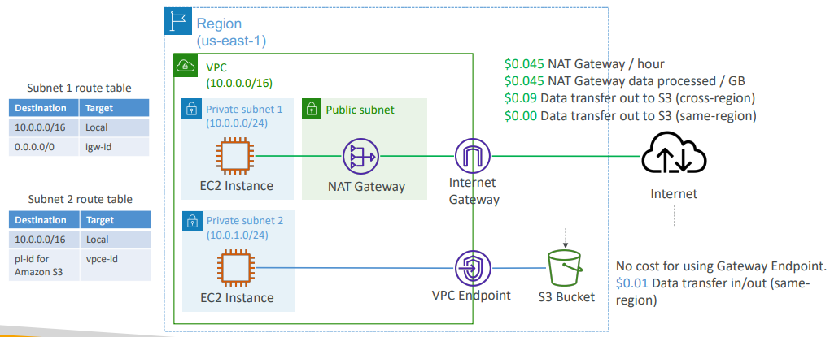

**Network Protection on AWS**

* To protect network on AWS, we’ve seen
  + Network Access Control Lists (NACLs)
  + Amazon VPC security groups
  + AWS WAF (protect against malicious requests)
  + AWS Shield & AWS Shield Advanced
  + AWS Firewall Manager (to manage them across accounts)
* But what if we want to protect in a sophisticated way our entire VPC?

**AWS Network Firewall**

|  |  |
| --- | --- |
| * Protect your entire Amazon VPC * From Layer 3 to Layer 7 protection * Any direction, you can inspect   + VPC to VPC traffic   + Outbound to internet   + Inbound from internet   + To / from Direct Connect & Site-to-Site VPN * Internally, the AWS Network Firewall uses the AWS Gateway Load Balancer * Rules can be centrally managed cross- account by AWS Firewall Manager to apply to many VPCs |  |

**Network Firewall – Fine Grained Controls**

* Supports 1000s of rules
  + IP & port - example: 10,000s of IPs filtering
  + Protocol – example: block the SMB protocol for outbound communications
  + Stateful domain list rule groups: only allow outbound traffic to *.mycorp.com or third-party software repo
  + General pattern matching using regex
* Traffic filtering: Allow, drop, or alert for the traffic that matches the rules
* Active flow inspection to protect against network threats with intrusionprevention capabilities (like Gateway Load Balancer, but all managed by AWS)
* Send logs of rule matches to Amazon S3, CloudWatch Logs, Kinesis Data Firehose

## Questions

**Top of Form**

**What does this CIDR 10.0.4.0/28 correspond to?**

* **10.0.4.0 to 10.0.4.15**
* **10.0.4.0 to 10.0.32.0**
* **10.0.4.0 to 10.0.4.28**
* **10.0.0.0 to 10.0.16.0**

Ans A correct /28 means 16 IPs (=2^(32-28) = 2^4), means only the last digit can change.

**Top of Form**

**You have a corporate network of size 10.0.0.0/8 and a satellite office of size 192.168.0.0/16. Which CIDR is acceptable for your AWS VPC if you plan on connecting your networks later on?**

* **172.16.0.0/12**
* **172.16.0.0/16**
* **10.0.16.0/16**
* **192.168.4.0/18**

**Bottom of Form**

Ans B Correct CIDR not should overlap, and the max CIDR size in AWS is /16.

**Top of Form**

**You plan on creating a subnet and want it to have at least capacity for 28 EC2 instances. What's the minimum size you need to have for your subnet?**

* **/28**
* **/27**
* **/26**
* **/25**

**Bottom of Form**

Ans A Too small, it's 16 IPs, 5 of them already reserved by AWS.

B Too small, it's 32 IPs, 5 of them already reserved by AWS.

C Perfect size, 64 IPs.

D Too big, it's 128 IPs.

**Top of Form**

**Security Groups operate at the ................. level while NACLs operate at the ................. level.**

* **EC2 instance, Subnet**
* **Subnet, EC2 instance**

**Bottom of Form**

Ans A Correct

**Top of Form**

**You have attached an Internet Gateway to your VPC, but your EC2 instances still don't have access to the internet. What is NOT a possible issue?**

* **Route Tables are missing entries**
* **The EC2 instances don't have public IPs**
* **The Security Group does not allow traffic in**
* **The NACL does not allow network traffic out**

**Bottom of Form**

Ans C Correct Security groups are stateful and if traffic can go out, then it can go back in.

**Top of Form**

**You would like to provide Internet access to your EC2 instances in private subnets with IPv4 while making sure this solution requires the least amount of administration and scales seamlessly. What should you use?**

* **NAT Instances with Source/Destination Check flag off**
* **Egress Only Internet Gateway**
* **NAT Gateway**

**Bottom of Form**

Ans A This means creating a NAT EC2 Instance and although this would work, it would require some integration and would not scale seamlessly.

B This is for IPv6 only.

C Correct

**Top of Form**

**VPC Peering has been enabled between VPC A and VPC B, and the route tables have been updated for VPC A. But, the EC2 instances cannot communicate. What is the likely issue?**

* **Check the NACL**
* **Check the Route Tables in VPC B**
* **Check the EC2 instance attached Security Groups**
* **Check if DNS Resolution is enabled**

Ans B Route tables must be updated in both VPCs that are peered.

**CCcBottom of Form**

**Top of Form**

**You have set up a Direct Connect connection between your corporate data center and your VPC A in your AWS account. You need to access VPC B in another AWS region from your corporate datacenter as well. What should you do?**

* **Enable VPC Peering**
* **Use a Customer Gateway**
* **Use a Direct Connect Gateway**
* **Set up a NAT Gateway**

**Bottom of Form**

Ans A You can't create a VPC Peering connection between VPC and on-premises corporate data center. Also, the VPC Peering connection is not transitive.

C Correct This is the main use case of Direct Connect Gateways.

**Top of Form**

**When using VPC Endpoints, what are the only two AWS services that have a Gateway Endpoint available?**

* **Amazon S3 & Amazon SQS**
* **Amazon SQS & DynamoDB**
* **Amazon S3 & DynamoDB**

**Bottom of Form**

Ans C correct These two services have a VPC Gateway Endpoint (remember it), all the other ones have an Interface endpoint (powered by Private Link - means a private IP).

**Top of Form**

**AWS reserves 5 IP addresses each time you create a new subnet in a VPC. When you create a subnet with CIDR 10.0.0.0/24, the following IP addresses are reserved, EXCEPT ....................**

* **10.0.0.1**
* **10.0.0.2**
* **10.0.0.3**
* **10.0.0.4**

**Bottom of Form**

Ans D correct

**Top of Form**

**You have 3 VPCs A, B, and C. You want to establish a VPC Peering connection between all the 3 VPCs. What should you do?**

* **As VPC Peering supports Transitive Peering, so you need to establish 2 VPC Peering connections (A-B, B-C)**
* **Establish 3 VPC Peering connections (A-B, A-C, B-C)**

Ans B Correct**Bottom of Form**

**Top of Form**

**How can you capture information about IP traffic inside your VPCs?**

* **Enable VPC Flow Logs**
* **Enable VPC Traffic Mirroring**
* **Enable CloudWatch Traffic Logs**

**Bottom of Form**

Ans A correct VPC Flow Logs is a VPC feature that enables you to capture information about the IP traffic going to and from network interfaces in your VPC.

B VPC Traffic Mirroring is a VPC feature that you can use to copy network traffic from an Elastic Network Interface (ENI). Use cases include content inspection, threat monitoring, and troubleshooting.

C There's no such feature.

**Top of Form**

**If you want a 500 Mbps Direct Connect connection between your corporate datacenter to AWS, you would choose a .................. connection.**

* **Dedicated**
* **Hosted**

Ans A A Dedicated Direct Connect connection supports 1Gbps and 10Gbps.

B Correct Hosted Direct Connect connection supports 50Mbps, 500Mbps, up to 10Gbps.

**Top of Form**

**When you set up an AWS Site-to-Site VPN connection between your corporate on-premises datacenter and VPCs in AWS Cloud, what are the two major components you want to configure for this connection?**

* **Customer Gateway and NAT Gateway**
* **Internet Gateway and Customer Gateway**
* **Virtual Private Gateway and Internet Gateway**
* **Virtual Private Gateway and Customer Gateway**

**Bottom of Form**

Ans D correct

**Top of Form**

**Your company has several on-premises sites across the USA. These sites are currently linked using private connections, but your private connections provider has been recently quite unstable, making your IT architecture partially offline. You would like to create a backup connection that will use the public Internet to link your on-premises sites, that you can failover in case of issues with your provider. What do you recommend?**

* **VPC Peering**
* **AWS VPN CloudHub**
* **Direct Connect**
* **AWS PrivateLink**

**Bottom of Form**

Ans A VPC Peering connection is a networking connection between two VPCs that enables you to route traffic between them using private IPv4/IPv6 addresses. It can't be used with on-premises networks.

B Correct AWS VPN CloudHub allows you to securely communicate with multiple sites using AWS VPN. It operates on a simple hub-and-spoke model that you can use with or without a VPC.

C AWS Direct Connect allows you to establish a dedicated network connection between AWS and your on-premises. This would work, but it will be very expensive. This is a private connection and the question states that the backup connection can use the public Internet.

**Top of Form**

**You need to set up a dedicated connection between your on-premises corporate datacenter and AWS Cloud. This connection must be private, consistent, and traffic must not travel through the Internet. Which AWS service should you use?**

* **Site-to-Site VPN**
* **AWS PrivateLink**
* **AWS Direct Connect**
* **Amazon EventBridge**

**Bottom of Form**

Ans A This would not be suitable, as traffic travels through the public Internet.

C correct

**Top of Form**

**Using a Direct Connect connection, you can access both public and private AWS resources.**

* **True**
* **False**

**Bottom of Form**

Ans A Correct

**Top of Form**

**You want to scale up an AWS Site-to-Site VPN connection throughput, established between your on-premises data and AWS Cloud, beyond a single IPsec tunnel's maximum limit of 1.25 Gbps. What should you do?**

* **Use 2 Virtual Private Gateways**
* **Use Direct Connect Gateway**
* **Use Transit Gateway**

**Bottom of Form**

Ans C Correct

**Top of Form**

**You have a VPC in your AWS account that runs in a dual-stack mode. You are continuously trying to launch an EC2 instance, but it fails. After further investigation, you have found that you are no longer have IPv4 addresses available. What should you do?**

* **Modify your VPC to run in IPv6 mode only**
* **Modify your VPC to run in IPv4 mode only**
* **Add an additional IPv4 CIDR to your VPC**

**Bottom of Form**

Ans C correct

**Top of Form**

**A web application backend is hosted on EC2 instances in private subnets fronted by an Application Load Balancer in public subnets. There is a requirement to give some of the developers access to the backend EC2 instances but without exposing the backend EC2 instances to the Internet. You have created a bastion host EC2 instance in the public subnet and configured the backend EC2 instances Security Group to allow traffic from the bastion host. Which of the following is the best configuration for bastion host Security Group to make it secure?**

* **Allow traffic only on port 80 from the company’s public CIDR**
* **Allow traffic only on port 22 from the company’s public CIDR**
* **Allow traffic only on port 22 from the company’s private CIDR**
* **Allow traffic only on port 80 from the company’s private CIDR**

**Bottom of Form**

Ans B correct

**Top of Form**

**A company has set up a Direct Connect connection between their corporate data center to AWS. There is a requirement to prepare a cost-effective secure backup connection in case there are issues with this Direct Connect connection. What is the most cost effective and secure solution you recommend?**

* **Setup another Direct Connect connection to the same AWS region**
* **Setup another Direct Connect connection to a different AWS region**
* **Setup a Site-to-Site VPN connection as a backupBottom of Form**

Ans C Correct

**Top of Form**

**Which AWS service allows you to protect and control traffic in your VPC from layer 3 to layer 7?**

* **AWS Network Firewall**
* **Amazon Guard Duty**
* **Amazon Inspector**
* **Amazon Shield**

**Bottom of Form**

Ans A correct

**Top of Form**

**A web application hosted on a fleet of EC2 instances managed by an Auto Scaling Group. You are exposing this application through an Application Load Balancer. Both the EC2 instances and the ALB are deployed on a VPC with the following CIDR 192.168.0.0/18. How do you configure the EC2 instances' security group to ensure only the ALB can access them on port 80?**

* **Add an Inbound Rule with port 80 and 0.0.0.0/0 as the source**
* **Add an Inbound Rule with port 80 and 192.168.0.0/18 as the source**
* **Add an Inbound Rule with port 80 and ALB's Security Group as the source**
* **Load an SSL certificate on the ALB**

**Bottom of Form**

Ans C Correct This is the most secure way of ensuring only the ALB can access the EC2 instances. Referencing by security groups in rules is an extremely powerful rule and many questions at the exam rely on it. Make sure you fully master the concepts behind it!**Bottom of Form**

# Disaster Recovery & Migrations

* Any event that has a negative impact on a company’s business continuity or finances is a disaster
* Disaster recovery (DR) is about preparing for and recovering from a disaster
* What kind of disaster recovery?
  + On-premise to On-premise🡪 traditional DR, and very expensive
  + On-premise to AWS Cloud🡪 hybrid recovery
  + AWS Cloud Region A to AWS Cloud Region B 🡪Full cloud DR
* Need to define two terms:
  + RPO: Recovery Point Objective
  + RTO: Recovery Time Objective

## RPO and RTO

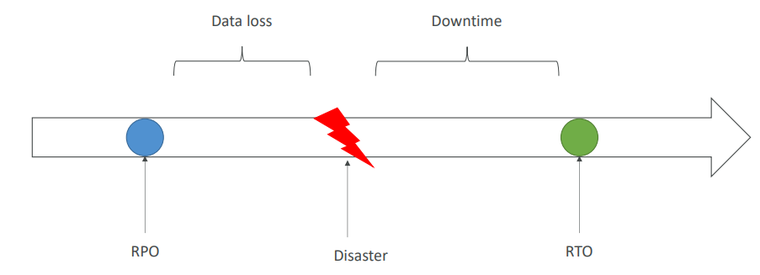

**RPO** The first one is the RPO, recovery point objective, and so this is basically how often basically you run backups, how back in time can you to recover. And when a disaster strikes, basically, the time between the RPO and the disaster is going to be a data loss. For example, if you back up data every hour and a disaster strikes then you can go back in time for an hour and so you'll have lost one hour of data. So the RPO, sometimes it can be an hour, sometimes it can be maybe one minute. It really depends on our requirements, but RPO is how much of a data loss are you willing to accept in case of a disaster happens?

**RTO** on the other end is when you recover from your disaster, okay. And so, between the disaster and the RTO is the amount of downtime your application has. So sometimes it's okay to have 24 hours of downtime, I don't think it is. Sometimes it's not okay and maybe you need just one minute of downtime, okay.

So basically optimizing for the RPO and the RTO does drive some solution architecture decisions, and obviously the smaller you want these things to be, usually the higher the cost.

## Disaster Recovery Strategies

* Backup and Restore
* Pilot Light
* Warm Standby
* Hot Site / Multi Site Approach

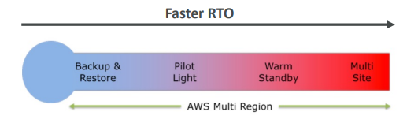

So if we basically rank them, all will have different RTO. Backup and restore will have the smaller RTO. Pilot light, then warm standby and multi site, all these things cost more money but they get a faster RTO. That means you have less downtime overall.

**Backup and Restore (High RPO)**

Backup and restore has a high RPO. That means that you have a corporate data center, for example, and here is your AWS Cloud and you have an S3 bucket. And so if you want to backup your data over time, maybe we can use AWS' Storage Gateway or and have some lifecycle policy put data into Glacier for cost optimization purposes, or maybe once a week you're sending a ton of data into Glacier using AWS' Snowball. So here you know if you use Snowball, your RPO is gonna be about one week because if your data center burns or whatever and you lose all your data then you've lost one week of data because you send that Snowball device once a week. If you're using the AWS' Cloud instead, maybe EBS volumes, Redshift and RDS. If you schedule regular snapshots and you back them up then your RPO is going to be maybe 24 hours or one hour based on how frequently you do create these snapshots. And then when you have a disaster strike you and you need to basically restore all your data then you can use AMIs to recreate EC2 instances and spin up your applications or you can restore straight from a snapshot and recreate your Amazon RDS database or your EBS volume or your Redshift, whatever you want. And so that can take a lot of time as well to restore this data and so you get a high RTO as well. But the reason we do this is actually it's quite cheap to do backup and restore. We don't manage infrastructure in the middle, we just recreate infrastructure when we need it, when we have a disaster and so the only cost we have is the cost of storing these backups. So it gives you an idea. Backup and restore, very easy, pretty expense-- not too expensive and you get high RPO, high RTO.

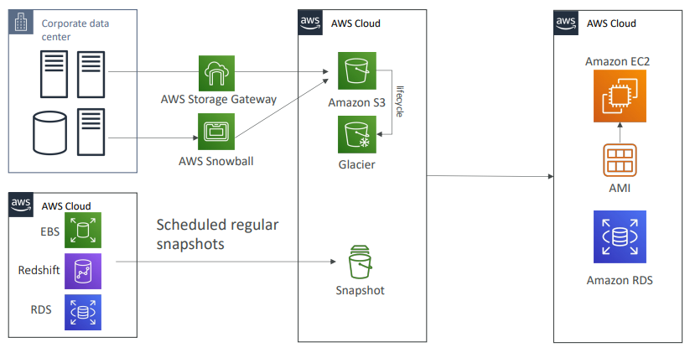

**Disaster Recovery – Pilot Light**

* A small version of the app is always running in the cloud
* Useful for the critical core (pilot light)
* Very similar to Backup and Restore
* Faster than Backup and Restore as critical systems are already up

The second one is going to be pilot light. So here with pilot light, a small version of the app is always running in the cloud, and so usually that's going to be your critical core, and this is what is called pilot light. So it's very similar to backup and restore, but this time it's faster because your critical systems, they're already up and running and so when you do recover, you just need to add on all the other systems that are not as critical. So let's have an example. This is your data center, it has a server and a data base, and this is the AWS' Cloud. Maybe you're doing to do continuous data replication from your critical database into RDS which is going to be running at any time so you get an RDS database ready to go running. But your EC2 instances, they're not critical just yet. What's really important is your data, and so they're not running, but in case you have a disaster happening, Route 53 will allow you fail over from your server on your data center, recreate that EC2 instance in the cloud and make it up and running, but your RDS database is already ready. So here what do we get? Well we get a lower RPO, we get a lower RTO and we still manage costs. We still have to have an RDS running, but just the RDS database is running, the rest is not and your EC2 instance only are brought up, are created when you do a disaster recovery. So pilot light is a very popular choice. Remember, it's only for critical core assistance.

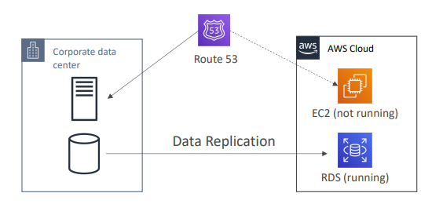

**Warm Standby**

* Full system is up and running, but at minimum size
* Upon disaster, we can scale to production load

Warm standby is when you have a full system up and running but at a minimum size so it's ready to go, but upon disaster, we can scale it to production load. So let's have a look. We have our corporate data center. Maybe it's a bit more complicated this time. We have a reverse proxy, an app server, and a master database, and currently our Route 53 is pointing the DNS to our corporate data center. And in the cloud, we'll still have our data replication to an RDS Slave database that is running. And maybe we'll have an EC2 auto scaling group, but running at minimum capacity that's currently talking to our corporate data center database. And maybe we'll have an ELB as well, ready to go. And so if a disaster strikes you, because we have a warm standby, we can use Route 53 to fail over to the ELB and we can use the failover to also change where our application is getting our data from. Maybe it's getting our data from the RDS Slave now, and so we've effectively basically stood by and then maybe using auto scaling, our application will scale pretty quickly. So this is a more costly thing to do now because we already have an ELB and EC2 Auto Scaling running at any time, but again, you can decrease your RPO and your RTO doing that.

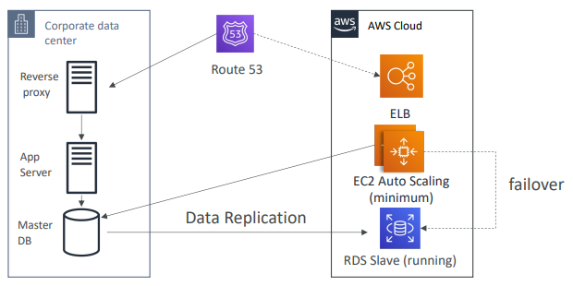

**Multi Site / Hot Site Approach**

* Very low RTO (minutes or seconds) – very expensive
* Full Production Scale is running AWS and On Premis

And then finally we get the multi site/hot site approach. It's very low RTO, we're talking minutes or seconds but it's also very expensive. But you get two full production scales running on AWS and On Premise. So that means we have your On Premise data center, full production scale, you have your AWS data center, full production scale with some data replication happening. And so here what happens is that because you have a hot site that's already running, your Route 53 can route request to both your corporate data center and the AWS Cloud and it's called an active, active type of setup. And so the idea here is that the failover can happen. Your EC2 can failover to your RDS Slave database if need be, but you get full production scale running on AWS and On Premise, and so this costs a lot of money, but at the same time, you're ready to fail over, you're ready and you're running into a multi DC type of infrastructure which is quite cool.

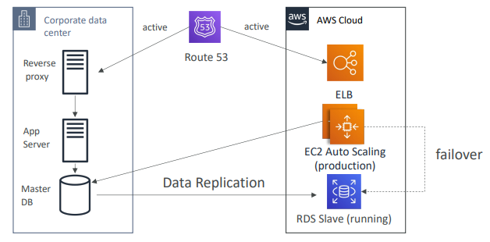

**All AWS Multi Region**

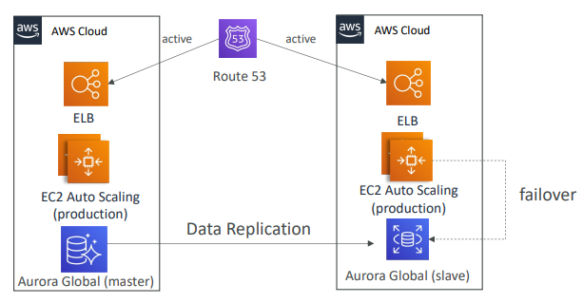

Finally, if you wanted to go all cloud, you know it would be the same kind of architecture. It will be a multi region so maybe we could use Aurora here because we're really in the cloud, so we have a master database in a region and then we have your Aurora Global database that's been replicated to another region as a Slave and so these both regions are working for me and when I want to failover, you know, I will be ready to go full production scale again in another region if I need to.

**Disaster Recovery Tips**

* Backup
  + Use EBS Snapshots, RDS automated backups / Snapshots, etc…
  + Regular pushes to S3 / S3 IA / Glacier, Lifecycle Policy, Cross Region Replication
  + From On-Premise: Snowball or Storage Gateway
* High Availability
  + Use Route53 to migrate DNS over from Region to Region
  + RDS Multi-AZ, ElastiCache Multi-AZ, EFS, S3
  + If you're talking about the high availability of your network, maybe you've implemented Direct Connect to connect from your corporate data center to AWS. But what if the connection goes down for whatever reason? Maybe you can use Site to Site VPN as a recovery option for your network
* Replication
  + RDS Replication (Cross Region), AWS Aurora + Global Databases
  + Database replication from on-premises to RDS
  + Storage Gateway
* Automation
  + CloudFormation / Elastic Beanstalk to re-create a whole new environment
  + Recover / Reboot EC2 instances with CloudWatch if alarms fail
  + AWS Lambda functions for customized automations
* Chaos

And then finally, chaos testing, so how do we know how to recover from a disaster? Then you create disasters, and so and example that's, I think, widely quoted now in the AWS' world is that Netflix, they run everything on AWS, and they have created something called a simian-army, and they randomly terminate EC2 instances, for example. They do so much more, but basically they just take an application server and terminate it randomly. In production, okay? Not in divert test, in production. So they want to make sure that their infrastructure is capable to survive failures, and so that's why they're running a bunch of chaos monkeys that just terminate stuff randomly just to make sure that their infrastructure is rock-solid and can survive any types of failures. So that's it for this section on disaster recovery.

## DMS – Database Migration Service

It's a quick and secure database service that allows you to migrate your database from on-premise to AWS

|  |  |
| --- | --- |
| * Quickly and securely migrate databases to AWS, resilient, self healing * The source database remains available during the migration * Supports:   + Homogeneous migrations: ex Oracle to Oracle   + Heterogeneous migrations: ex Microsoft SQL Server to Aurora * Continuous Data Replication using CDC * You must create an EC2 instance to perform the replication tasks |  |

**DMS Sources and Targets**

So what if the source database and the target database do not have the same engine? Then you need to use something called AWS SCT, for Schema Conversion Tool, and it will convert the database schema from one engine to another. So for example, if you're using an OLTP, we can migrate from SQL server or Oracle to MySQL, PostgreSQL, or Aurora. As you can see on the left hand side, the database engine is different from the one on the right hand side, but also you can transform for analytics process, such as Teradata or Oracle, all the way to Amazon Redshift. So the idea is that here, the source database has a different engine than the Target database. In the middle, we have DMS, but it's now also running SCT, or Schema Conversion Tool. And the thing to know going into the exam is that you do not need to use SCT if you are migrating the same database engine. So if you're doing on-premise PostgreSQL to RDS PostgreSQL, it is the same database agent, it is PostgreSQL. And so this for, you will not use SCT. But if you're doing something such as Oracle to Postgres, then you will need to use SCT. So just so you know, the database agent is PostgreSQL, but RDS is just a platform that we're using to run this database engine.

|  |  |
| --- | --- |
| SOURCES:   * On-Premises and EC2 instances databases: Oracle, MS SQL Server, MySQL, MariaDB, PostgreSQL, MongoDB, SAP, DB2 * Azure: Azure SQL Database * Amazon RDS: all including Aurora * Amazon S3 * DocumentDB | TARGETS:   * On-Premises and EC2 instances databases: Oracle, MS SQL Server, MySQL, MariaDB, PostgreSQL, SAP * Amazon RDS * Redshift, DynamoDB, S3 * OpenSearch Service * Kinesis Data Streams * Apache Kafka * DocumentDB & Amazon Neptune * Redis & Babelfish |

**AWS Schema Conversion Tool (SCT)**

* Convert your Database’s Schema from one engine to another
* Example OLTP: (SQL Server or Oracle) to MySQL, PostgreSQL, Aurora
* Example OLAP: (Teradata or Oracle) to Amazon Redshift
* Prefer compute-intensive instances to optimize data conversions

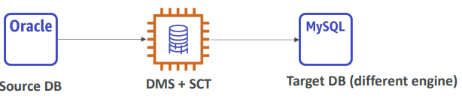

* You do not need to use SCT if you are migrating the same DB engine
  + Ex: On-Premise PostgreSQL => RDS PostgreSQL
  + The DB engine is still PostgreSQL (RDS is the platform)

**DMS - Continuous Replication**

So how would you go to set up a continuous replication for DMS? Well, you would have your corporate data center, for example, with an Oracle database as a source and an Amazon RDS database for MySQL DB as a target. And as we can see, we have two different kinds of types of database. So in this case, we have to use SCT, otherwise it will not work. So the Schema Conversion Tool. So we set up a server with AWS SCT installed and we can set it up on-premises, this is best practice, and then we will do the schema conversion into our Amazon RDS database running MySQL. Then we can set up a DMS replication instance that will do the full load and the change data capture, CDC, to have continuous replication. And so it will perform the data migration by reading the database on-premises, the source Oracle database, and inserting the data into your private subnets. That's it. So that's all you need to know for DMS. This is for Database Migration Service. Remember, you need to use SCT whenever you have two different kinds of databases that you're migrating from.

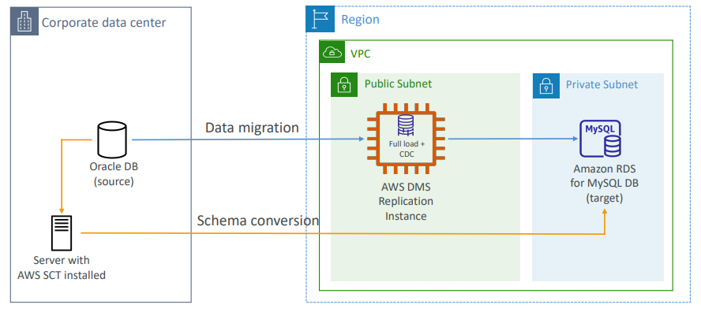

**AWS DMS – Multi-AZ Deployment**

And for DMS, there is a multi AZ deployment. So when you have this, then you have a DMS replication instance in one AZ and then you have synchronous replication of that instance into another AZ, which is going to be a standby replica. So the benefits of using this is, of course, to be resilient to a failure in one specific AZ, but also gives you data redundancy, will eliminate IO freezes and will minimize latency spikes.

|  |  |
| --- | --- |
| * When Multi-AZ Enabled, DMS provisions and maintains a synchronously stand replica in a different AZ * Advantages:   + Provides Data Redundancy   + Eliminates I/O freezes   + Minimizes latency spikes |  |

**RDS & Aurora MySQL Migrations**

|  |  |
| --- | --- |
| * RDS MySQL to Aurora MySQL   + Option 1: DB Snapshots from RDS MySQL restored as MySQL Aurora DB   + Option 2: Create an Aurora Read Replica from your RDS MySQL, and when the replication lag is 0, promote it as its own DB cluster (can take time and cost $) * External MySQL to Aurora MySQL   + Option 1:     - Use Percona XtraBackup to create a file backup in Amazon S3     - Create an Aurora MySQL DB from Amazon S3   + Option 2:     - Create an Aurora MySQL DB     - Use the mysqldump utility to migrate MySQL into Aurora (slower than S3 method) * Use DMS if both databases are up and running |  |

**RDS & Aurora PostgreSQL Migrations**

|  |  |
| --- | --- |
| * RDS PostgreSQL to Aurora PostgreSQL * Option 1: DB Snapshots from RDS PostgreSQL restored as PostgreSQL Aurora DB * Option 2: Create an Aurora Read Replica from your RDS PostgreSQL, and when the replication lag is 0, promote it as its own DB cluster (can take time and cost $) * External PostgreSQL to Aurora PostgreSQL * Create a backup and put it in Amazon S3 * Import it using the aws_s3 Aurora extension * Use DMS if both databases are up and running |  |

**Hands on**

Okay, so let's practice using AWS Backup. So I'm going to type AWS Backup into the search bar and open the Backup service. So we are going to create our first backup plan. So I'm going to click on Create Backup plan. And we have three options. Either we start with a template or we build a new plan, or we define a plan using JSON. So the simplest for us is to start with a template, and we can have different templates. For example, Daily-35day-Retention, Daily-Monthly-1yr-Retention, and so on. So let's go with Daily-Monthly-1yr-Retention, and I'll call it TestPlan. Next, we click at Backup rules. And you see we can have many Backup rules in our Backup rules. So we have two, we have daily Backups and monthly. So if I click on Daily Backup, as we can see, there's a rule name. The Backup vault is wherever the backup is going. So we can use a default one by AWS, or we can create our own new Backup vault if we wanted to. The Backup frequency, the Backup window, so when to start, which is 5:00 AM UTC, start within eight hours, or you can customize it if you want. Whether or not you want to transition to cold storage, never, after some days, weeks, months, or years. And the retention period of your backup, for example, this one is retained for five weeks. Then we can also copy these backups to a specific destination. For example, another region for disaster recovery purposes. So I'm going to save this backup rule. And for monthly while we get the similar thing, so it's going into the default Backup vault. It's monthly on day one of each month, and the rest looks the same. So we actually transition these ones to cold storage after one month, and then we retain them for one year. Okay, so we have these ready, and then I can just scroll down and click on create plan. So now our test plan is created and we need to assign resources to it. So I'm going to click on assign resources, and I will just call it TestAssignments. And so here for IAM role, we're going to use the default role, which is going to create a role for us with the correct permissions, or you can choose your own one, but let's go with default role, easy. And then for resource selection, we have two things we can do. Number one, we can include all resource types, or number two, we can include specific resource types. For example, if you wanted to just have a DynamoDB table, and then you could select the resource you want on there, you could do this. Or if you wanted to, you can have all tables. So it's one way of doing it. Or if you go with all resource types, usually we'd use this as a combination with tags. And so for tags you would say, well, if the key environment is equal to the value production, then do a backup. This would be the kind of use cases for backups, but you're free to do anything you want, of course. And then when you're done, you click on assign resources. And so just to make it very, very clear, if I went into EC2 and I were to create an EBS volume, and that volume would have, so for example, one gigabytes and then the key would be environment production. Then this would be automatically backed up by my Backup plan because it has the correct tags. So if we look at our volume right now, and we go into tags, as we can see has environment production, which corresponds to the tags that I've set up for my backup plan, okay? So this is the assignments right here. And we can have multiple assignments as well in here. Okay? And then that's it. The backup plan is going to run automatically, and then the backups are going to happen here in my Backup vaults, okay? The jobs are the jobs that are going to be scheduled and happening. So we have backup jobs, restore jobs and copy jobs if we wanted to. And then we can look at the settings. So the settings is around, do you want to have backup policies, cross account monitoring, cross account backups, and so on. But we've seen the basics of how backups work. And so that's it. I want to show you all this, okay? That's all you need to know. And I'm going to delete everything. So for that, please make sure to delete your EBS volume, or you could wait a day if you wanted to see if the backups work, obviously. And then when you're done, you take the assignments and you delete it. So type the name of the assignment in here, and then for the Daily Backup rules, you can delete them or delete directly the Backup plan. So let's have a look at the different options offered by the AWS Database Migration Service, or DMS. So we're going to get started and we are going to, with the screen, to figure out the right kind of migration we need. So here, I can first discover and assess. So this is going to use AWS DMS Fleet Advisor, which is going to have a look at the inventory of all your on-premises database and will identify the right potential migration path. So this is used to give you results in hours, and save you a lot of planning time without using third-party tools or hiring migration experts. The second option is to convert. So this is to use the DMS Schema Conversion tool to basically convert database schemas from one database technology to another one. And so this is good to just get an idea of the kind of transformations you can do. Then you have migration options, and this is to actually migrate your data. So you have different kind of migrations that are possible. The first one is homogenous data migration. And so this is when you go from, for example, one database to the very same database technology. So for example, from Oracle to Oracle, and this is very helpful, for example, and you would use native database tools to gain some speed and be faster. Then you have the heterogeneous migrations and so they are when the database types are different. For example, you migrate from Oracle to Aurora or from Oracle to PostgreSQL, whatever. In this case, you can use serverless replication or instance-based migration. So the difference here is that with instance-based migration, there is an EC2 instance behind those scenes that you manage to do the migration, but that DMS manages the instance itself and does the the task on it. And serverless, well, you don't manage any kind of resources, but it doesn't support every kind of database engines. So try out with serverless because obviously, it's a little bit nicer, easier, but see if your technology is supported or not. If not, use instance-based migrations. So I'm going to show you instance-based migrations in which we're going to create a replication instance and just look at the options. So you would give it a name, then you would give a description, and then you configure the instance. So of course, based on how much data has to be transiting, you would need to size up your instance. So you have different options from t3.micro, all the way to really large instances. And it's really up to you to see what is going to be necessary based on what load you are getting. You choose a DMS version and see the DMS release notes to see what are the new updates given by different engine versions. And then you choose high availability. So if you're doing a production workload of replication, it's usually better to be in multiple availability zones, in case one of these AZ goes down. If you're doing a very simple migration in dev or test, then single AZ may be sufficient. So we use multi AZ, and sometimes you get restrictions around the type of database class you need. So let's just go for Single-AZ to get no warning. Then how much storage you want on your EC2 instance, and then the connectivity and security. So the IP, the VPC, the subnet group, whether or not you want your instance to be publicly accessible. And then you have more advanced settings if you wanted to, and maintenance settings to do maintenance on the operating system of your instance. When you're good, you click on Create replication instance, but we're not going to do this because this would cost us money, and we don't have databases anyway to migrate to and from. So just cancel this, but I just wanna show you the options. So once you have chosen a replication instance, on the left hand side, we can create what's called a endpoint. So endpoints allow you to define where your databases are. So you can create an endpoint and it could be a source endpoint or a target endpoint. If it's a database in RDS, you have a easy selector by choosing this option. If not, then you can set up the endpoint identifier, then the source engine type. So you have all of these options in here for source engine. And if you choose targets, you have all of these options right here as well. And then you would choose the endpoint settings. So either a wizard to get guided to connect or an editor and to provide it as a JSON format. So these are very specific to your database, and this is why I don't go deep into it, but they provide information on how to connect to your source or your target database. So then you can test your connection from a specific replication instance as well. So when you have your source and your target defined, then you would go into Database migration tasks. And this is where you can create a task and say, Hey, here is my replication instance I want to use. Here is my source database endpoint. Here's my target database endpoint, and what is my migration type. So here we can migrate existing data or we can also migrate the existing data and replicate ongoing changes. So that's for continuous data replication, or just do the replication of data changes only. Again, we can have a test setting, so what settings we want, we use Wizard and we choose all these settings, or we just specify it as a JSON to see everything that can be configured for your DMS task, and as you can see, that is a lot of settings. This is why maybe JSON editor may be better at some point. Okay? Then you can do an assessment and do some configuration and then create your task. Obviously, we're not doing any of this because this would cost us some money, but you get the idea. You create a replication instance, then endpoints. And then finally, a database migration tasks, and DMS is evolving towards serverless replication where you can just create a replication directly from database to database without managing any replication instance. And then you have more features around schema conversion and Fleet Advisor recommendations, and as well as homogenous data migrations to leverage the native database tooling to perform these migrations. So that's it for DMS and its overview. That should be enough for the exam. And for this, just enter the name of the backup plan and press delete. And that's it.

## On -Premise strategy with AWS

* So we have the ability to download the Amazon Linux 2 AMI as a virtual machine and that will be in the ISO format. And you can load this ISO image into the common software used to create VMs. So that includes VMWare, KVM, Virtual Box, which is Oracle VM or Microsoft Hyper-V. And this would allow you to run Amazon Linux 2 on your on-premise infrastructure directly using that VM. So that means that you can make it work with some user data and so on.
* VM Import / Export
  + Migrate existing applications into EC2
  + Can be used as a Disaster Recovery repository strategy for your on-premises VMs
  + Can export back the VMs from EC2 to on-premises
* AWS Application Discovery Service
  + Gather information about your on-premises servers to plan a migration
  + This is very high level, but it does give you some server utilization information and dependency mappings. And that could be quite helpful when you want to do a massive migration from on-premise to the cloud.
* You can track all that migration using the AWS Migration Hub.
* which allows you to replicate from on-premise to AWS, AWS to AWS or AWS to on-premise for your database. So this is quite nice because if you had a MySQL or a Postgres database running on-premise, and you wanted to start moving your workload into AWS, you could use DMS to replicate that database in the meantime, and when you're ready, you can fully transition to using AWS only. And the nice thing about it is that they work with various database technologies that includes Oracle, MySQL, DynamoDB, et cetera, and allows you to do some really fancy use cases for example, migrate data from MySQL into DynamoDB.
  + replicate On-premise => AWS , AWS => AWS, AWS => On-premise
  + Works with various database technologies (Oracle, MySQL, DynamoDB, etc..)
* AWS Server Migration Service (SMS) And this is for incremental replication of on-premise live servers to AWS. So you can replicate the volumes directly into AWS. And this is used for more ongoing type of replication. Incremental replication. And this is the last one that I have in my mind for on-premise migration to AWS.

## AWS Backup

* Fully managed service
* Centrally manage and automate backups across AWS services
* No need to create custom scripts and manual processes
* Supported services:
  + Amazon EC2 / Amazon EBS
  + Amazon S3
  + Amazon RDS (all DBs engines) / Amazon Aurora / Amazon DynamoDB
  + Amazon DocumentDB / Amazon Neptune
  + Amazon EFS / Amazon FSx (Lustre & Windows File Server)
  + AWS Storage Gateway (Volume Gateway)
* Supports cross-region backups
* Supports cross-account backups

**AWS Backup**

* Supports PITR for supported services
* On-Demand and Scheduled backups
* Tag-based backup policies
* You create backup policies known as Backup Plans
  + Backup frequency (every 12 hours, daily, weekly, monthly, cron expression)
  + Backup window
  + Transition to Cold Storage (Never, Days, Weeks, Months, Years)
  + Retention Period (Always, Days, Weeks, Months, Years)

**AWS Backup**

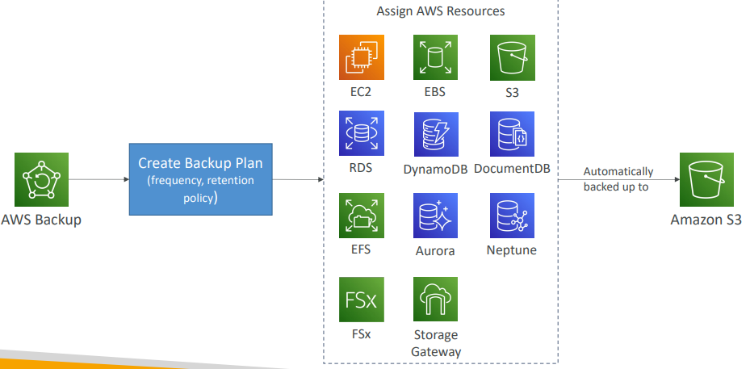

**AWS Backup Vault Lock**

|  |  |
| --- | --- |
| * Enforce a WORM (Write Once Read Many) state for all the backups that you store in your AWS Backup Vault * Additional layer of defense to protect your backups against:   + Inadvertent or malicious delete operations   + Updates that shorten or alter retention periods * Even the root user cannot delete backups when enabled |  |

**Hands On**

Okay, so let's practice using AWS Backup. So I'm going to type AWS Backup into the search bar and open the Backup service. So we are going to create our first backup plan. So I'm going to click on Create Backup plan. And we have three options. Either we start with a template or we build a new plan, or we define a plan using JSON. So the simplest for us is to start with a template, and we can have different templates. For example, Daily-35day-Retention, Daily-Monthly-1yr-Retention, and so on. So let's go with Daily-Monthly-1yr-Retention, and I'll call it TestPlan. Next, we click at Backup rules. And you see we can have many Backup rules in our Backup rules. So we have two, we have daily Backups and monthly. So if I click on Daily Backup, as we can see, there's a rule name. The Backup vault is wherever the backup is going. So we can use a default one by AWS, or we can create our own new Backup vault if we wanted to. The Backup frequency, the Backup window, so when to start, which is 5:00 AM UTC, start within eight hours, or you can customize it if you want. Whether or not you want to transition to cold storage, never, after some days, weeks, months, or years. And the retention period of your backup, for example, this one is retained for five weeks. Then we can also copy these backups to a specific destination. For example, another region for disaster recovery purposes. So I'm going to save this backup rule. And for monthly while we get the similar thing, so it's going into the default Backup vault. It's monthly on day one of each month, and the rest looks the same. So we actually transition these ones to cold storage after one month, and then we retain them for one year. Okay, so we have these ready, and then I can just scroll down and click on create plan. So now our test plan is created and we need to assign resources to it. So I'm going to click on assign resources, and I will just call it TestAssignments. And so here for IAM role, we're going to use the default role, which is going to create a role for us with the correct permissions, or you can choose your own one, but let's go with default role, easy. And then for resource selection, we have two things we can do. Number one, we can include all resource types, or number two, we can include specific resource types. For example, if you wanted to just have a DynamoDB table, and then you could select the resource you want on there, you could do this. Or if you wanted to, you can have all tables. So it's one way of doing it. Or if you go with all resource types, usually we'd use this as a combination with tags. And so for tags you would say, well, if the key environment is equal to the value production, then do a backup. This would be the kind of use cases for backups, but you're free to do anything you want, of course. And then when you're done, you click on assign resources. And so just to make it very, very clear, if I went into EC2 and I were to create an EBS volume, and that volume would have, so for example, one gigabytes and then the key would be environment production. Then this would be automatically backed up by my Backup plan because it has the correct tags. So if we look at our volume right now, and we go into tags, as we can see has environment production, which corresponds to the tags that I've set up for my backup plan, okay? So this is the assignments right here. And we can have multiple assignments as well in here. Okay? And then that's it. The backup plan is going to run automatically, and then the backups are going to happen here in my Backup vaults, okay? The jobs are the jobs that are going to be scheduled and happening. So we have backup jobs, restore jobs and copy jobs if we wanted to. And then we can look at the settings. So the settings is around, do you want to have backup policies, cross account monitoring, cross account backups, and so on. But we've seen the basics of how backups work. And so that's it. I want to show you all this, okay? That's all you need to know. And I'm going to delete everything. So for that, please make sure to delete your EBS volume, or you could wait a day if you wanted to see if the backups work, obviously. And then when you're done, you take the assignments and you delete it. So type the name of the assignment in here, and then for the Daily Backup rules, you can delete them or delete directly the Backup plan. And for this, just enter the name of the backup plan and press delete. And that's it.

## AWS Application Discovery Service

So there are two use cases when you move to the cloud. For example, you wanna start fresh and you wanna leverage the cloud directly. In this case, you don't need to do a migration. But if you have on-premises servers and data centers and you want to migrate to the cloud, then you need to plan your migration. And a way to do this is to plan your migration using the **AWS Application Discovery Service**. And the way to do this is

* Plan migration projects by gathering information about on-premises data centers
* Server utilization data and dependency mapping are important for migrations
* There are 2 kinds of migration which we can do
  + Agentless Discovery (AWS Agentless Discovery Connector)
    - VM inventory, configuration, and performance history such as CPU, memory, and disk usage
  + Agent-based Discovery (AWS Application Discovery Agent)
    - And this gives you more updates and more information from within your virtual machines. For example, system configuration, performance, processes are running, and the details of all the network connections between your systems, which is good to get your dependency mapping
* Resulting data can be viewed within AWS Migration Hub

So this Application Discovery Service really helps you to map out what you need to move and how they are interconnected. But then you actually need to move. And the simplest way to move from on-premises to AWS is using the **AWS Application Migration Service**, also called MGN.

**AWS Application Migration Service (MGN)**

* So, this used to be called CloudEndure Migration, but now it's been replaced.
* Lift-and-shift (rehost) solution which simplify migrating applications to AWS
  + Convert your physical, virtual, and cloud-based servers to run natively on AWS

Well, say you have a corporate data center with OS apps and databases, and they run on disks. What's going to happen is that you're going to run the Application Migration Service. And then the replication agent that you have to install on your data center is going to perform a continuous replication of your disks so that you have, for example, low-cost EC2 instances and EBS volumes that get this replication of data. Now, the day you're ready to perform a cut over, you can actually move from staging to production, and have a bigger EC2 instance of the size you want, as well as EBS volumes that match the performance you need. So the idea is that you replicate data, and then at some point, you do a cut over. And that is by far the simplest way of doing it

* Supports wide range of platforms, Operating Systems, and databases
* Minimal downtime, reduced costs

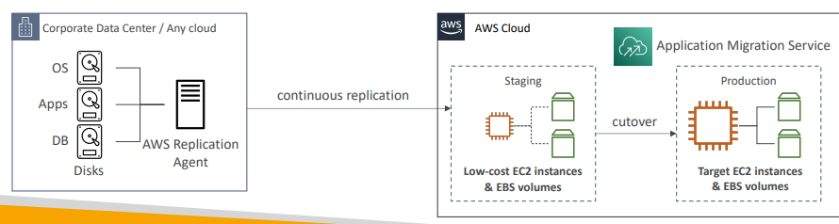

## Transferring large amounts of data into AWS

So here is a quick summary lecture to describe to you all the ways you can transfer a large amount of data into AWS and which one is going to be the most appropriate based on the constraints you have.

* Scenario: transfer 200 TB of data in the cloud. We have a 100 Mbps internet connection.
  + Option 1 Over the internet / Site-to-Site VPN:
    - Benifits
      * Immediate to setup
      * Will take 200(TB)*1000(GB)*1000(MB)*8(Mb)/100 Mbps = 16,000,000s = 185d long time
      * So this can take a long time. Obviously, based on the size you have the data it could be appropriate or not. And in this case, I will never probably transfer 200 terabytes over this internet connection speed.
  + Option 2 Over direct connect 1Gbps:
    - Long for the one-time setup (over a month)
    - Will take 200(TB)*1000(GB)*8(Gb)/1 Gbps = 1,600,000s = 18.5d
    - So a lot quicker, but still quite long.
  + Over Snowball:
    - Will take 2 to 3 snowballs in parallel
    - Takes about 1 week for the end-to-end transfer
    - And, on top of it, if there was a database that was being transferred through Snowball, it could be combined with DMS to transfer the rest of the data, aferwards.

So, finally, for ongoing replications, so this is for one-off transfers, for ongoing replications, we could use techniques such as Site-to-Site VPN, again, because we'll have less data to transfer on an ongoing basis. Or use direct connect, or use DMS, or use a service like we just saw, like DataSync. So all these things would allow us to transfer the data, ongoing, on the ongoing basis, continuously or not, through some more reasonable internet's lines, such as Site-to-Site VPN or direct connect.

Snowball is going to be used more for one-off, large transfers, and as we can see, Snowball, in this case, is really, really helpful into speeding up our fist data transfer into AWS.

## VMware Cloud on AWS

So now let's talk about VMware Cloud on AWS. So here's some context. When you have an on-premises data center, sometimes you would use the VMware Cloud to manage your own on-premise data center. So you have your vSphere-based environment and your VMs all managed from VMware Cloud. And consumers who have their own data center with VMware, they want to extend their data center capacity to also leverage the cloud and in particular, they want to leverage AWS. But they want to keep on managing everything, their own data center and the cloud, using the VMware Cloud software. So this is the idea behind VMware Cloud on AWS. Thanks to it you can extend your entire VMware Cloud infrastructure to also be on AWS and run vSphere, vSAN, NSX, and so on, which you don't have to know but they are VMware sub-services. So once you have this, what are the use cases? Well, the first thing is that now you can extend computing power from data center to the cloud or storage from the data center to the cloud, and therefore you can start migrating your VMware-based workloads to AWS. You can also run your production workloads across multiple data centers, and you can choose between private, public, or hybrid cloud environments. And finally, it gives you a disaster recovery strategy because now you can quickly go to the cloud using the same suite of software that you know. And because that now you are on the AWS cloud you can actually access the different AWS services and start leveraging them such as Amazon EC2, Amazon FSx, S3, RDS, Direct Connect, Redshift, and so on. So that's it. It's just a high level overview that you need to know.

* Some customers use VMware Cloud to manage their on-premises Data Center
* They want to extend the Data Center capacity to AWS, but keep using the VMware Cloud software
* …Enter VMware Cloud on AWS
* Use cases
  + Migrate your VMware vSphere-based workloads to AWS
  + Run your production workloads across VMware vSphere-based private, public, and hybrid cloud environments
  + Have a disaster recover strategy

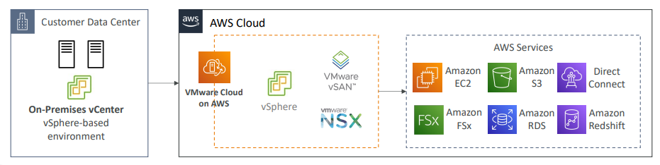

## Questions

**Top of Form**

**As part of your Disaster Recovery plan, you would like to have only the critical infrastructure up and running in AWS. You don't mind a longer Recovery Time Objective (RTO). Which DR strategy do you recommend?**

* **Backup and Restore**
* **Pilot Light**
* **Warm Standby**
* **Multi-Site**

**Bottom of Form**

Ans B correct If you're interested, read more about Disaster Recovery options in AWS here: https://docs.aws.amazon.com/whitepapers/latest/disaster-recovery-workloads-on-aws/disaster-recovery-options-in-the-cloud.html

**Top of Form**

**You would like to get the Disaster Recovery strategy with the lowest Recovery Time Objective (RTO) and Recovery Point Objective (RPO), regardless of the cost. Which DR should you choose?**

* **Backup and Restore**
* **Pilot Light**
* **Warm Standby**
* **Multi-Site**

**Bottom of Form**

Ans D Correct If you're interested, read more about Disaster Recovery options in AWS here: https://docs.aws.amazon.com/whitepapers/latest/disaster-recovery-workloads-on-aws/disaster-recovery-options-in-the-cloud.html

**Top of Form**

**Which of the following Disaster Recovery strategies has a potentially high Recovery Point Objective (RPO) and Recovery Time Objective (RTO)?**

* **Backup and Restore**
* **Pilot Light**
* **Warm Standby**
* **Multi-Site**

**Bottom of Form**

Ans A Correct If you're interested, read more about Disaster Recovery options in AWS here: https://docs.aws.amazon.com/whitepapers/latest/disaster-recovery-workloads-on-aws/disaster-recovery-options-in-the-cloud.html

**Top of Form**

**You want to make a Disaster Recovery plan where you have a scaled-down version of your system up and running, and when a disaster happens, it scales up quickly. Which DR strategy should you choose?**

* **Backup and Restore**
* **Pilot Light**
* **Warm Standby**
* **Multi-Site**

**Bottom of Form**

Ans C correct If you're interested, read more about Disaster Recovery options in AWS here: https://docs.aws.amazon.com/whitepapers/latest/disaster-recovery-workloads-on-aws/disaster-recovery-options-in-the-cloud.html

**Top of Form**

**You have an on-premises Oracle database that you want to migrate to AWS, specifically to Amazon Aurora. How would you do the migration?**

* **Use AWS Schema Conversion Tool (AWS SCT) to convert the database schema, then use AWS Database Migration Service (AWS DMS) to migrate the data**
* **Use AWS Database Migration Service (AWS DMS) to convert the database schema, then use AWS Schema Conversion Tool (AWS SCT) to migrate the data**

**Bottom of Form**

Ans A Correct

**Top of Form**

**You are running many resources in AWS such as EC2 instances, EBS volumes, DynamoDB tables... You want an easy way to manage backups across all these AWS services from a single place. Which AWS offering makes this process easy?**

* **Amazon S3**
* **AWS Storage Gateway**
* **AWS Backup**
* **EC2 Snapshots**

**Bottom of Form**

Ans C correct AWS Backup enables you to centralize and automate data protection across AWS services. It helps you support your regulatory compliance or business policies for data protection.

**Top of Form**

**A company planning to migrate its existing websites, applications, servers, virtual machines, and data to AWS. They want to do a lift-and-shift migration with minimum downtime and reduced costs. Which AWS service can help in this scenario?**

* **AWS Database Migration Service**
* **AWS Application Migration Service**
* **AWS Backup**
* **AWS Schema Conversion Tool**

Bottom of Form

Ans B Correct

C

D

**Top of Form**

**A company is using VMware on its on-premises data center to manage its infrastructure. There is a requirement to extend their data center and infrastructure to AWS but keep using the technology stack they are using which is VMware. Which AWS service can they use?**

* **VMware Cloud on AWS**
* **AWS DataSync**
* **AWS Application Migration Service**
* **AWS Application Discovery Service**

**Bottom of Form**

Ans A Correct

**Top of Form**

**A company is using RDS for MySQL as their main database but, lately they have been facing issues in managing the database, performance issues, and the scalability. And they have decided to use Aurora for MySQL instead for better performance, less complexity and less administrative tasks required. What is the best way and most cost-effective way to migrate from RDS for MySQL to Aurora for MySQL?**

* **Raise an AWS support ticket to do the migration as it is not supported**
* **Create a database dump from RDS from MySQL, store it in an S3 bucket, then restore it to Aurora for MySQL**
* **You can not migrate directly to Aurora for MySQL, you have to create a custom application to insert the data manually**
* **Create a snapshot from RDS for MySQL and restore it to Aurora for MySQL**

**Bottom of Form**

Ans D Correct

**Top of Form**

**Which AWS service can you use to automate the backup across different AWS services such as RDS, DynamoDB, Aurora, and EFS file systems, and EBS volumes?**

* **Amazon S3 Lifecycle Policy**
* **AWS DataSync**
* **AWS Backup**
* **Amazon Glacier**

**Bottom of Form**

Ans C Correct

# More Solutions Architecture

## Lambda, SNS & SQS

So let's talk about event processing in AWS and the different possibilities we have and the kind of constraints that we have alongside them. So the first one is to use SQS and Lambda. And if you use SQS and Lambda with our SQS queue in the Lambda function and so the events are going to be inserted into our SQS queue. And the Lambda service is going to pull the SQS queue. And in case there are issues, it's going to put back the messages into the SQS queue and try and retry to pull them, okay? And this can go into some sort of infinite loop. So in case there is a big problem with one message, what we can do is set up SQS to send the message to a dead letter Q after say, five tries, okay? This will be our way out of it. Now we can also use SQS FIFO and Lambda. In this case, FIFO means first in, first out. And that means that the messages are going to be processed in order. So now our Lambda function is going to try and retry to get the messages from the queue. But because it's just to process them in order, in case one message doesn't go through, it's going to be a blocking, never ending process and the whole queue processing will be blocked. In which case, yet again, we can set up a dead letter queue to send these messages off to SQS queue and allow our functions to keep on processing it. Okay. Next, we have another option, SNS and Lambda. In this case, SNS is a service and the message goes through with it and then the message is sent asynchronously to Lambda. In which case, the Lambda function is a different retry behavior. In case it cannot process that message, it's going to retry, but internally. And that retry will be three times. And if the message is not processed successfully, it will be discarded, or we can set up a DLQ. But this time, at the Lambda service level to send that message into, for example, the SQS queue for letter processing. So as we can see, this is a different kind of architecture. With SQS, the DLQ is set up on the SQS side. And for Lambda, the DLQ is set up on the Lambda side. So different architectures with different needs.

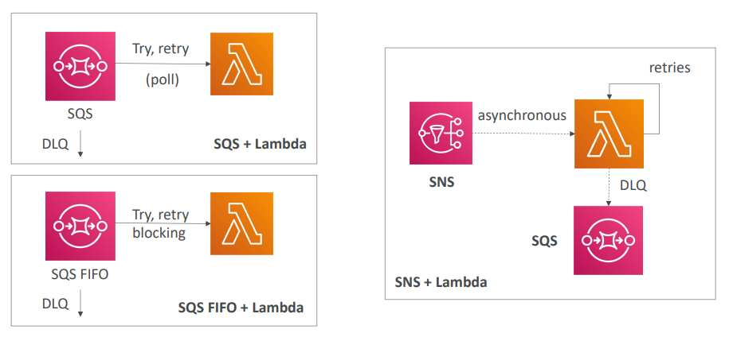

**Fan Out Pattern: deliver to multiple SQS**

Now let's talk about the Fan Out pattern, which is, how do you deliver a data to multiple SQS queues? So, option one, we have our application and it has the AWS SDK installed on it. And we have say three SQS SQS we'd like to deliver a message on to. So what we could do, very easily, is to write our application, to first send a message to the first queue and then send a message to the second queue. And then send again the same message to the third queue. And that would work, but that would be somewhat not too reliable, right? Because for example, if our application crashes after we send a message to the second queue, then the third queue will never receive the last message. And the content of each queue will be different. So while this works, this is not very reliable and this is not pretty. Instead, we can use a fan out pattern, which is to combine your SQS queue with an SNS topic in the middle. And in this case, what happens? Well, our SQS queues are going to be subscribers of our SNS topic in the middle? And what will happen is that anytime we send a message to the SNS topic, it will be sent by the SNS service into all of our SQS queues, which is a higher guarantee. So from our application perspective now, we just do a put into our SNS topic. And automatically, the SNS service will fan out that message into your other SQS queue. And this works really well. And that's a very common design pattern on AWS.

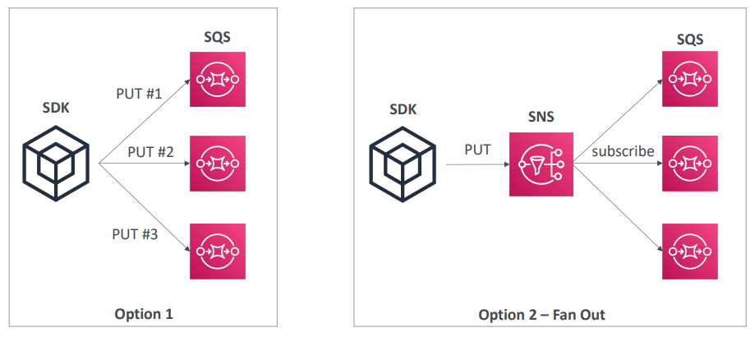

**S3 Event Notifications**

Regarding S3 event notifications, it's possible for you to react to specific events on your Amazon S3 buckets such as when the objects is created, removed, restored, when replication happens, and you can filter by name as well. So a use case would be to generate thumbnails of images uploaded to Amazon S3. So from Amazon S3 events, you can send to SNS, SQS or a Lambda function and you can create as many S3 events as desired. And these event notifications typically get delivered within seconds, but sometimes it can take a minute or longer. So you have to remember these three integrations.

|  |  |
| --- | --- |
| * S3:ObjectCreated, S3:ObjectRemoved, S3:ObjectRestore, S3:Replication… * Object name filtering possible (*.jpg) * Use case: generate thumbnails of images uploaded to S3 * Can create as many “S3 events” as desired * S3 event notifications typically deliver events in seconds but can sometimes take a minute or longer |  |

**S3 Event Notifications with Amazon EventBridge**

And there's one last, which is to use Amazon event bridge. So in this case the events will happen in your Amazon S3 buckets. And all the events are actually sent to now Amazon event bridge. And using rules, we can send them to over 18 AWS services as destination. So why would you use EventBridge? Well, because you get filtering options with adjacent rules. So you can filter on metadata, on object-size, on name and so on. You can also send it to multiple destinations at once, such as step functions, Kinesis Streams or Data Firehose. And then, you can also the EventBridge capabilities, such as archiving, replaying, and reliable delivery of events, which is something that may be desirable.

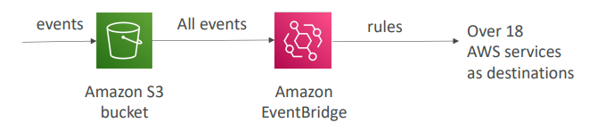

* Advanced filtering options with JSON rules (metadata, object size, name...)
* Multiple Destinations – ex Step Functions, Kinesis Streams / Firehose…
* EventBridge Capabilities – Archive, Replay Events, Reliable delivery

**Amazon EventBridge – Intercept API Calls**

Talking about EventBridge. Remember, you can intercept any API call with Amazon EventBridge by using the integration with CloudTrail. So for example, if you wanna react to the events of a user deleting a table from DynamoDB so using the delete table API call. Then this API call is going to be logged in CloudTrail. Actually all of them will be logged in CloudTrail. These will trigger an event in Amazon EventBridge. And from this, you can create alerts to alert Amazon SNS.

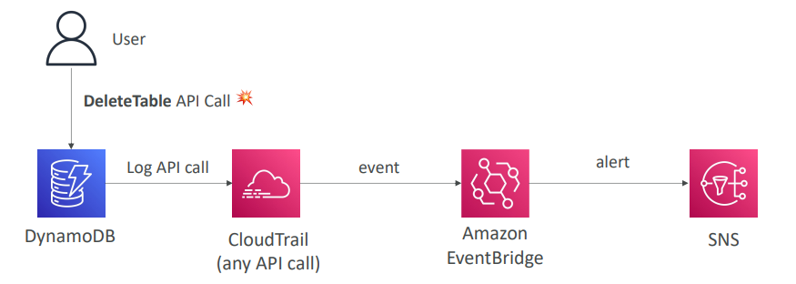

**API Gateway – AWS Service Integration Kinesis Data Streams example**

And finally, you can have external events onto AWS. For example, using the API gateway. So they say clients will send the request into an API gateway. The API gateway will send messages into Kinesis Data Stream. The records will end up at Nemesis data Firehose and then the data for example, can end up in Amazon S3. So you've seen a lot of options to integrate events in AWS and to build some cool automations

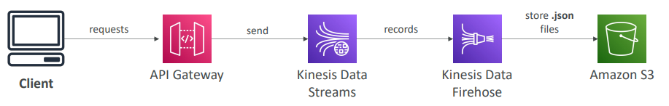

## Caching Strategies

Okay, so let's talk about caching strategies on AWS, and what they imply. So this is a typical solution architecture that I've just described, it could be, obviously, very different for you. But, we have something that we know of. So we have CloudFront in front of an API Gateway, which is in front of our application logic, could be EC2, could be Lambda. Our application stores and uses data from the database, and maybe you will use an internal cache such as Redis, Memcached and DAX. And then, that's where the dynamic routes, or all the dynamic content. And there be will an aesthetic content route, in which our client goes through a CloudFront and the CloudFront will source data from S3. So this is something we've seen, this is not very new. But what I wanna talk about is all the caching strategies you have, and their implication. So, if we look at CloudFront, these two CloudFronts right here they're doing caching at the edge. That means that they're doing caching as close as possible to our users. So that means that if we enable caching in CloudFront, and the users do hit the cache, then they get a response right away, it's very very quick. But because it's at the edge, there is a chance that things have changed in the back end, and obviously that the thing is outdated here. So we can use a TTL to make sure the cache is often very renewed, and the new stuff is picked up from backend. And so we have a balancing act to do between how much more to cache at the edge, versus how much we want to cache in the app logic. Okay, next, we go to API gateway. And API gateway also has some caching capabilities, so it doesn't have to be used with CloudFront. And so the API gateway is a regional service and so in case we do use the cache at the API gateway, then the cache will be regional. So that means that where there's going to be network lying between the clients and the API gateway, if the cache is hit here. Then we have our app logic. And our app logic usually doesn't do any caching, but it will do caching in a cache that we could use such as Redis, Memcached, or DAX if we have DynamoDB. And the idea here is that we don't want to repeatedly hit our database, which does not have any caching capability. We want to make sure that the frequent queries or the complex queries, the result is stored into a shared cache that can be accessed by your app logic more easily. And so here, we are saving by using caching here. We are saving pressure on our database, and we are augmenting the read capacity. Finally, I want you to notice that there is no caching capability in your database in Amazon S3 and so on. And so, as we move along this line of caching, the more we move alongside, the more there's gonna be a computation to cost and it's gonna be a latency. So it's really up to you, there's no right way or wrong way of doing caching. It's all up to what you want to achieve and how you want to set up your application to achieve that behavior. So it's all about choosing where do we want to cache content how do we want to cache content, how long do we want to cache content, and then, are we okay with some latency, and which content actually do we want to be cached? So, this lecture again is not a "you should do this", it's just to hopefully show you that there's a lot of different ways to do caching on AWS, and it really depends on what the scenario is to figure out where the caching is going to be most appropriate and most efficient.

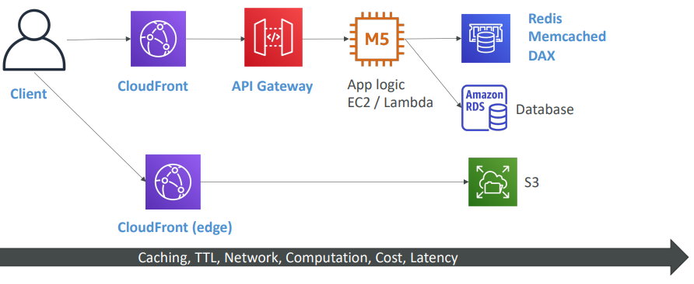

## Blocking an IP address

Okay, so this is going to be more a lecture around network discussion and security, but very important because I want you to really understand what goes on when a request comes from the client and goes all the way to your application. So sometimes we may want to block an IP address from a client because it's going to be a bad actor. Maybe it's trying to access our application. And so, we want to know the line of defenses. So let's start from this very simple solution architecture in which we have an EC2 instance in a security group, in a VPC. And that instance has a public IP, so it's publicly accessible. And this how our clients get into our EC2 instance. So say we wanted to block that client. The first line of defense would be the network ACL in our VPC, which is at the VPC level. And in this network ACL, we can create a denial rule for this client IP address. Very simple, very quick, very cheap, and the client will just be ejected. Then for the security group of the EC2 instance, we cannot have deny rules, we can only have allow rules. So if we know that only a subset of authorized client can access our EC2 instance, then it is good in our security group to just define a subset of IP to allow into our EC2 instance. But if our application is global, we obviously don't know all the IP addresses that will access our application and so the security group here will not be very helpful. Finally, you could run an optional firewall software on your EC2 to block from within your software the request from the client. Now obviously, if the requests already reached your EC2 instance, then it will have to be processed and there will be a CPU cost to processing that request. So that's a very simple use case, but we see already the difference between a NACL, a security group, and the host firewall.

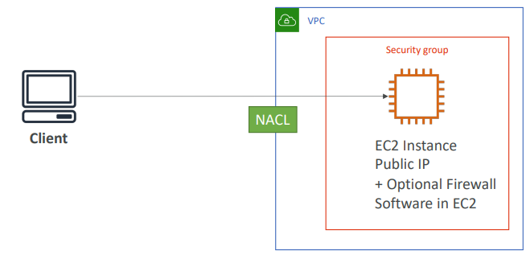

**Blocking an IP address – with an ALB**

Now let's push this one step further. We introduce an application load balancer. So again, this ALB is defined within our VPC and we still have our EC2 instance, but now we have two security groups. We have the ALB security group and we have the EC2 security group. And so in this case, our load balancer in this architecture is going to be in between our clients and our EC2 and it will do something called connection termination. So the client actually connects to the ALB which will terminate the connection and initiate a new connection from the ALB into our EC2 instance. In this case, our EC2 security group must be configured to allow the security group of the ALB because the EC2 instance can be deployed in a private subnet with a private IP, and the source of the traffic it sees comes from the ALB, not the client. So from the security group perspective here we only allow the ALB security group and we're safe on this side. Now, for the security group of the ALB, we need to allow the clients. And again, if we have the range of IP we know, then we can configure the secret to group. If it's a global application we have to allow everything. And then, our line of defense is going to be at the network ACL level. Okay, this makes sense and this should be something you already know.

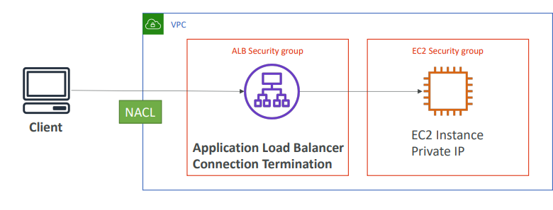

**Blocking an IP address – with an NLB**

So with the network load balancer it is quite similar now where you attach an security group to your network load balancer and a security group to your EC2 instances. You make sure the rules allow traffic from the network balancer into the EC2 security group and from the NLB security group from the client and you have control of the traffic along the way.

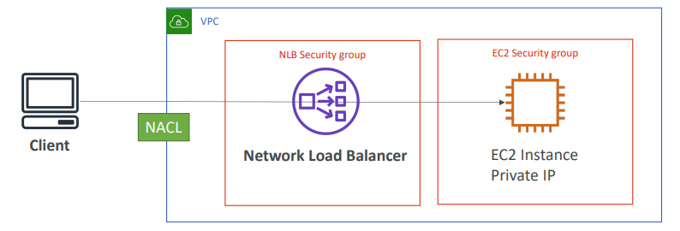

**Blocking an IP address – ALB + WAF**

Now let's go back to our application balancer and see how we can filter traffic even more. Something we can do to deny an IP is to install WAF or web application firewall. Now this WAF is going to be a little bit more expensive because this is an additional service and a firewall service. But in here we are able to do some complex filtering on IP addresses and we can establish rules that will count for the request to prevent a lot of requests going at the same time from the client and so we have more power over our security of our ALB. And so, WAF is not a service in between your client and your ALB, it's a service we have installed on the ALB and we can define a bunch of rules so this is one more line of defense.

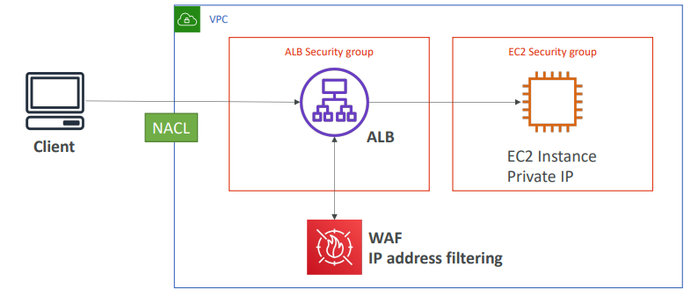

**Blocking an IP address – ALB, CloudFront WAF**

. Similarly, if we use CloudFront in front of the ALB, CloudFront front sits outside our VPC, okay? So as such our ALB needs to allow all the CloudFront public IPs coming from the edge locations and there's a list of it online, but that's it. So coming from the ALB, it does not see the client IP. What it sees is the CloudFront public IP. And so as such, the network is ACL here, which sits at the boundary of our VPC, is not helpful at all because it cannot help us block the client's IP address. And so in this case, if we are trying to block a client from CloudFront we have two possibilities. Say we're attacked by a country, then we can use the CloudFront Geo Restriction feature to restrict all the country from a client to be denied on CloudFront. Or if there's one specific IP that annoys us we can again use WAF or web application firewall to do some IP address filtering just like we did before. But so as we can see, based on the architecture we have we have different line of defenses to block an IP address and they're normal. Once we put everything together it all makes sense. But I think it's so good to show you exactly for a diagram what happens from the network perspective, how to properly configure a security group, and where to set up your IP address filtering

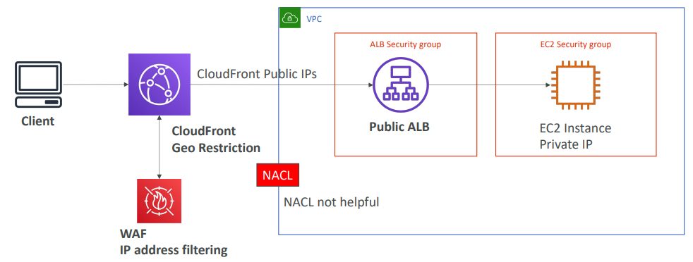

## High Performance Computing (HPC)

* The cloud is the perfect place to perform HPC reason
  + You can create a very high number of resources in no time
  + You can speed up time to results by adding more resources
  + You can pay only for the systems you have used

So the idea here is that we can have an extremely high number of instances performing competition for us, and then be done with it and just pay for what we used. This is perfect. This is a great use case for the cloud,

* We need it for Perform genomics, computational chemistry, financial risk modeling, weather prediction, machine learning, deep learning, autonomous driving

Which services help perform HPC?

**Data Management & Transfer**

So the first category is, how do we manage the data and how do we transfer the data into AWS? The first one is going to be Direct Connect to move data gigabytes per second of data into the cloud over a private secure network.

* AWS Direct Connect:
  + Move GB/s of data to the cloud, over a private secure network
* Then we have Snowballs and Snowmobile to move PetaBytes of data to the cloud through a physical route, and they're usually four big transfers or one off transfers.
* AWS DataSync
  + where we have to install the data sync agents and they will help us move large amount of data between on-premise and FS or SMB systems into S3 EFS or FSX for windows.

**Compute and Networking**

* EC2 Instances:
  + CPU optimized, GPU optimized
  + Spot Instances / Spot Fleets for cost savings + Auto Scaling
* EC2 Placement Groups: Cluster for good network performance. if our EC2 instances need to talk to one another and perform some computation in a distributed fashion, then using an EC2 placement group of type cluster is great to get the best network performance. In which case, we have a Low latency, 10 gigabyte per second network in this example, and for the cluster placement group, everything is on the same rack, everything is on the same AZ.

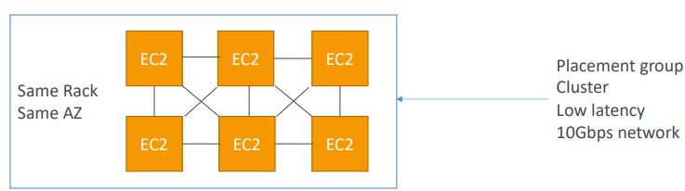

**Compute and Networking**

* EC2 Enhanced Networking (SR-IOV)
  + Higher bandwidth, higher PPS (packet per second), lower latency
  + Option 1: Elastic Network Adapter (ENA) up to 100 Gbps
  + Option 2: Intel 82599 VF up to 10 Gbps – LEGACY
* Elastic Fabric Adapter (EFA)
  + Improved ENA for HPC, only works for Linux
  + Great for inter-node communications, tightly coupled workloads
  + Leverages Message Passing Interface (MPI) standard
  + Bypasses the underlying Linux OS to provide low-latency, reliable transport

**Storage**

* Instance-attached storage:
  + EBS: scale up to 256,000 IOPS with io2 Block Express
  + Instance Store: scale to millions of IOPS, linked to EC2 instance, low latency
* Network storage:
  + Amazon S3: large blob, not a file system
  + Amazon EFS: scale IOPS based on total size, or use provisioned IOPS
  + Amazon FSx for Lustre:
    - HPC optimized distributed file system, millions of IOPS
    - Backed by S3

**Automation and Orchestration**

* AWS Batch
  + AWS Batch supports multi-node parallel jobs, which enables you to run single jobs that span multiple EC2 instances.
  + Easily schedule jobs and launch EC2 instances accordingly
* AWS ParallelCluster
  + Open-source cluster management tool to deploy HPC on AWS
  + Configure with text files
  + Automate creation of VPC, Subnet, cluster type and instance types
  + Ability to enable EFA on the cluster (improves network performance)

## Creating a highly available EC2 instance

So now let's talk about solution architecture, to see how we can make an EC2 instance become highly available. Because we know that an EC2 instance, by default, it's launched in one Availability Zone, and it's not really highly available, but we can engineer something to make it highly available, and that is the whole purpose of this lecture. We'll see there're different ways of doing things, and it all depends on your requirements and the amount of work you wanna do. So, let's say we have a Public EC2 instance that's running a web server, and we wanna be able to access the web server, so what we'll do is that we'll attach an Elastic IP to that EC2 instance, and so our users can access our website directly through this Elastic IP, and they will be directly talking to the EC2 instance thanks to it, and we get a result from our web server, so this is great. But now, what we want to do is have a Standby EC2 instance, just in case things go wrong, that makes our EC2 instance highly available. Now, we need to be able to failover to our Standby EC2 instance, in case something goes wrong. So how do we know if something goes wrong? Well, you should think that anytime you wanted to know that something is about to go wrong, there must be some kind of monitoring in place. So, we're going to create a CloudWatch Event or a CloudWatch Alarm, based on an event we know. For example, if we have a CloudWatch Event, maybe we want to see if an instance is getting terminated. Or if we are having a web server, and we know the CPU can go all the way to 100%, maybe you want to have a CloudWatch Alarm that monitors the CPU, and if we see the CPU is at 100%, maybe the EC2 instance has gone wrong, and we want to trigger an alarm based on that. So there's different ways of monitoring your EC2 instance, based on what your requirements may be. Then, from the Alarm or the CloudWatch Events, you could go ahead and trigger a Lambda function. And that Lambda function, will allow you to do whatever you want, and that lambda function, for example, can issue API calls to start the instance if it hasn't been started yet, okay, if there's no Standby EC2 instance. And then, issue an API call to attach the Elastic IP to my Standby instance. So now the Elastic IP will be attached, and it will be obviously detached from the other EC2 instance, because an Elastic IP can only be attached to one instance at a time, and the other EC2 instance, can be terminated or disappear, and we have effectively failed over to a new Standby EC2 instance. But our users because they communicate to our architecture, thanks to the Elastic IP, they don't really see anything happening, it's all in the back end. And so that's one way, of creating a highly available EC2 instance. But there are more ways.

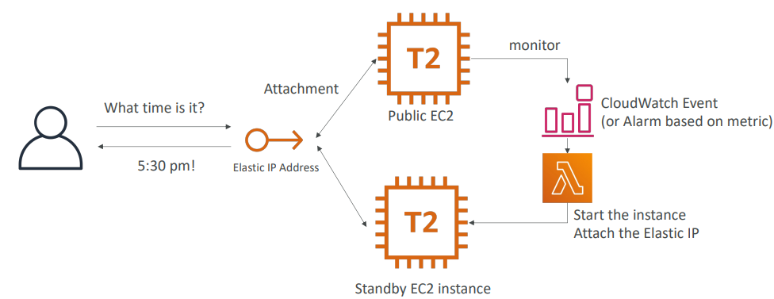

**Creating a highly available EC2 instance With an Auto Scaling Group**

Okay, let's talk about a second way of doing it, with an Auto Scaling Group. So, we have an ASG in two Availability Zones, and again, we're using the same concept, where a user is going to be talking to our application using an Elastic IP because it makes things a little bit simpler. So now how should we configure our Auto Scaling Group? What if we configure it this way, we say the minimum amount of instances is one, the maximum is one, and we want one desired, and we specify over two Availability Zones. So, what does it mean? That means we're going to get only one EC2 instance, and that EC2 instance may be in the first AZ. And that's what we get out of these settings. So why would we use these settings? Well, for example, we can say that on the user data of the EC2 instance, when it does come up, its going to acquire and attach this Elastic IP address based on Tags. So this user data will issue API calls and the Elastic IP will be attached to our Public EC2 instance, and our users will be able to talk to our web server. But now, let's discuss that this instance is being terminated, it goes down, and so what the ASG will do, is that it will terminate the first instance and create a Replacement EC2 instance in another AZ, and thanks to that, what we get is that, the first instance is terminated, and the second instance will run it's EC2 user data scripts and attach the Elastic IP. And we have effectively failover, so in this case, we don't need a CloudWatch Alarm or a CloudWatch Event, the Auto Scaling Group as soon as it sees that one instance has been terminated, thanks to its settings, will create a new EC2 instance and another AZ. And the reason we have one mix, one max and one desired is that we'll never get more than one instance running at the same time in our entire ASG, which is great. Finally, because our EC2 instance does do API calls directly, to attach this Elastic IP Address, then we need to make sure that the EC2 instance has an instance role, that allows it to issue API calls to attach this Elastic IP Address. So here we have a combo of using EC2 User Data to attach the Elastic IP Address, and also having an EC2 instance role to make sure the API call will succeed.

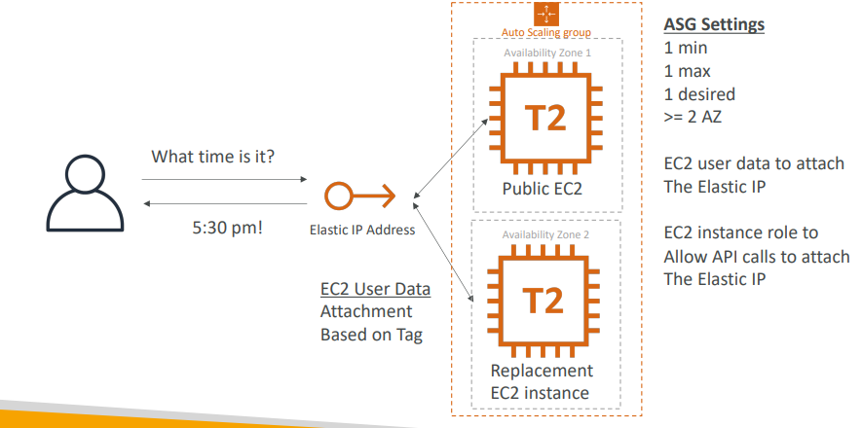

**Creating a highly available EC2 instance With ASG + EBS**

So we can extend the previous pattern to another thing. For example, our EC2 instance, can be stateful and have an EBS volume, so we can get even more complicated, so let's get started with it, so we have an Auto Scaling Group, two AZ, our Public EC2 instance, and an Elastic IP, so we already know this. But now, we also have an EBS Volume attached to our EC2 instance, let's imagine for example, that EC2 instance is a database, and we're trying to make that database highly available. So, all of our data is onto our EBS Volume, and we know an EBS Volume is locked into a specific Availability Zone. So let's imagine that our EC2 instance is being terminated, and now what should we do? Well, we know that on termination, the Auto Scaling Group can use lifecycle hooks, and thanks to this lifecycle hook, we can create a script to take that EBS Volume and create an EBS Snapshot from it. Because, it will be triggered as soon as the EC2 instance goes down, and so we know that the EBS volume will be frayed. So we have an EBS Snapshot, and we tag it properly, and the ASG will be launching a Replacement EC2 instance, we have the same settings as before, and now, by properly configuring again our Auto Scaling Group to create a lifecycle hook on the Launch event, then we can create an EBS Volume out of this EBS Snapshot into the correct Availability Zone, and then attach it to the Replacement EC2 instance. And then the EC2 user now can just check that and also attach the Elastic IP address directly, and we need to make sure obviously the API calls are correct so we need to have an EC2 instance role, which as we can see here, we've done a combo of EC2 user data, and also lifecycle hooks to make sure that the EBS Volume was first getting Snapshots and then being restored from the Snapshot into a different AZ. And that makes it a highly available EC2 instance, with an EBS volume. So as we can see the possibilities are endless, but it's good to see them once to see how these kind of architectures can work, obviously, they're a bit more work, they're a bit more custom, but we can achieve great things with automation.

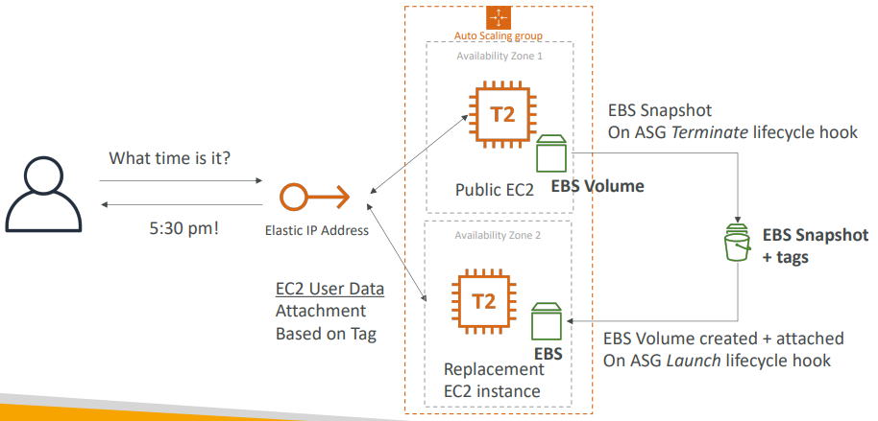

## Questions

**Top of Form**

**You are working on a Serverless application where you want to process objects uploaded to an S3 bucket. You have configured S3 Events on your S3 bucket to invoke a Lambda function every time an object has been uploaded. You want to ensure that events that can't be processed are sent to a Dead Letter Queue (DLQ) for further processing. Which AWS service should you use to set up the DLQ?**

* **S3 Events**
* **SNS Topic**
* **Lambda Function**

**Bottom of Form**

Ans C correct The Lambda function's invocation is "asynchronous", so the DLQ has to be set on the Lambda function side.

**Top of Form**

**As a Solutions Architect, you have created an architecture for a company that includes the following AWS services: CloudFront, Web Application Firewall (AWS WAF), AWS Shield, Application Load Balancer, and EC2 instances managed by an Auto Scaling Group. Sometimes the company receives malicious requests and wants to block these IP addresses. According to your architecture, Where should you do it?**

* **CloudFront**
* **AWS WAF**
* **AWS Shield**
* **ALB Security Group**
* **EC2 Security Group**
* **NACL**

Bottom of Form

Ans B Correct

**Top of Form**

**You have a set of Linux EC2 instances deployed in a Cluster Placement Group in order to perform High-Performance Computing (HPC). You would like to maximize network performance between your EC2 instances. What should you use?**

* **Elastic Fabric Adapter (EFA)**
* **Elastic Network Interface (ENI)**
* **Elastic Network Adapter (ENA)**
* **FSx for Lustre**

**Bottom of Form**

Ans A correct

# Other Services

## Cloud Formation

What is CloudFormation

* CloudFormation is a declarative way of outlining your AWS Infrastructure, for any resources (most of them are supported).
* For example, within a CloudFormation template, you say:
  + I want a security group
  + I want two EC2 instances using this security group
  + I want an S3 bucket
  + I want a load balancer (ELB) in front of these machines
* Then CloudFormation creates those for you, in the right order, with the exact configuration that you specify

**Benefits of AWS CloudFormation**

* Infrastructure as code
  + No resources are manually created, which is excellent for control
  + Changes to the infrastructure are reviewed through code
* Cost advantage
  + Each resources within the stack is tagged with an identifier so you can easily see how much a stack costs you
  + You can estimate the costs of your resources using the CloudFormation template
  + Savings strategy: For e.g. In Dev, you could automation deletion of templates at 5 PM and recreated at 8 AM, safely
* Productivity
  + Ability to destroy and re-create an infrastructure on the cloud on the fly
  + Automated generation of Diagram for your templates!
  + Declarative programming: so you don't need to figure out if you need to create a DynamoDB table first, or an EC2 instance, or all these things together. The CloudFormation template is smart enough to figure out how to do things.
* Don’t re-invent the wheel
  + Leverage existing templates on the web!
  + Leverage the documentation
* Supports (almost) all AWS resources:
  + Everything we’ll see in this course is supported
  + You can use “custom resources” for resources that are not supported

**CloudFormation + Application Composer**

* Example: WordPress CloudFormation Stack
* We can see all the resources
* We can see the relations between the components

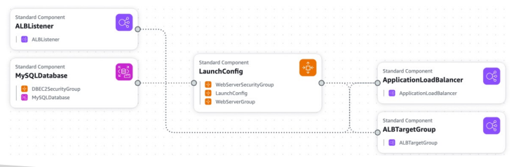 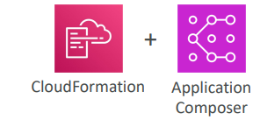

So from an exam perspective, CloudFormation is going to be used when we have infrastructure as code, when we need to repeat an architecture in different environments, different regions, or even different AWS accounts.

**Hands On**

Okay, so I'm going to give you a quick introduction to CloudFormation and give you an overview that really allows you to understand how it works. So let's create a stack and let's make sure first of all that we are in the US East, Northern Virginia, US East 1 region, because the template I've created for you only works in that region. And I will tell you why when we see the template. So please make sure to switch the region to this one. Next we create a stack and we have to prepare templates. So multiple options. We can choose an existing one, use a sample template and some samples are provided or build from Application Composer. But we're going to choose an existing template. We're going to upload a template file and let me show you what the file looks like. So in your course code under CloudFormation, you have 0-just-EC2.yaml. And this is a very simple file right now which has a resource blog and it creates an instance called My instance. The type is EC2 instance, and then you have a few properties. The first one is the availability zone, which is US East 1a and this is why you have to choose US East 1 as your region in CloudFormation service right now. And the image ID is this AMI ID. And as you should know, AMI IDs are scoped within the region. So for these two reasons, you must be in US East 1 for this hands-on. The instance type is T2 micro. And so as you can see we define how to launch an EC2 instance through this YAML file. So let's go ahead and actually upload this file. So select it and then you can actually view it in Application Composer. So open this in a new tab. So here is my template. So as you can see, Application Composer gives us a visual understanding of our templates. So if we look within templates, we get back the code that we just uploaded right here and we can switch it to YAML and JSON if we wanted to. But in the canvas we see that we have one standard component, which is an EC2 instance in my instance. You could double click on it and view it the fact that it's an EC2 instance as well. So Application Composer is a nice way of getting a visual feedback of your templates. Anyway, back into our stack. Let's click on next. We have to provide a demo stack name. So I'll call this one demo CloudFormation and then some parameters. But because we don't define any parameters in our templates so far, we don't do anything here. Let's click on next here we have tags. So I'm just going to show you tag being CFDemo just to show you how tags work in CloudFormation. We scroll down, no permissions to set. We don't touch these options and neither of these options. So let's click on next and we review and create. And when we're good to go, let's click on submit. So as you can see now this template I uploaded is going to generate some events and that was very quick. So the events are done and this actually created a resource right here, which is an EC2 instance. So the code got a resource out of it, and this is why it's called Infrastructure as Code. So you can click on this EC2 instance. As you can see right now in the EC2 console, my instance is running and you can check the fact that indeed it is a T2 micro type of instance. And you can also check the fact that the AMI ID we have selected is the one that was entered in our template. So this is all very convenient. On top of it, we notice that if you go to our EC2 instance and we look at the tags, we can see that some tags were applied by CloudFormation, which are the name of the CloudFormation, the name of the logical ID and the stack ID, but also the name we have specified. So the tag we specified has name CFDemo has also been applied to this EC2 instance, and therefore it's named correctly. Okay, so now that we have an instance, let's go ahead and update this stack. So we click on update and we replace the existing template. And this time we're going to choose this 1-ec2-with-sg-eip file. And if you have a look at it, this file is right here. So we have a more complete file now. We have a parameter section to set the security group description. We have the EC2 instance section, which is a bit more complete because now it has security groups and it has two of those. We have an Elastic IP here that is attached to my instance. And we have one security group here defined for SSH rules. So port 22 is going to be open and we have the server security group, which is going to be open on port 80 from everyone and port 22 from a very specific IP. So this is a more complete CloudFormation template. Now let's go back to CloudFormation and we're going to apply these template. So here we are prompted with a parameter. So what is the security group description? So let's enter demo description. And as you can see now we are entering some texts, which is going to make everything vary. We don't touch the tags, we don't touch anything. Let's click on next. And now because we are applying an update, as you can see, we have a change set. And so we can preview the change sets, which is what is going to change in our CloudFormation stack. So as you can see, a few things are added. There is an Elastic IP, there is an SSH security group and a server security group. And it's add, so it's new. And my instance is going to change, it's going to be modified, and there is a column here says replacement true. That means that this EC2 instance is going to be replaced, that means that the previous one is going to be deleted and a new one is going to be created. So it's good to know in case you had some data on your EC2 instance. So now let's submit this update and see what happens. So CloudFormation is a very smart service because well, from just this code right here it's able to figure out exactly what to do thanks to the change sets, so it knows exactly what to create first. So as you can see, the server security group and the SSH security group already are created. And only then will it update the EC2 instance. So now the my instance is an update in progress, and as you can see, it says requested updates requires the creation of a new physical resource, hence creating one. So if you go into the EC2 console and we remove this filter, now we see that we have two EC2 instances. This one was created before and this one is the new one and it was pending and now it is running. So a new instance got created and once it's created, again, it's going to be updated here, the update is complete. And now we have MyEIP. So now the Elastic IP is going to be created and then attached to my EC2 instance. So if we're quick and we go on the left hand side to Elastic IP, even though we may not have seen what it is here is Elastic IP that is properly created, properly tagged, and it is attached already to our EC2 instance. So now if I click on this one and then I click on networking at the bottom, you see Elastic IP address here was attached. So everything was done by CloudFormation and was done well. And if you look at CloudFormation now in the events, as you can see, the Elastic IP was created and then there was a cleanup in progress due in progress. So that means that the previous EC2 instance right here, this one got terminated, which is very handy because CloudFormation takes care of everything. So you can go into the resources tab and see everything that was created through CloudFormation. On top of it, if you go to the template and you click on view in Application Composer, you're able to see now your new architecture. So we have an EC2 instance connected to an Elastic IP and connected to two security groups. So this is very handy because it gets a visual representation again of our templates. So finally, of course, confirmation. You could go ahead and delete things manually. You could delete this Elastic IP and so on, and the EC2 instances manually. But this is actually not recommended. You don't wanna touch anything manually when using CloudFormation. Instead, you want to either update the templates, or if you wanted to delete everything, just click on delete. And CloudFormation will delete all the stack resources. And the stack resources are also going to be deleted in the right orders. So CloudFormation will figure out what to delete first and so on to clean up everything. So CloudFormation is a really powerful service to do infrastructure as code because it's declarative. You just say what you want and CloudFormation figures it out, and all the code will control your infrastructure, which is very, very handy. So learning how to use it and write it can be a very good skill in AWS.

**CloudFormation – Service Role**

|  |  |
| --- | --- |
| * IAM role that allows CloudFormation to create/update/delete stack resources on your behalf * Give ability to users to create/update/delete the stack resources even if they don’t have permissions to work with the resources in the stack * Use cases: * You want to achieve the least privilege principle * But you don’t want to give the user all the required permissions to create the stack resources * User must have iam:PassRole permissions |  |

## Amazon Simple Email Service (SES)

|  |  |
| --- | --- |
| * Fully managed service to send emails securely, globally and at scale * Allows inbound/outbound emails * Reputation dashboard, performance insights, anti-spam feedback * Provides statistics such as email deliveries, bounces, feedback loop results, email open * Supports DomainKeys Identified Mail (DKIM) and Sender Policy Framework (SPF) * Flexible IP deployment: shared, dedicated, and customer-owned IPs * Send emails using your application using AWS Console, APIs, or SMTP * Use cases: transactional, marketing and bulk email communications |  |

## Amazon Pinpoint

And Amazon Pinpoint is scalable two ways, so inbound and outbound marketing communication service.

|  |  |
| --- | --- |
| * Scalable 2-way (outbound/inbound) marketing communications service * Supports email, SMS, push, voice, and in-app messaging * Ability to segment and personalize messages with the right content to customers * Possibility to receive replies * Scales to billions of messages per day * Use cases: run campaigns by sending marketing, bulk, transactional SMS messages * Versus Amazon SNS or Amazon SES   + In SNS & SES you managed each message's audience, content, and delivery schedule   In Amazon Pinpoint, you create message templates, delivery schedules, highly-targeted segments, and full campaigns |  |

And so you may be wondering, well, what is the difference between Pinpoint and Amazon SNS or Amazon SES? Because there is obviously some overlap. So the idea is that in SNS or SES, you have to manage each message's audience, content, and delivery schedule. And this is the responsibility of your application. And that may be a lot of work, and that may be not very scalable. So in Amazon Pinpoint, instead, you're going to create message templates, delivery schedules, highly targeted segments, and full campaigns. And all of this is managed by the Pinpoint service. So see Pinpoint as the next evolution of SNS and SES, in case you wanna do full-blown marketing communications service.

## Systems Manager – SSM Session Manager

Well, the EC2 instance that we're going to show you in a second has an SSM Agent and that agent is connected to the Session Manager service. So that means that our users can access through the Session Manager service these two instance and execute some commands on it. This has support for Linux, macOS and Windows and we can send log data to Amazon S3 or CloudWatch Logs to make it super secure.

|  |  |
| --- | --- |
| • Allows you to start a secure shell on your EC2 and on-premises servers  • No SSH access, bastion hosts, or SSH keys needed  • No port 22 needed (better security)  • Supports Linux, macOS, and Windows  • Send session log data to S3 or CloudWatch Logs |  |

**Hands On**

So let's have a look at the SSM Session Manager service, but first, we need to launch an EC2 instance. So let's launch an instance right now and I will scroll down. We will choose Amazon Linux 2 AMI, t2.micro. We will not use any key pair. And then I will disable SSH traffic. So as you can see, my EC2 instance will have a security group that allows nothing. No HTTP, no HTTPS, no SSH. Yet, we will be able to use an SSM Session Manager shell. So what I need to do actually is to attach an IAM instance profile to my instance to allow it to talk to the SSM service. So I have a few right here, but I'm going to create a new one just to show the process. So click on create a new IAM role profile. Then let's create a role. For a service on AWS, it will be Amazon EC2. Click on next. Then, for permissions, we're going to filter for SSM and we will choose the Amazon SSM managed instance core. So let's select this and click on next. And then I will call it demo EC2 role for SSM, which allows the EC2 instance to use this policy to talk to the SSM service. So this is necessary for my instance to be managed by the SSM service and so we can use the SSM Session Manager feature. So now that this role is created, we're going to refresh here and we're going to look for this demo EC2 role for SSM. Perfect. So let's go ahead and now, create and launch our instance, which is now launched and it's going to boot. And so the thing I have to check now is the SSM service. So let's go into Systems Manager. And on the left hand side, you're going to look for Fleet Manager and Fleet Manager is a service where all the EC2 instances that are registered with SSM will appear here. So they're called managed nodes. And as you can see right now, we don't have any managed nodes, but we need to wait for the EC2 instance to boot up and then it will appear right here. Okay. So I just refreshed and as you can see, there's one instance. It's running. We can see the SSM Agent is online. We can see the platform, the operating system, Amazon Linux 2, the SSM Agent version and then links to the EC2 instance if we wanted to. Okay. So as soon as our instance is under Fleet Manager, that means that we're ready to run a secure shell against it. So to do so, I will scroll down and I will look for Session Manager. Now, Session Manager is a way for us to access our Linux instances and Windows instances. So let's start a session. And as you can see here, okay, my EC2 instance under the security group does not have any inbound rule. Okay. So zero inbound rules in here. So let's start a session on this EC2 instance and start it. And the idea is that we're going to get a secure shell, as you'll see in a second. Here we go, we have a secure shell and I didn't need to have SSH access so I can do ping google.com and this command is going to work, obviously. And if I do host to get the host name, so host name, we can see that this is IP 172-31-1-148, which is exactly corresponding to, and if you go into networking, the private IP address of my instance. So that means that using the SSM secure shell, we're able to have indeed a secure shell directly from AWS without having SSH security keys and SSH access. So to summarize, we have three ways of accessing our EC2 instance. Number one is to open the port 22 and then use SSH keys and with a terminal to do the SSH command. Number two is to use EC2 Instance Connect and that didn't require to get SSH keys because they will be temporarily uploaded onto the Amazon EC2 instance if we need to. So that was number two, but this required still the port 22 to be opened on our EC2 instance to have access with using EC2 Instance Connect. And then we've explored the third option which is Session Manager. So we need to make sure that we had an EC2 instance with Amazon Linux 2 and make sure that this EC2 instance had an IAM role and this IAM role, okay, as you can see under security, had an IAM role and this IAM role allowed access from the EC2 instance to Systems Manager and this is what allowed us to get the secure shell running. So that's it for this lecture. We can terminate this session and the cool thing is that the session history will be saved in terms of logs. So we can see the session history right here. So this is awesome. And to finish, just take your instance and terminate it.

## SSM other service

**Systems Manager – Run Command**

|  |  |
| --- | --- |
| • Execute a document (= script) or just run a command  • Run command across multiple instances (using resource groups)  • No need for SSH  • Command Output can be shown in the AWS Console, sent to S3 bucket or CloudWatch Logs  • Send notifications to SNS about command status (In progress, Success, Failed, …)  • Integrated with IAM & CloudTrail  • Can be invoked using EventBridge |  |

**Systems Manager – Patch Manager**

|  |  |
| --- | --- |
| * Automates the process of patching managed instances * OS updates, applications updates, security updates * Supports EC2 instances and on-premises servers * Supports Linux, macOS, and Windows * Patch on-demand or on a schedule using Maintenance Windows * Scan instances and generate patch compliance report (missing patches) |  |

**Systems Manager – Maintenance Windows**

* Defines a schedule for when to perform actions on your instances
* Example: OS patching, updating drivers, installing software, …
* Maintenance Window contains
  + Schedule
  + Duration
  + Set of registered instances
  + Set of registered tasks

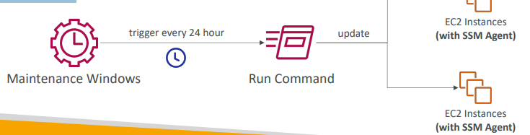-.l,

**Systems Manager – Automation**

|  |  |
| --- | --- |
| * Simplifies common maintenance and deployment tasks of EC2 instances and other AWS resources * Examples: restart instances, create an AMI, EBS snapshot * Automation Runbook – SSM Documents to define actions preformed on your EC2 instances or AWS resources (pre-defined or * custom) * Can be triggered using: * Manually using AWS Console, AWS CLI or SDK * Amazon EventBridge * On a schedule using Maintenance Windows * By AWS Config for rules remediations |  |

## Cost Explorer

* Visualize, understand, and manage your AWS costs and usage over time
* Create custom reports that analyze cost and usage data.
* Analyze your data at a high level: total costs and usage across all accounts
* Or Monthly, hourly, resource level granularity
* Choose an optimal Savings Plan (to lower prices on your bill)
* Forecast usage up to 12 months based on previous usage

**Cost Explorer – Monthly Cost by AWS Service**

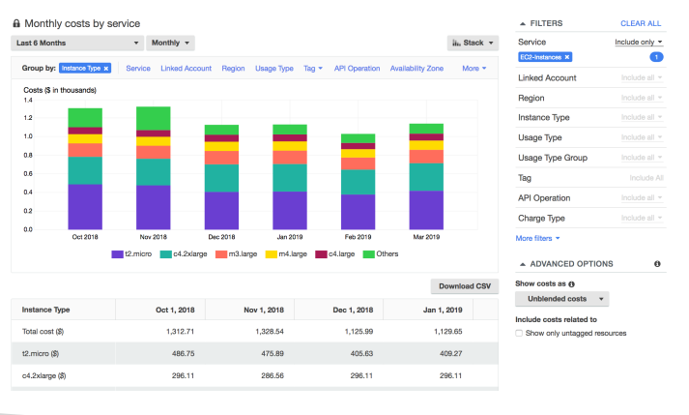

**Cost Explorer– Hourly & Resource Level**

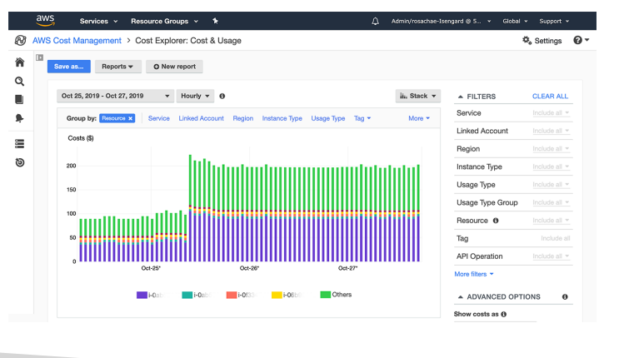

**Cost Explorer – Savings Plan Alternative to Reserved Instances**

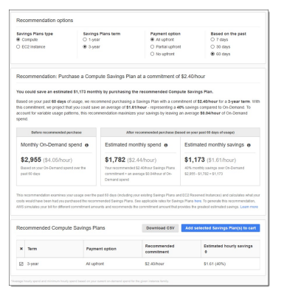

**Cost Explorer – Forecast Usage**

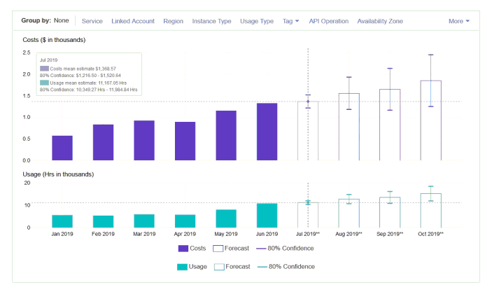

**AWS Cost Anomaly Detection**

* Continuously monitor your cost and usage using ML to detect unusual spends
* It learns your unique, historic spend patterns to detect one-time cost spike and/or continuous cost increases (you don’t need to define thresholds)
* Monitor AWS services, member accounts, cost allocation tags, or cost categories
* Sends you the anomaly detection report with root-cause analysis
* Get notified with individual alerts or daily/weekly summary (using SNS)

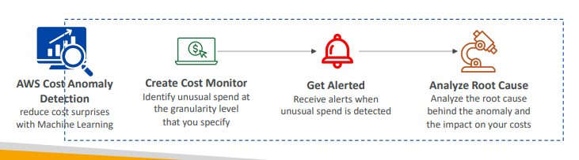

## AWS Outposts

|  |  |
| --- | --- |
| * Hybrid Cloud: businesses that keep an on - premises infrastructure alongside a cloud infrastructure * Therefore, two ways of dealing with IT systems:   + One for the AWS cloud (using the AWS console, CLI, and AWS APIs)   + One for their on -premises infrastructure * AWS Outposts are “server racks” that offers the same AWS infrastructure, services, APIs & tools to build your own applications on-premises just as in the cloud * AWS will setup and manage “Outposts Racks” within your on -premises infrastructure and you can start leveraging AWS services on-premises * You are responsible for the Outposts Rack physical security |  |

**AWS Outposts**

* Benefits:
  + Low-latency access to on-premises systems
  + Local data processing
  + Data residency
  + Easier migration from on-premises to the cloud
  + Fully managed service
* Some services that work on Outposts:

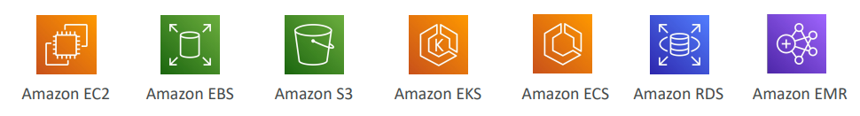

## AWS Batch

* Fully managed batch processing at any scale
* Efficiently run 100,000 computing batch jobs on AWS
* A “batch” job is a job with a start and an end (opposed to continuous)
* Batch will dynamically launch EC2 instances or Spot Instances
* AWS Batch provisions the right amount of compute / memory
* You submit or schedule batch jobs and AWS Batch does the rest!
* Batch jobs are defined as Docker images and run on ECS
* Helpful for cost optimizations and focusing less on the infrastructure

**AWS Batch – Simplified Example**

So for example, say we wanted to process images submitted by users into Amazon S3 in a batch way. So image will be put into Amazon S3, and this will trigger a batch job. And so batch will automatically have an ECS cluster made of EC2 instances, or Spot Instances and batch would make sure that you have the right amount of instances to accommodate the load of batch jobs you have in the batch queue. And then these instances will be running your Docker images that will be doing your job. And then maybe that job will be to insert the processed object. Maybe it's a filter on top of the image into another Amazon S3 buckets. So the question you may have is what is the difference between batch and Lambda because they look similar? So Lambda has a time limit, it's 15 minutes, and you only get access to a few programming languages. On top of it, you have limited temporary disk space if you want to run your jobs, and it's going to be serverless, whereas batch is very different. So batch has no time limit, because it relies on EC2 instances. It's any runtime that you want as long as you package it as a Docker image. And for storage, you rely on the storage that comes with an EC2 instance. So it could be an EBS volume, or an EC2 instance store for disk space, which can be a lot more than for Lambda functions. And then finally, batch is not a serverless service. It's a managed service, but it relies on actual EC2 instances being created. But these EC2 instances are managed by AWS so we don't have to worry about the auto scaling and so on.

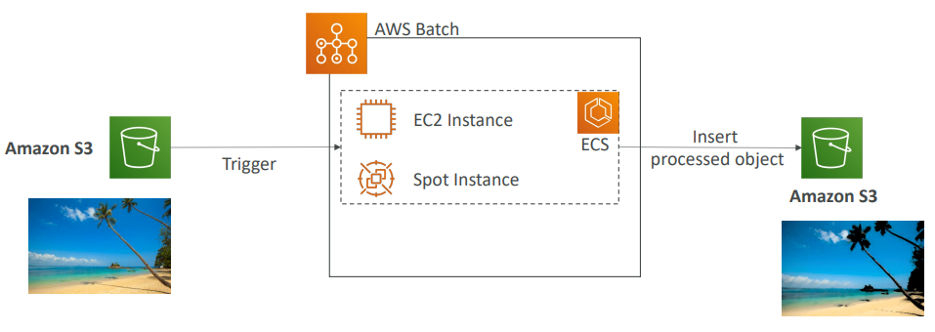

**Batch vs Lambda**

|  |  |
| --- | --- |
| * Lambda:   + Time limit   + Limited runtimes   + Limited temporary disk space   + Serverless | * Batch:   + No time limit   + Any runtime as long as it’s packaged as a Docker image   + Rely on EBS / instance store for disk space   + Relies on EC2 (can be managed by AWS) |

## Amazon AppFlow

* Fully managed integration service that enables you to securely transfer data between Software-as-a-Service (SaaS) applications and AWS So, these integrations are quite difficult to write, and with AppFlow they're very easy.
* Sources: Salesforce, SAP, Zendesk, Slack, and ServiceNow
* Destinations: AWS services like Amazon S3, Amazon Redshift or nonAWS such as SnowFlake and Salesforce
* Frequency: on a schedule, in response to events, or on demand
* Data transformation capabilities like filtering and validation
* Encrypted over the public internet or privately over AWS PrivateLink
* Don’t spend time writing the integrations and leverage APIs immediately

## AWS Amplify

So now let's talk about AWS Amplify and it's a complicated service, but at its core I want you to think of it as a web and mobile application development tool. So this Amplify will basically allow you to integrate a lot of the stack of AWS into one place to build your web and mobile applications. So you're a developer, and you know you wanna do a lot of things. You wanna first create backends. So you're going to use the Amplify CLI to create an Amplify Backend. And this backend is going to internally use a lot of resources from AWS that we know. Amazon S3 for data storage, Amazon Cognito for identity, AppSync for APIs, API Gateway for APIs as well, StageMaker for machine learning, Lex for text detection, Lambda for functions data service, DynamoDB for data and so on. And so the idea is that thanks to Amplify, we have one place to configure authentication, storage, API will be REST API or GraphQL API, CI/CD, PubSub, Analytics, AI/ML predictions, monitoring, and so on. Then you connect your code. It could be from anywhere from GitHub, from CodeCommit on AWS or Bitbucket, GitLab, or you can upload your code directly. And so you would go ahead you integrate all these backend services directly from within Amplify. Then you add the Amplify Frontend Libraries to connect to your Amplify Backend. And so you have Frontend Libraries for web applications, mobile applications, as well as many, many frameworks. And finally, when you're ready, you're going to deploy using the Amplify Console to Amplify itself and Amazon CloudFront for your web or mobile application to be available. Now they may seem like a lot but I want you to think as Amplify as the Elastic Beanstalk for web and mobile applications. It's just a high level overview, but you need to see that it allows you to integrate all these things of AWS into one place, to have a one stop shop for developers to create web and mobile applications.

**AWS Amplify - web and mobile applications**

* A set of tools and services that helps you develop and deploy scalable full stack web and mobile applications
* Authentication, Storage, API (REST, GraphQL), CI/CD, PubSub, Analytics, AI/ML Predictions, Monitoring, …
* Connect your source code from GitHub, AWS CodeCommit, Bitbucket, GitLab, or upload directly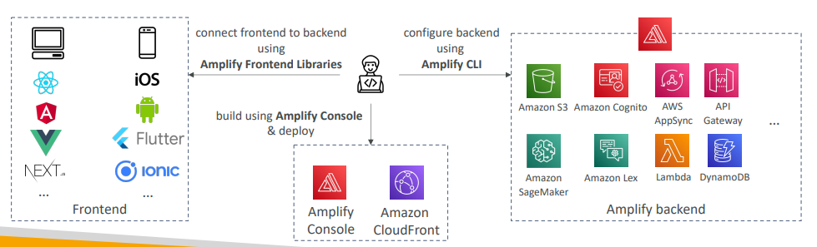

## Instance Scheduler on AWS

* Not a service it’s a AWS solution deployed through CloudFormation (not a service)
* Automatically start/stop your AWS services to reduce costs (up to 70%)
* Use case Example: stop company’s EC2 instances outside business hours
* Supports EC2 instances, EC2 Auto Scaling Groups, and RDS instances
* Schedules are managed in a DynamoDB table
* Uses resources’ tags and Lambda to stop/start instances
* Supports cross -account and cross -region resources
* <https://aws.amazon.com/solutions/implementations/instance-scheduler-on-aws/>

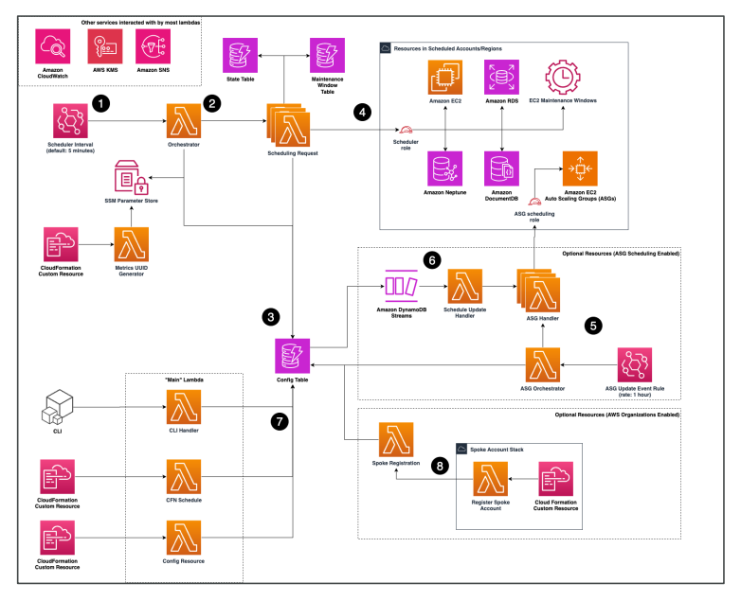

**Hands On**

Now I just wanna show you how this gets deployed. We're not going to use it, but I want for you to see it in action for the deployment part. So let's type Instance Scheduler AWS, and then we click on the solution and we arrive on this webpage. So this is to stop and start Amazon EC2 and RDS instances to manage cost. So we get the benefits, we get some information around the version, the release, we can look at the implementation guide and you can download it, it's very helpful. The source code is there, this is the CloudFormation template and so on. And then we have a developer guide and an operator guide. So it's quite a complete solution and one of the most, I would say complete one on AWS and this is architecture and it shows you what is step 1, step 2, step 3, step 4, step 5, step 6 and step 7. Obviously, using it is out of the scope of this course, but we're just going to do the quick start to see how we can get started. So the way to actually launch the stack is to use the management console and you click on launch solution here and this takes you directly into CloudFormation. And then automatically is going to pre-fill the instance at this template and the Amazon S3 URL and then we click on next. So this is going to deploy the solution as a CloudFormation template so I'll call this one Instance Scheduler and you don't have to do it, I just wanna show you how it's done. And here we get some information around the different parameters. So we have... And I need to have no space, okay. So we have here the tech key is Schedule. This is every five minutes that we're going to look at if we can shut down things. What's the default time zone? If you want to enable yes or no scheduling, so no if you want to disable it or yes, if you want to enable the solution. Then we have services. So do we want to allow it to enable EC2 scheduling, yes; RDS, RDS cluster as well as Neptune, DocumentDB and auto-scaling so it's possible that over time more services are added to this, but the main ones to remember are EC2 instances and RDS instances and cluster. And then you have tagging. So this is what happens when an instance is started or stopped. A tag is going to be added automatically describing how instant scheduler actually did an action on this date, on this time zone. And then, more service specific things that we don't need to really look at. Do we want to have RDS instances snapshot on stop? What do we want to look at for ASG and so on? So it's quite a very complete, I would say solution monitoring and then other things. But for now, we're good. Let's click on next and then let's click on yes and click on next. And so this is going to create based on all these parameters, a stack on CloudFormation with all the solution. So now I'm just going to wait for it to be created. Okay, so the stack is now created and what's important to see is the resources. As you can see, there's a lot of resources that have been created and so we can tree view or a flat view. And what I wanna show you though is a DynamoDB table. So if a type dynamo, okay, we have three tables, we have the config tables, and that's the most important table here. So, in this table that you would set your schedules. So let's explore the table item and here we go. So we have here the types of things that happen. So we have the name, the begin time, the description, the end time, and so on. So this is just an example, but it tells you like for example, how to have office hours or days in the week or working days or every first Monday of each quarter. So this is where you would actually schedule and set up everything. And then for the rest, then if you go into the Lambda console over here, it's just a bunch of Lambda functions. You can see I have a lot of them right here. This bunch of Lambda functions are going to do all the scheduling. Of course, getting into the details of the architecture is not what's necessary, but for you to understand the idea behind it. Okay, so that's it. I went a little bit too deep into it probably, but it's good for you to see it. And I'm just going to go ahead and delete my stack and we'll be done.

## Questions

**Top of Form**

**As part of your Disaster Recovery strategy, you would like to make sure your entire infrastructure is code (IaC) so that you can easily re-deploy it in any AWS region. Which AWS service do you recommend?**

* **AWS CodePipeline**
* **AWS Elastic Beanstalk**
* **AWS CodeDeploy**
* **AWS CloudFormation**

Ans A AWS CodePipeline is a fully managed continuous delivery (CD) service that helps you automate your release pipeline for fast and reliable application and infrastructure updates. It automates the build, test, and deploy phases of your release process every time there is a code change.

B AWS Elastic Beanstalk is an easy-to-use service for deploying and scaling web applications and services developed with Java, .NET, PHP, Node.js, Python, Ruby, Go, and Docker. It automatically handles the deployment, from capacity provisioning, load balancing, auto-scaling to application health monitoring.

C AWS CodeDeploy is a fully managed deployment service that automates software deployments to a variety of computing services such as EC2, Fargate, Lambda, and your on-premises servers.

D Correct AWS CloudFormation is the de-facto service in AWS for infrastructure as code (IaC). It enables you to create and provision AWS infrastructure deployments predictably and repeatedly.

**Top of Form**

**Which AWS service allows you to send marketing SMS and push notifications to a large number of customers with personalized messages?**

* **Amazon SNS**
* **Amazon PinPoint**
* **Amazon SES**
* **AWS Lambda**

Ans B correct

**Top of Form**

**What is the most secure way to connect to an EC2 instance without exposing the SSH port 22?**

* **SSM Session Manager**
* **Site-to-Site VPN**
* **AWS Client VPN**
* **Bastion Host**

Ans A correct**Bottom of Form**

**Top of Form**

**Which AWS service allows you to run and schedule hundreds of thousands of computing jobs on AWS such as big data and complex analytics jobs?**

* **AWS Simple Batch Service**
* **Amazon EC2**
* **AWS Batch**
* **AWS Lambda**

Ans C correct Bottom of Form

Bottom of Form

AA

**Top of Form**

**The company you are working on is using Salesforce and Slack internally. For archival and some analytics requirements, you have been tasked to transfer the data in both Salesforce and Slack to AWS in an S3 bucket. Which AWS service is best suited for this scenario?**

* **Amazon AppFlow**
* **AWS DataSync**
* **AWS Data Migration Service**
* **AWS Application Migration Service**

Ans A correct **Bottom of Form**

**Bottom of Form**

# White Papers & Architectures

Section Overview

• Well Architected Framework Whitepaper

• Well Architected Tool

• AWS Trusted Advisor

• Reference architectures resources (for real -world)

• Disaster Recovery on AWS Whitepaper

## Well Architected Framework

There is a framework called the AWS Well-Architected Framework. And I'm going to describe it to you. This is a tool as well as a framework that allows you to do good applications on AWS.

**Well Architected Framework General Guiding Principles**

<https://aws.amazon.com/architecture/well-architected>

Summary

* Stop guessing your capacity needs instead use ASG
* Test systems at production scale . So with AWS, you can very quickly perform big test big infrastructure, and then shut them down an hour later. So there's no reason for you not to test at production scale.
* Automate to make architectural experimentation easier. E.g. If you have a Cloud formation template you can easily deploy it in multiple environments to experiments.
* Allow for evolutionary architectures, for example, start with EC2 instances and a load bouncer and evolve towards a more serverless architecture such as API Gateway and Lambda.
* Design based on changing requirements
* Drive architectures using data
* Improve through game days. The idea is that you must try out your architecture go production, give it a go and see how you can improve. So, you need to submit your application, for example
  + E.g. Simulate applications for flash sale days

**Well Architected Framework 6 Pillars**

* 1) Operational Excellence
* 2) Security
* 3) Reliability
* 4) Performance Efficiency
* 5) Cost Optimization
* 6) Sustainability

• They are not something to balance, or trade-offs, they’re a synergy

**AWS Well-Architected Tool**

* Free tool to review your architectures against the 6 pillars Well-Architected Framework and adopt architectural best practices
* How does it work?
  + Select your workload and answer questions
  + Review your answers against the 6 pillars
  + Obtain advice: get videos and documentations, generate a report, see the results in a dashboard
* Let’s have a look: <https://console.aws.amazon.com/wellarchitected>

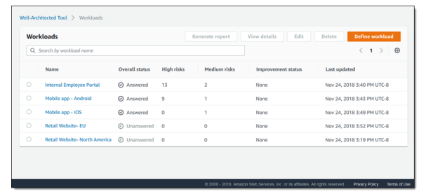

<https://aws.amazon.com/blogs/aws/new-aws-well-architected-tool-review-workloads-against-best-practices/>

**Hands On**

So to help you guide you through this framework there is something called the AWS Well-Architected tool. And it's a framework tool to review your architectures against the six pillars I just defined. And then you adapt architectural best practices. So this is whether your looks like and we'll see this in a second. So how does it work? Well, you select your workload and then you answer questions. You review your answers against the six pillars that I just defined. And then you obtain advice. You get videos, documentation reports and you see results in a dashboard. So let's have a look to see how this tool works. So here I am in the well-architected tool UI and I'm going to define a workload. So you can, for example, define a demo workload and say this is your production application. You can say, this is my prod application. Okay, the review owner will be John@example.com. We are in production and we are functioning in two either of this regions that I will choose. So this one and then US-West-2, perfect. We can specify non-AWS regions, account IDs and so on. And you can just specify a lot of information around your infrastructure and architecture. So next I'm going to apply lenses. And these lenses are the kind of questions you apply to your architecture. So we'll apply the well-architected framework lens. But you have the FTR lens, the serverless lens, the SaaS lens and you can even create your custom lenses if you wanted to. But for now, we'll keep it simple and just answer questions regarding the well-architected framework. So let's define the workload. And once you have that, you need to start reviewing. So we'll start reviewing and then we'll review for the lens of the AWS Well-Architected Framework. So in here I get some resources on the right hand side that I can close. And the idea is that you're going to have a lot of questions on the six pillars, for example, 11 questions on operational excellence and then 10 questions on security, six on sustainability and things can change over time, of course but the idea is that you answer questions and then you're gonna get recommendations. So for example, how do you determine that what your priorities are? And we'll say, okay, we evaluate governance requirements external customer needs and trade offs. And then next, so answer one question. And then how do you structure your organization? Maybe I just have this answer and then next. And so you can answer questions in the various pillars and you should answer them all for all pillars, but let's answer one as well in performance efficiency, randomly and next. So once you answer maybe three questions of course they're a lot more, then you save and continue. And then here, as you can see, we have three high risks. So you can click on this lens right here and then you're going to get the overview of this lens as well as the risks. So you can click on the risk itself by going to improvement plan. We see we have three high risk and zero medium risk and so this one was a high risk and here are the recommendations regarding this risk. So I need to evaluate internal customer needs evaluate threat landscape and so on. And then if I click on it, I get the section in the framework itself that tells me exactly what I need to do. So it's very important. And then I will go back to answering more questions and making sure that this is addressed. And so this tool just gives you feedback. And over time you can define milestones. You can look at your improvement plans and so on. And the idea is that once you are very confident that this framework works for you then your application is production ready and your workload is compliant and well architected, okay? So that's it for this tool.

## Trusted Advisor

So now, let's talk about AWS Trusted Advisor. So you don't need to install anything. It's a service that gives you a high level account assessment on your account. It's going to check for a few things and advise you on them. So the checks can be, for example, do you have EBS Public Snapshots? Or do you have RDS Public Snapshots? Or are you using the root accounts for your accounts? So all these things are checked by Trusted Advisor and they are grouped in six categories.

|  |  |
| --- | --- |
| * No need to install anything – high level AWS account assessment * Analyze your AWS accounts and provides recommendation on 6 categories:   + Cost optimization   + Performance   + Security   + Fault tolerance   + Service limits   + Operational Excellence   So you have what's called the three sets of checks, the core sets of checks, and then you have the full set of checks. And to have access to the full set of checks, you need to have a business or an enterprise support plan.   * Business & Enterprise Support plan * Full Set of Checks * Programmatic Access using AWS Support API |  |

**Hands On**

So I think it's best for you to see what Trusted Advisor is made of to really understand it. So here, I am in Trusted Advisor. And as you can see, you have recommendations. So zero actions are recommended, but two investigations are recommended for me, and then there are some checks on excluded items or not. But as we can see, we have two on security that must be looked at. So it turns out that one of my bucket is actually allowing a global access. So I need to verify it and make sure it's correct. And as you can see, 29 of my 60 security group rules allow unrestricted access to a specific port. So again, this is something I should look at. Maybe that's my intention, maybe that's a problem. But you can see right away, I get prompted to upgrade my support plan to get all Trusted Advisor checks. So let me show you what I mean. On the left-hand side, we have the Recommendation categories. And if I click on Cost optimization, as you can see, I get none of the checks available because I need to update my support plan. So all these things are actually not available for me and I need to pay for the service to actually make some cost optimizations. Same for performance, I get access to nothing. If I go to Fault tolerance, again, I get access to nothing. Operational excellence, again, access to nothing. The only two things I have access to is security. So here, we get some checks, the core checks. And in here, I have my Bucket Permissions, my Security Group ports, my EBS Public Snapshot, RDS Public Snapshot, and so on. But as soon as I go in here to the more advanced security checks, then, again, I need to update my support plan. Finally, you can have a look at Service limits directly in Trusted Advisor. That's one way of doing it. So you can have a look at your Auto Scaling Groups, your CloudFormation Stacks, your DynamoDB Read and Write Capacity and so on. So Trusted Advisor is not a very interesting service to look at when you don't pay for the support plan, but at least this should give you an idea of how Trusted Advisor is used in AWS, and therefore answer your exam questions on it.

**More Architecture Examples**

* We’ve explored the most important architectural patterns:
  + Classic: EC2, ELB, RDS, ElastiCache, etc…
  + Serverless: S3, Lambda, DynamoDB, CloudFront, API Gateway, etc…
* If you want to see more AWS architecture:
* <https://aws.amazon.com/architecture/>
* <https://aws.amazon.com/solutions/>

So here I am on the AWS Architecture Center, and this is where you're going to find reference architecture examples and diagrams. So if you scroll down, you get access to different links, such as, for example, a link to the Well-Architected Framework. But let's scroll down even more. In here, we can browse the contents with all the architecture diagrams. So as you can see, we have over 2,000 of those. So this is huge. And therefore, on the left-hand side, you have some filters to select whatever you want. So for example, here, if I automate your DR solution for relational databases, I click on it and I get access to this in PDF form or HTML form. So let's access it in PDF form, and you get access to a lot of information. And within that information, you will find some architecture diagrams and everything is explained, which I think is tremendously good resources as a solution architect. So it's very detailed. As you can see, we have CloudFormation templates that functions, I mean, everything is there. You also have, for example, WordPress architecture. So if you type WordPress, you have best practices of WordPress on AWS. Again, let's open the PDF version and scroll down. And here we go again. We have some architecture diagrams and we have an even bigger architecture diagram. So everything is quite thorough and there's a lot of text that really helps you to step up as a solution architect. The other one I really liked is the AWS Solutions Library. So this is vetted solutions and guidance for businesses and technical use cases. And I really like it because it provides you not only architecture diagrams, but also CloudFormation templates to actually implement things. So here, let's look at this AWS solution called Live Streaming on AWS. And here, this is how to build a highly available architecture that delivers reliable, real-time viewing experience. Okay, perfect, let's scroll down, and we get some information around the type of solution we have. So we have one on S3 and one on AWS, which use different kind of services, where they support, what they don't support and so on. And then the technical details. So we have the first architecture, the second architecture, so they're both here. And we can actually get implementation guides and we can actually launch it in the console. So there is a CloudFormation template, the source being here, and the source code is also on GitHub, as you can see. And these CloudFormation template allow you to actually develop and deploy these kind of architectures. So this is awesome because you really do a huge steps forward as a solution architect into deploying some of these solutions. So if you scroll down on the solutions library, you will find that you can browse by industry based on what industry it is or cross industry solutions or by technology or by organization type. And finally, again, you have a lot of filters on the on the left-hand side. So if I type, for example, serverless in here, I can find the Serverless Image Handler, which shows me how to handle some images, such as smart cropping, constant moderation, na, na, na, and so on. And this is the architecture. Again, there's a CloudFormation template. You have an implementation guide and so on. So everything is super well described, and I really like these two resources because they really propel you into the real world of solution architecture.

**Top of Form**

**Which AWS Service analyzes your AWS account and gives recommendations for cost optimization, performance, security, fault tolerance, and service limits?**

* **AWS Trusted Advisor**
* **AWS CloudTrail**
* **AWS Identity and Access Management (AWS IAM)**
* **AWS CloudFormation**

**Bottom of Form**

Ans A correct AWS Trusted Advisor provides recommendations that help you follow AWS best practices. It evaluates your account by using checks. These checks identify ways to optimize your AWS infrastructure, improve security and performance, reduce costs, and monitor service quotas.

B AWS CloudTrail allows you to log, continuously monitor, and retain account activity related to actions across your AWS infrastructure. It provides the event history of your AWS account activity, audit API calls made through the AWS Management Console, AWS SDKs, AWS CLI. You can use CloudTrail to detect unusual activity in your AWS accounts.

C AWS IAM enables you to manage access to AWS services and resources securely. You can create and manage IAM users, groups, and roles, and use permissions to allow and deny their access to AWS resources.

D AWS CloudFormation is the de-facto service in AWS for infrastructure as code (IaC). It enables you to create and provision AWS infrastructure deployments predictably and repeatedly.

# Exam Review & Tips

**State of learning checkpoint**

* Let’s look how far we’ve gone on our learning journey
* <https://aws.amazon.com/certification/certified-solutions-architectassociate/>

**Practice makes perfect**

* If you’re new to AWS, take a bit of AWS practice thanks to this course before rushing to the exam
* The exam recommends you to have one or more years of hands-on experience on AWS
* Practice makes perfect!
* If you feel overwhelmed by the amount of knowledge you just learned, just go through it one more time

**Proceed by elimination+**

* Most questions are going to be scenario based
* For all the questions, rule out answers that you know for sure are wrong
* For the remaining answers, understand which one makes the most sense
* There are very few trick questions
* Don’t over-think it
* If a solution seems feasible but highly complicated, it’s probably wrong

**Skim the AWS Whitepapers**

* You can read about some AWS White Papers here:
* Architecting for the Cloud: AWS Best Practices
* AWS Well-Architected Framework
* AWS Disaster Recovery (https://aws.amazon.com/disaster-recovery/)
* Overall we’ve explored all the most important concepts in the course
* It’s never bad to have a look at the whitepapers you think are interesting!

**Read each service’s FAQ**

* FAQ = Frequently asked questions
* Example: <https://aws.amazon.com/vpc/faqs/>
* FAQ cover a lot of the questions asked at the exam
* They help confirm your understanding of a service

**Get into the AWS Community**

* Help out and discuss with other people in the course Q&A
* Review questions asked by other people in the Q&A
* Do the practice test in this section
* Read forums online
* Read online blogs
* Attend local meetups and discuss with other AWS engineers
* Watch re-invent videos on Youtube (AWS Conference)

**How will the exam work?**

* You’ll have to register online at <https://www.aws.training/>
* Fee for the exam is 150 USD
* Provide one identity documents (ID, Passport, details are in emails sent to you…)
* No notes are allowed, no pen is allowed, no speaking
* 65 questions will be asked in 130 minutes
* Use the “Flag” feature to mark questions you want to re-visit
* At the end you can optionally review all the questions / answers
* To pass you need a score of a least 720 out of 1000
* You will know within 5 days if you passed / failed the exams (most of the time less)
* You will know the overall score a few days later (email notification)
* You will not know which answers were right / wrong
* If you fail, you can retake the exam again 14 days later

**Your AWS Certification journey**

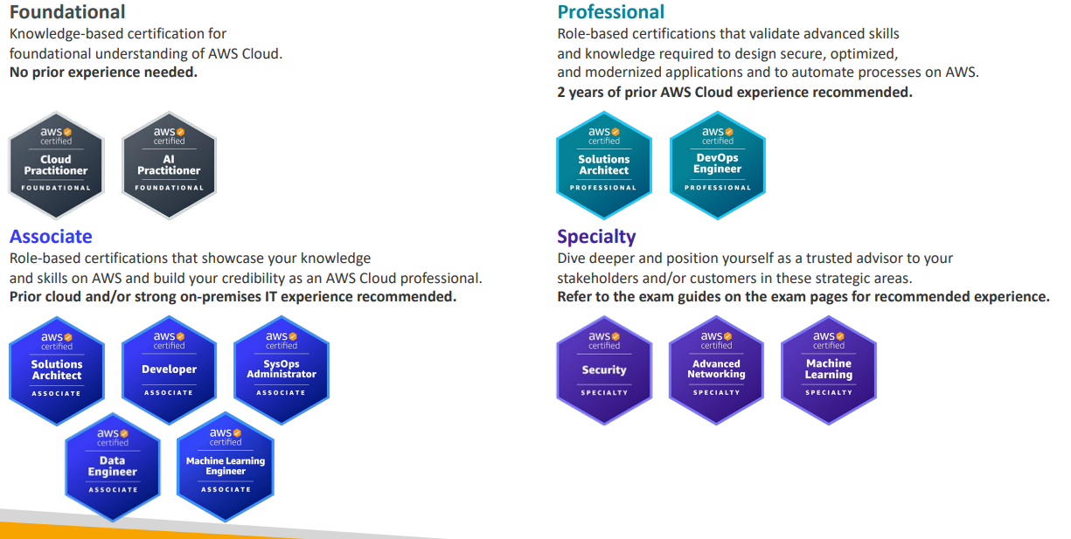

**AWS Certification Paths – Architecture**

|  |  |
| --- | --- |
| Architecture Solutions Architect Design, develop, and manage cloud infrastructure and assets, work with DevOps to migrate applications to the cloud |  |
| Architecture Application Architect Design significant aspects of application architecture including user interface, middleware, and infrastructure, and ensure enterprise-wide scalable, reliable, and manageable systems |  |

<https://d1.awsstatic.com/training-and-certification/docs/AWS_certification_paths.pdf>

**AWS Certification Paths – Operations**

|  |  |
| --- | --- |
| Operations Systems Administrator Install, upgrade, and maintain computer components and software, and integrate automation processes |  |
| Operations Cloud Engineer Implement and operate an organization’s networked computing infrastructure and Implement security systems to maintain data safety |  |

**AWS Certification Paths – DevOps**

|  |  |
| --- | --- |
| DevOps Test Engineer Embed testing and quality best practices for software development from design to release, throughout the product life cycle |  |
| DevOps Cloud DevOps Engineer Design, deployment, and operations of large-scale global hybrid cloud computing environment, advocating for end-to-end automated CI/CD DevOps pipelines |  |
| DevOps DevSecOps Engineer Accelerate enterprise cloud adoption while enabling rapid and stable delivery of capabilities using CI/CD principles, methodologies, and technologies |  |

**AWS Certification Paths – Security**

|  |  |
| --- | --- |
| Security Cloud Security Engineer Design computer security architecture and develop detailed cyber security designs. Develop, execute, and track performance of security measures to protect information |  |
| Security Cloud Security Architect Design and implement enterprise cloud solutions applying governance to identify, communicate, and minimize business and technical risks |  |

**AWS Certification Paths – Development & Networking**

|  |  |
| --- | --- |
| Development Software Development Engineer Develop, construct, and maintain software across platforms and devices |  |
| Networking Network Engineer Design and implement computer and information networks, such as local area networks (LAN), wide area networks (WAN), intranets, extranets, etc. |  |

**AWS Certification Paths – Data Analytics & AI/ML**

|  |  |
| --- | --- |
| Data Analytics Cloud Data Engineer Automate collection and processing of structured/semi-structured data and monitor data pipeline performance |  |
| AI/ML Machine Learning Engineer Research, build, and design artificial intelligence (AI) systems to automate predictive models, and design machine learning systems, models, and schemes |  |

**AWS Certification Paths – AI/ML**

|  |  |
| --- | --- |
| AI/ML Prompt Engineer Design, test, and refine text prompts to optimize the performance of AI language models |  |
| AI/ML Machine Learning Ops Engineer Build and maintain AI and ML platforms and infrastructure. Design, implement, and operationally support AI/ML model activity and deployment infrastructure |  |
| AI/ML Data Scientist Develop and maintain AI/ML models to solve business problems. Train and fine tune models and evaluate their performance |  |